
Notable Alumni
 |  | 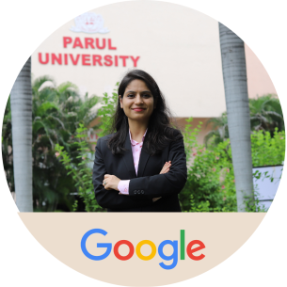 | 
Ms. Vishakha Panchal | Mr. Dhairya Kikani | Ms. Manasi Dalwani | Ms. Manoranjan Padhy
Frontend Manager | Lead Supply Chain Manager | Data Analyst | Developer & Startup Ops Lead.
Apple, USA | Google, USA | Google | Google
 |  |  | 
Ms. Sandhyarani Dash | Ms. Priyanka Bhati | Mr. Milind Purswani | Mr. Jay Vaidya
Staff Firmware Engineer | BIOS Engineer | Security Engineer | Sr. Cloud Technical Account Manager
Intel, USA | Intel Corporation | Snap Inc. | Amazon, USA
 |  |  | 
Ms. Juhi Sharma | Mr. Kandarp Patel | Mr. Shubham Tandlekar | Mr. Rohan Patel
Software Developer | Senior Software  Developer | Principal Security Researcher | Software Developer
IBM | SAP | Oracle | Microsoft
 |  |  | 
Mr. Gunjan Pandya | Mr. Malav Shah | Dr. Raghuvirsinh Parmar | Ms. Riddhi Solanki
Data Engineering Manager | Analyst | Manager | Senior Cabin Attendant
Facebook | Deloitte | Sun Pharma | IndiGo
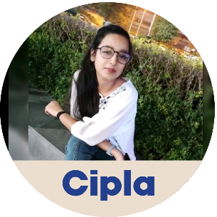 | 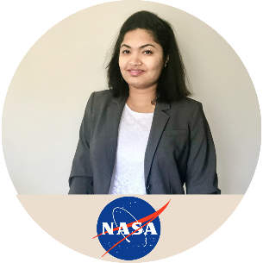 |  | 
Ms. Pragati Rajpurohit | Ms. Dharaben Pathak | Mr. Mahesh Patel | Mr. Dipesh Badgujar
Quality Control Microbiologist | Space Flight Hardware Quality Engineer | Asst. District Manager | Supply Chain Analyst
Cipla | NASA Goddard Space Flight Center | Johnson and Johnson | Unilever

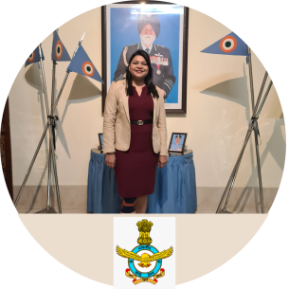 |  | 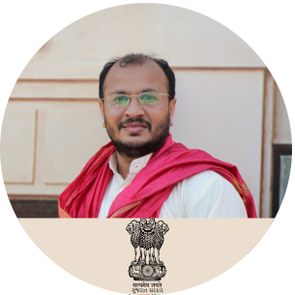 | 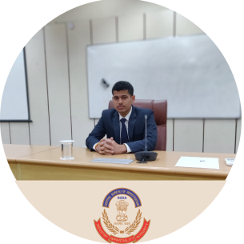
Sqn. Ldr. Pallavi Thakur | Mr. Gurjeet Singh | Mr. Sanjay Patel | Mr. Shubham Shukla
Squadron Leader | HR Officer | State Tax Officer | Sub-Inspector
Indian Air Force | Hindustan Aeronautics Limited,  Ministry of Defence, Govt. of India | SGST, Govt. of Gujarat | Central Bureau of Intelligence
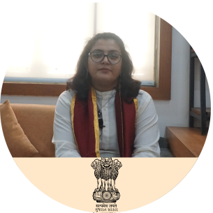 | 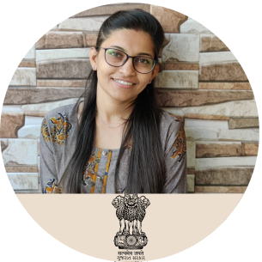 | 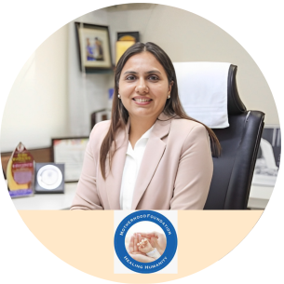 | 
Dr. Amisha Patel | Dr. Aarati Bhensadadiya | Dr. Twinkal Patel | Mr. Ajay D. Sojitra
Assistant Commissioner of Labour | State Tax Officer | Social Entrepreneur | Sr. Sales Officer
Govt. of Gujarat | Govt. of Gujarat | Motherhood Women's & Childcare Hospital Pvt. Ltd | Indian Oil Corporation Limited
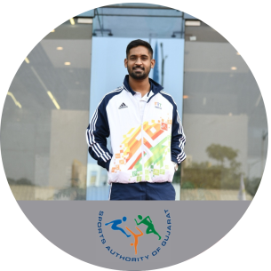 | 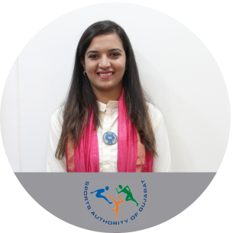 | 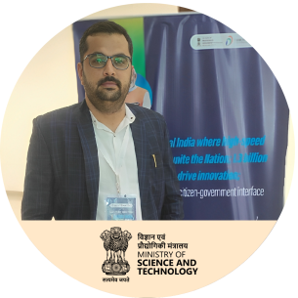 | 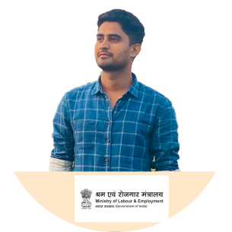
Dr. Shubham Dube | Dr. Janki Panchal | Mr. Danpalsingh Sisodia | Mr. Shivam Singh
Sports Physiotherapist | Sports Physiotherapist | Assistant Director | Officer
Sports Authority of Gujarat | Sports Authority of Gujarat | Department of Science and Technology | Ministry of Labour & Employment
 | 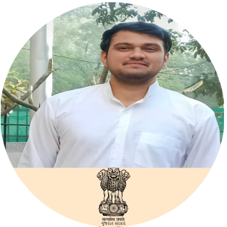 |  | 
Dr. Binita Patel | Dr. Vivek Choudhary | Dr. Jaydeep Gajera | Dr. Nandani Srivastava
Nutritionist, Psychologist | Community Health Officer | NEET PG Cleared | NEET PG Cleared
Respect Obesity Center & Anemic Center | Govt. of Gujarat | AIR – 1145 | AIR – 1016



















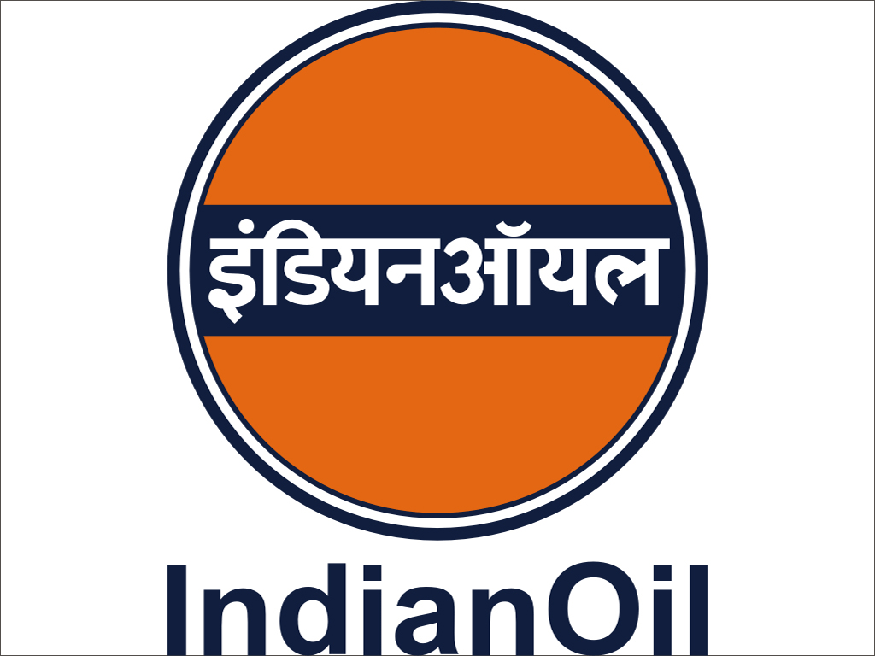

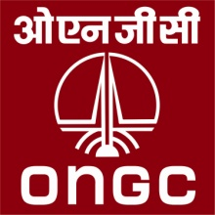




1500+ Industries/ Organizations Connected Via Alumni

