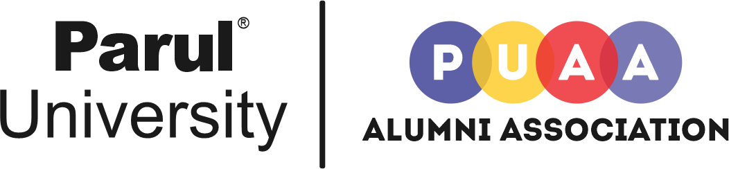

About Parul University Alumni Association

Established in 2015, Parul University Alumni Association creates and maintains a lifelong connection between its alumni and the university. In collaboration with a highly dedicated volunteer Board of Directors, the Alumni Association connects alumni, supports students, and builds an unforgettable Institute experience through a diversity of events, programs, and services. With over 35000+ registered Alumni members, Parul University Alumni Association has been working diligently to serve its alumni and alma mater and a host of related constituencies.

Parul University Alumni Association is also registered as a Public Trust under the Bombay Public Trust Act 1950 (Under Section 29), Trust Registration No: F/3483/Vadodara, 27.08.2021.

MISSION
The mission of the Parul University Alumni Association is to foster strong bonds between alumni, students, and Institute, to keep alumni informed, and to create a network enabling them to remain engaged with their alma mater and help shape its future through the Association’s programs and services.

VISION
As a pre-eminent Alumni Association, we serve the diverse and evolving needs of each member of our global alumni community and create opportunities to strengthen bonds between each other and Alma mater for all time coming.

4Cs followed by PU alumni association
Connectivity: To connect and develop a diverse and inclusive Parul University Alumni community worldwide through registration drives and regional chapters.

Communication: To provide a platform for the Alumni to interact with their Alma mater and current students and also to engage with alumni and friends both near and far, promoting dedication, commitment, and philanthropy to alma mater and to the greater good.

Conversation: To ensure a thriving alumni network through alumni meets and initiatives for all time coming and to promote active engagement in the life of the University through going, giving, and serving.

Creation: To provide added value benefits to the PU Alumni community by offering placements and other assistance.

OUR OBJECTIVES
- To encourage, foster, and promote close relations amongst the Alumni members and improve engagement between the Alumni and the University.
- To promote a sustained sense of belonging to the Alma Mater among the Alumni by being in regular contact with them.
- To create and promote dedicated regional chapters to cater to the needs of Alumni of the region.
- To promote and enhance the University’s good name and reputation.
- To provide and disseminate information regarding their Alma Mater, its graduates, faculties, and students to the Alumni.
- To provide a forum for the Alumni to exchange ideas on academic, cultural, and social issues of the day by organizing and coordinating reunion activities for the Alumni.
- To encourage, promote and facilitate education and research and other activities of the Institute.
- To improve the facilities and infrastructure of the University with the help of the active participation of the alumni.
- To guide and assist Alumni who have recently completed their courses of study to keep them engaged in productive pursuits beneficial to society.
- To let the alumni acknowledge their gratitude to their Alma Mater.
- To provide career and vocational guidance to the Alumni community at large. Additionally, provide guidance enhancement offers for their professional and career development.
- To maintain the website, publish periodical magazines or bulletins with valuable, helpful information to the members and students.

Core committee members of PU Alumni Association
Sr. No. | Name | Designation
1 | Dr. Warish D. Patel | President
2 | Ms. Hemisha Thakkar | Vice President
3 | Mr. Parth Purohit | Secretary
4 | Mr. Kashyapkumar Patel | Joint Secretary
5 | Mr. Rintu Ranjan | Joint Secretary
6 | Mr. Dhruvil Shah | Treasurer
7 | Dr. Rakesh Patel | Member
8 | Mr. Fenil Trivedi | Member
9 | Mr. Jaimin Shah | Member

Register For Lifetime Alumni Membership Card and Regular Updates:
www.pualumni.in
(HTML Button to redirect to this link directly)

Contact Us
Dr. Warish Patel,
Director, Alumni Association Cell
BBA Building, Ground Floor, Parul University
P.O.Limda, Ta.Waghodia – 391760
Dist. Vadodara, Gujarat (India)
+91-2668-260399
alumni@paruluniversity.ac.in
www.pualumni.in

