ONE DAY CME ON THE OCCASION OF WORLD AIDS DAY
On the occasion of World AIDS Day, Departments of Shalyatantra , Faculty of Ayurved has jointly organized one day CME at Parul Institute of Ayurved and Research. The programme was inaugurated by Dr Hemant Toshikhane, Dean Faculty of Ayurved. On this occasion, eminent speakers delivered lectures regarding all aspects of AIDS. Essay & Poster competition was also arranged for the students. The winners were awarded with prizes. This event was organized and conducted under the guidance of Dr B. G. Kulkarni, Principal, Parul Institute of Ayurved and Research.
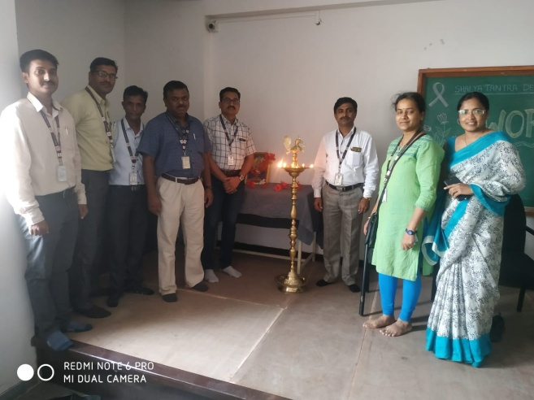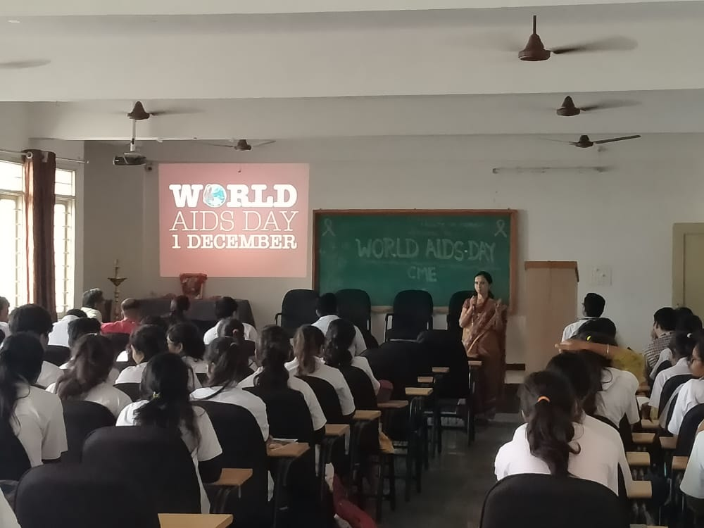

National Children’s Day Celebration
Parul Institute of Ayurveda & Research celebrated National Children’s Day on November 14, 2017 at its Ishwarpura Campus by inviting children from various aanganwadis, their parents and teachers of these aanganwadis in the august presence of Dr.B.G.Kulkarni, Principal, Parul Institute of Ayurveda & Research and Dr Sarita Ohol, Head of the Department of Kriya Shareera (Physiology), PIAR. Dr.Deepthi Viswaroopan, Assistant Professor, Department of Kaumarabritya (Pediatrics) and Dr. Zeel Patel, 1st year PG Scholar, Department of Kriya Shareera conducted a session on “Importance of Good Habits and Good Manners” for these school children using audio-visual aids. The Children also played various games and sang rhymes praising the importance of cleanliness and patriotism. Department of Kaumarbritya in Parul Institute of Ayurveda & Research also conducted free health check-up camp for these students and provided them medicines free-of-cost.
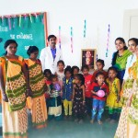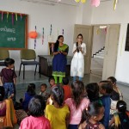

World Heart Day Celebration
Parul Institute of Ayurveda & Research celebrated World Heart Day on September 29, 2017 at its Ishwarpura Campus. Ayurveda Practitioners of PIAR conducted talks for villagers residing in Ishwarpura making them aware about various heart diseases and treatments available in treating patients suffering from heart diseases.
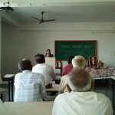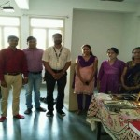

World Environment Day Celebration
Parul Institute of Ayurved & Research, a constituent institution of Parul University, celebrated World Environment Day in collaboration with Himalaya Drug Company on the theme “Connecting People to Nature” on June 5, 2017 by organizing an event at Khemdas Ayurved Hospital. Dr.Komal Patel, Trustee, Parul Arogya Seva Mandal Trust, Dr. B.G.Kulkarni, Principal, Parul Institute of Ayurved & Research, Dr.Rekha Parmar, Professor and Head of the Department of Dravyaguna in Parul Institute of Ayurved, Dr.Samir Chauhan, Manager-Scientific Services, Himalaya Drug Company graced the occassion with their august presence and also delivered talks on orienting people towards healthy lifestyle by adopting Ayurved & Yoga. Faculty members and students of ayurveda participated enthusiastically in the event.
