World Oral Health Day Celebration
A session was conducted for the present outpatients and inpatients of Khemdas Ayurved Hospital, by the Shalakya Tantra Department, on 20 th March 2018 at 10.30a.m on occasion of World Oral Health Day to educate and spread awareness regarding the importance of oral health. The Session was conveyed by Dr.Eshwari, HOD, Dept of Shalakya Tantra. Proper brushing technique was taught by a live demo. An Oath Taking was conducted in the colloquial language to make all the patients (including tobacco users) pledge of not using tobacco in any form for the good health of themselves and people around them. A positive response was obtained from the patients. Session was concluded and on disperse there was free distribution of Ayurvedic tooth powder-Dashana Samskara Choorna done to the patients, free of cost.

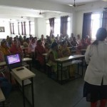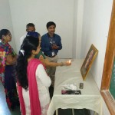

Gurupoornima – 2018
Gurupoornima has celebrated on 27 th July, 2018 at Parul Institute of Ayurved and Research at 04:00 pm in Lecture hall No.1. The function commenced with Dhanwantari prayer by Ms.Anjali Brahmbhatt and lighting the lamp by Dr. Manisha Dunghav, Dr. Madhavi Hebli, Dr. Sarita Ohol and Dr. Anita Joshi. The Function was anchored by Dr. Shyamasundaran K and coordinated by Mr. Tejas Vyas. Dr.Manisha Dunghav, Dr. Madhavi Hebli, Dr. Prasanna Mathad spoke on the importance of Guru and how they influence in life. The students of 1st year BAMS, PIAR also spoke on the occasion. The function was concluded by rendering of vote of thanks by Dr. Ravi B Joshi.

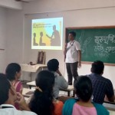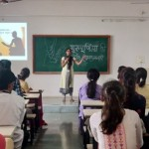

Environment Day Celebration– 2018
World Environment Day was celebrated at Parul Institute of Ayurved & Research, PARUL UNIVERSITY on 5th of June 2018. Morning 11.30 onwards we the staffs and students of PIAR have started planted 60 new medicinal plants.
From 12 to 1 pm a lecture was conducted by Dr.Bhavin Asst professor Dpt of Dravya guna on “Beat plastic pollution” for the health seekers of Kemdas hospital. 60 patients and all the college staffs were present for the same. The management, respected principal sir and all the professors and all teaching staffs have given full support to the program and made it a grant success I take this opportunity to thank them all for their support and co-operation.
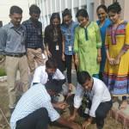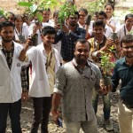

National Ayurved Day

Ayurveda is most ancient well documented system of medicine in practice since ancient era to today’s modern days. Ministry of Ayush observes “National Ayurveda Day” on every year the day of ‘Dhanvantari Jayanti’ Dhanatrayodashi). Ayush Institutes at Parul University observed “AYURVED DAY” with a motive to promote Ayurveda as a primary mode of treatment and also to make people at large aware about the strengths of Ayurveda Medicine.
The students also arranged a rally in Vadodara city, to create awareness about Ayurveda to the public. The rally was co-hosted by Himalaya drug company; Approximately around 500 students took part in the rally so conducted.
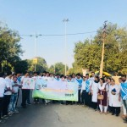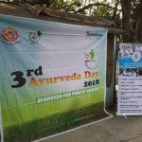

World Piles Day

World Piles Day was celebrated at Khemdas Ayurved Hospital on 20th November 2018. A camp was organised for the patients giving free consultation, check-up, investigation and surgical procedure. The patients who visited the camp were informed about the piles, its causes symptoms, treatment options of precautions. The Ayurvedic treatment for piles was explained in detail to the patients and the benefits for opting Ayurvedic treatments. Proper check-up of the patients were performed in Shalya OPD of Khemdas Ayurved Hospital. 3 patients were admitted for further managements. Free blood investigation was performed the next day and operation procedure was done on 22nd November 2018 free of charge.

