Shishyopanayan Samskara
Shishyopanayan is one of the traditional samskaras that marks the acceptance of a student by a guru and an individual’s entrance to a school. Parul University of Ayurveda and Parul Institute of Ayurved and Research, constituent institutions of Parul University, follow the same system in welcoming the newly admitted students by conducting Shishyopanayan. Parul Institute of Ayurved and Parul Institute of Ayurveda and Research conducted Shishyopanayan on January 3, 2019 during which Holy Hawan was performed with chanting of shlokas from Veda. About 250 under graduate and post graduate students along with Principals of ayurved institutions and teachers from Faculty of Ayurved took out rally across the whole campus with an aim to promote Ayurveda and Its Uniqueness.
Later in the day, Dr.Gaurang Joshi, Renowned Ayurved Practitioner in Rajkot, conducted Guest Lecture for the newly admitted under graduate and post graduate students and urged them to adopt ayurveda practice in place of integrated practice. Dr.Devanshu Patel, President, Parul University; Dr.Komal Patel, Member, Governing Body; Dr.Hemant Toshikhane and Dr.B.G.Kulkarni, Principals of Parul Institute of Ayurved and Parul Institute of Ayurved and Research addressed the gathering with motivational speeches.

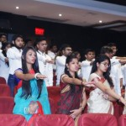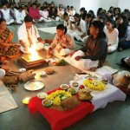

Leprosy Day
On 30-1-2019 leprosy awareness programme was organized by department of swasthavritta, Parul Institute of Ayurved & Research to educate the public about prevention and control measures of leprosy. Programme conduction carried by Dr. Archana .V. Panchaxarimath HOD Department of swasthavritta. Dr. B.G.Kulkarni Principal PIA&R addressed the gathering. Dr.Rakesh.M.Pathak Prof. Department of swasthavritta delivered speech on leprosy in Gujarati language. All the faculties and consultants graced the occasion with their presence, more than 70 people of Ishwarapura got benefited by the programme. Dr. Ramen.Santra. Asst Prof. department of swasthavritta proposed the vote of thanks.

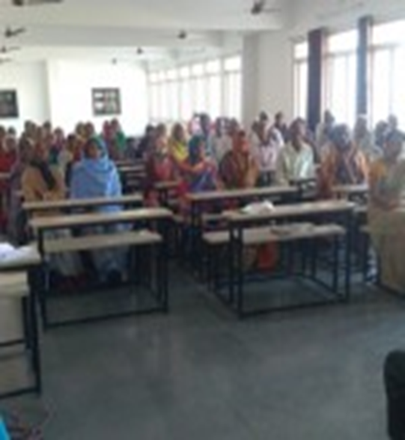 | 