World Environment Day Celebration– 2020
World Environment Day was celebrated at Parul Institute of Ayurved & Research, Parul University on 5th of June 2020. Morning 10.30 onwards we the staffs of PIAR have started planted more than 30 new medicinal plants.
Our faculties tried to improve global warming condition by planting saplings. All the faculties of our institute planted the saplings of medicinal plants with lots of enthusiasm and care towards nature.

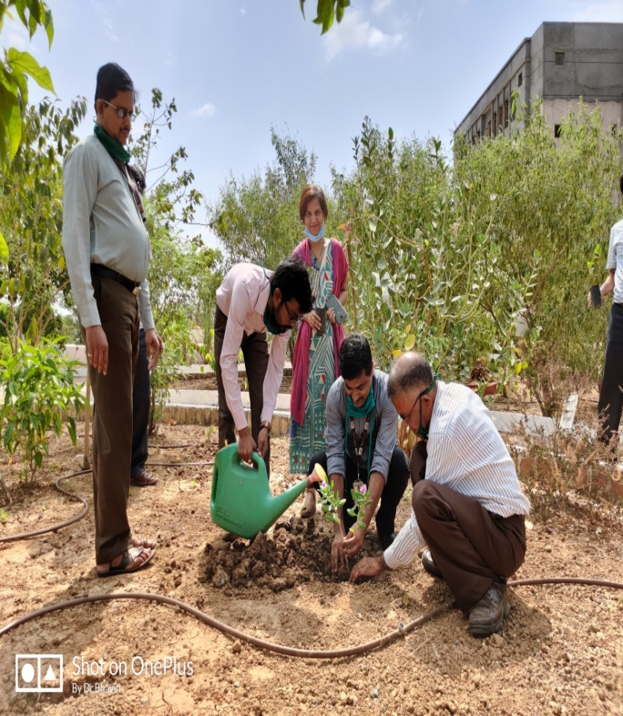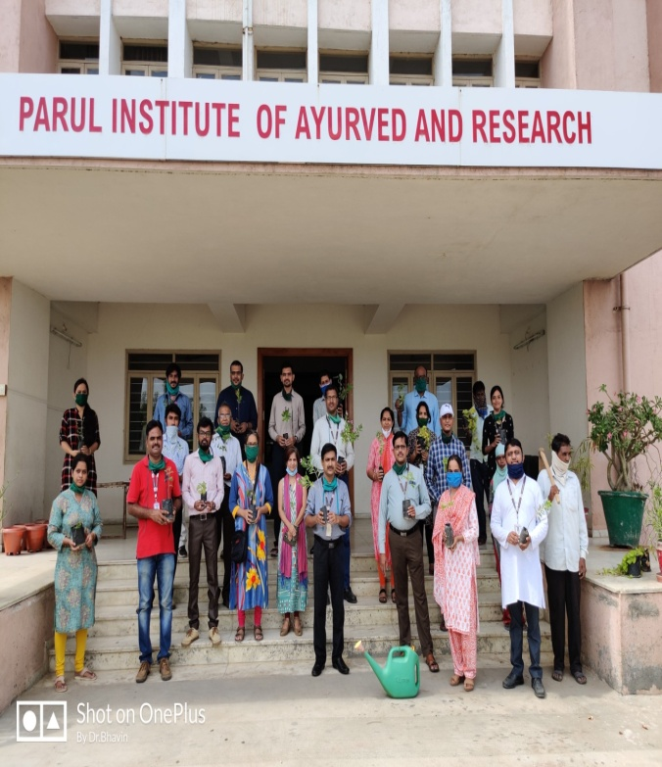

WORLD RHEUMATOID ARTHRITIS AWARENESS DAY
On the ocassion of World Rheumatoid Arthritis Awareness Day was observed by the Department of Panchakarma, PIAR on 31.01.2020 from 02:00 AM to 03:00 PM. A guest lecture was arranged on the same by Dr. Nilam Deore, Professor & Head, Department of Panchakarma, Parul Institute of Ayurved & Research to create awarness about Rheumatoid Arthritis and about 109 healthseekers were benifitted.
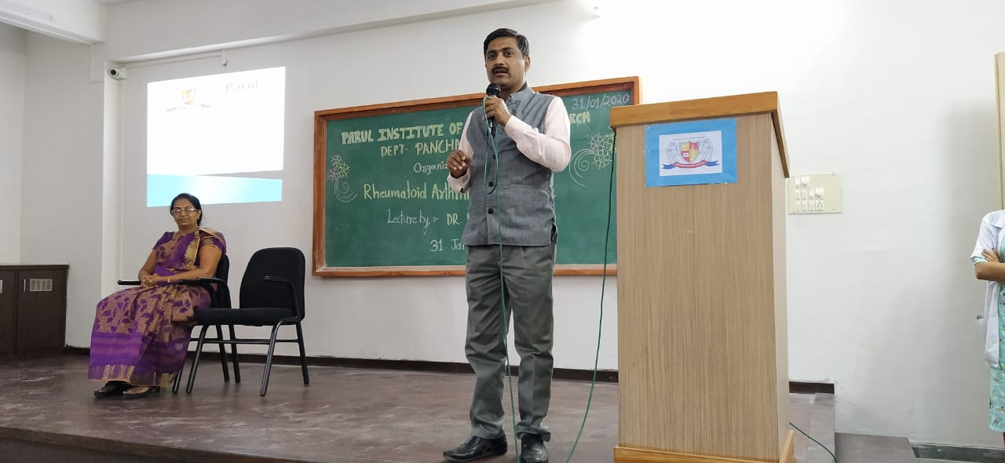 | 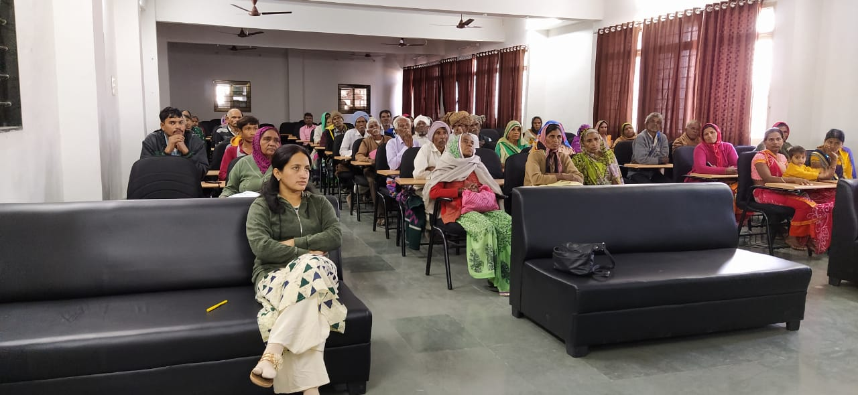

In continuation with above Rheumatoid Arthritis Awareness Day celebration in Khemdas Ayurved Hospital, Ishwarpura also awareness lecture was deliver by Dr. Nilam Pritesh Deore for the patients of Navapura, Vadodara on 2/2/2020 organized by Khemdas Ayurved Hospital in association with Parul Institute f Ayurveda, Ishwarpura and arranged by Dr. Pritesh Arvind Deore well known practitioner of Navapura, Vadodara. In this awareness program 25 patients were actively participated.
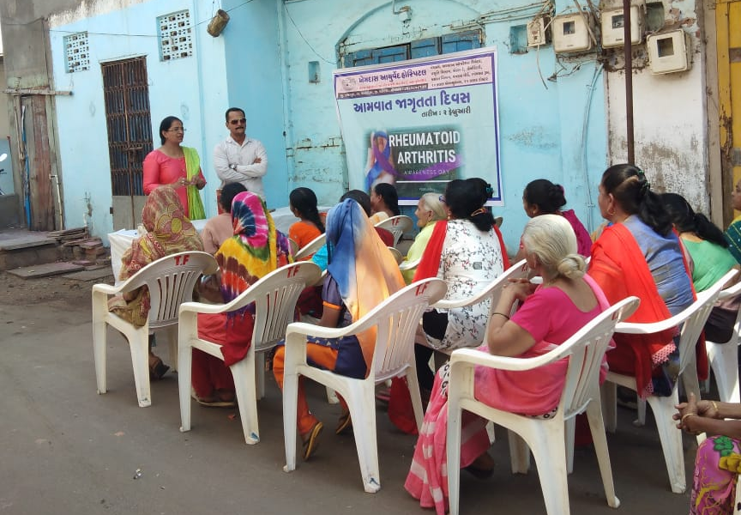 | 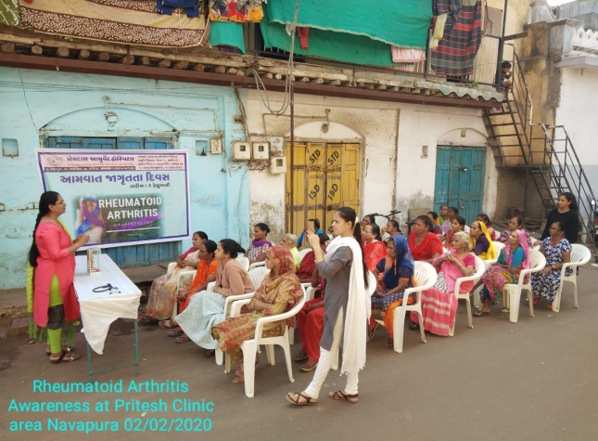

WORLD CANCER DAY

On the occasion of World Cancer Day, Department of Kayachikitsa has organized an awareness programme on 4-2-2020 at Parul Institute of Ayurved and Research. The programme was inaugurated by Dr. Komal Patel, Trustee Parul University. On this occasion various competitions were held for students to spread awareness among the patients. The winners and runner up were awarded with certificates and medals. This programme was organized and conducted under the guidance of Dr. B. G. Kulakarni Sir, Principal Parul Institute of Ayurved and Research.

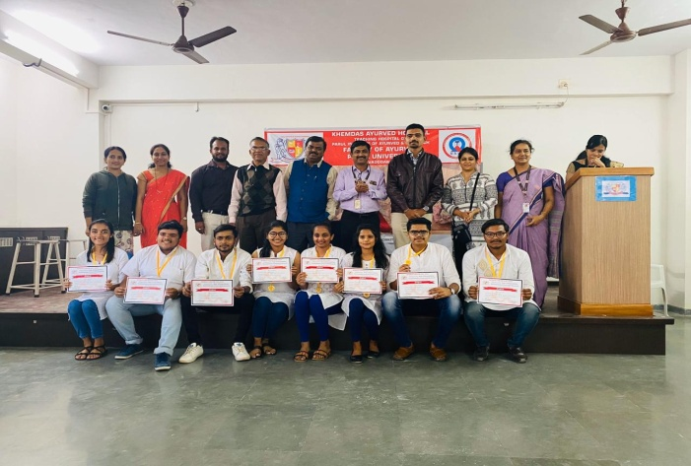 | 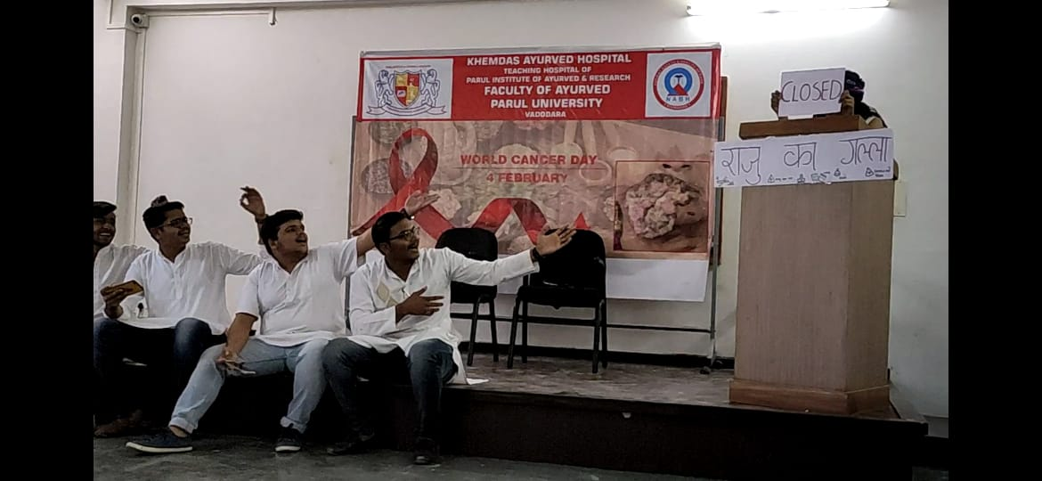

LEPROSY DAY

On the occasion of world leprosy day – 2020 department of swasthavritta& yoga from Parul Institute of Ayurveda & Research organized an awareness programme on Leprosy on 30 -01-2020. The beneficiaries were the patients attending Khemadas Ayurveda Hospital, Ishwarapura. The speaker Dr.Arohi Parmar, Assistant Professor, Department of Shalakyatantra educated the patients about the communicable disease Leprosy. More than 50 patients were benefited by the lecture. On the precise day series of lectures were organized for the students of 3rd year BAMS in the afternoon session.

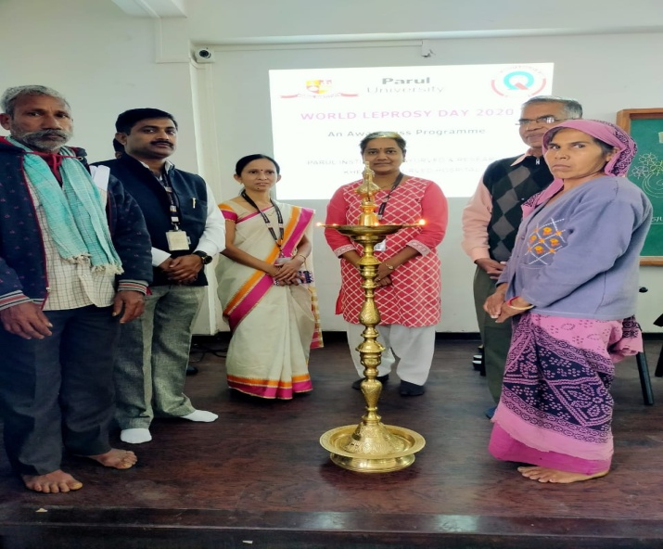 | 