CME/Days Celebration

WORLD DIABETES DAY – 2021

Parul Institute of Ayurved & Research in association with Technical Events Cell, Parul University, organized ABHINAYAM - NATIONAL LEVEL ROLE-PLAY COMPETITION on 23.11. 2021 on the occasion of "WORLD DIABETES DAY". This event was organized to spread necessary awareness about Diabetes as a public health issue and to share what needs to be done, collectively and individually, to improve the prevention, diagnosis, and management of diabetes. Every year, the World Diabetes Day campaign focuses on a dedicated theme that runs for one or more years. The theme for this year is Access to Diabetes Care – If Not Now, When? The event was organised offline and the topic was focused to raise awareness about diabetes. Maximum 7 participants in a group were allowed. The misbeliefs regarding the disease and side effects were conveyed through this competition.
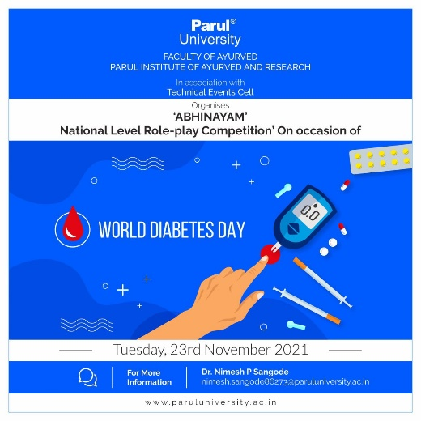 | 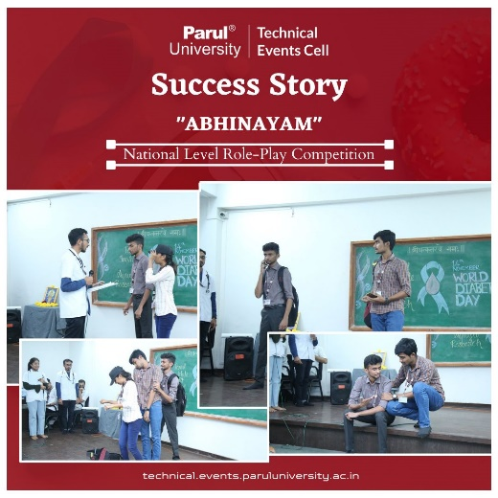

WORLD PILES DAY – 2021

World Piles Day was observed on 22.11.2021 at Parul Institute of Ayurved and Research, Parul University.
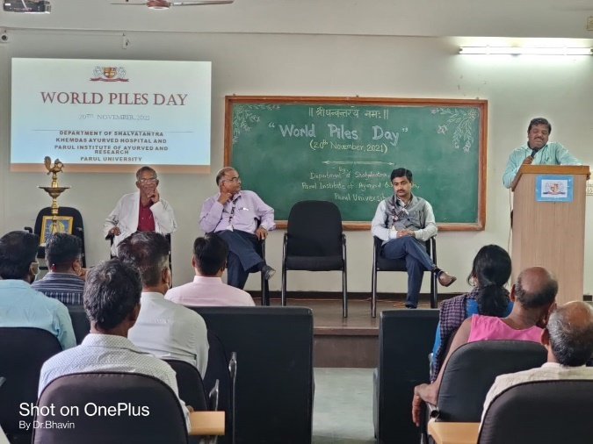 | 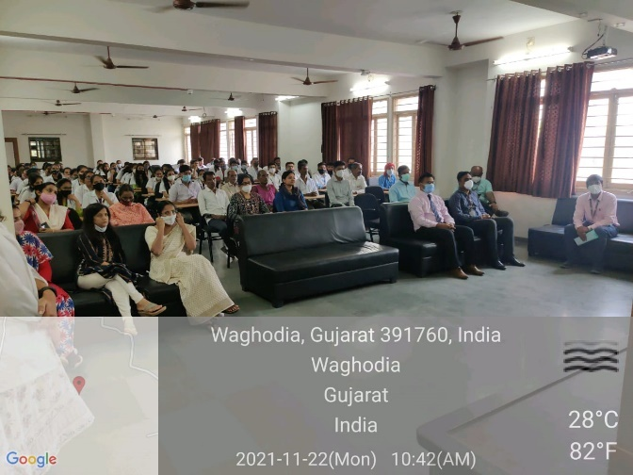

TEACHERS DAY – 2021

On the occasion of Teachers Day, Parul Institute of Ayurved and Research, Parul university, had conducted a programme for the faculty of Ayurved on 06.09.2021. The session was graced with the presence of honourable guests:
- Dr. Atulkumar Mafatlal Bhavsar, MD, PH.D, Director, Kanchan Hira Ayurvedic Hospital & Cancer Research Centre, Madhi, Mehsana, Gujarat.
- Dr. Supriya Bhalerao, Research Director
- Dr. Komal Patel, Director, Medical & Paramedical, Member of BOG, Parul University.
- Dr. Hemant Toshikhane, Dean, Faculty of Ayurved, Parul University.
- Dr. B.G. Kulkarni, Principal, Parul Institute of Ayurved & Research, Parul University.
Teachers and students were benifitted with the motivational speech delivered by the resource persons.
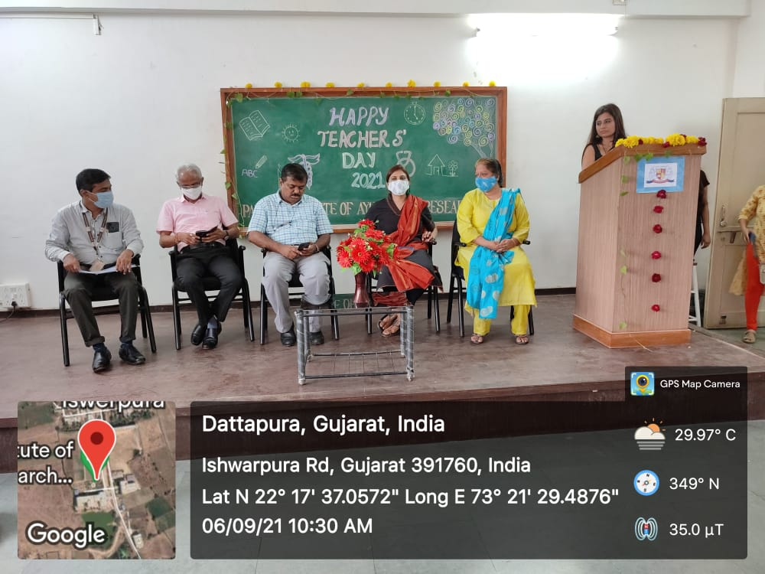 | 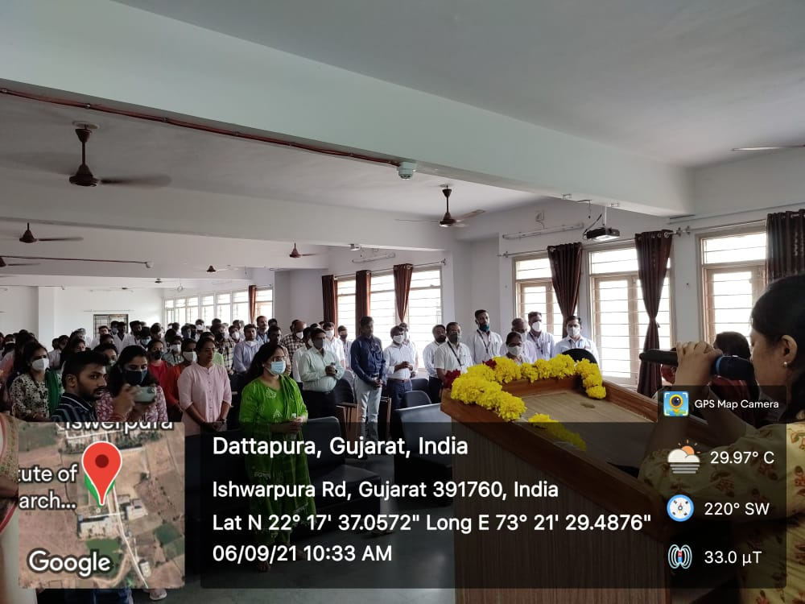
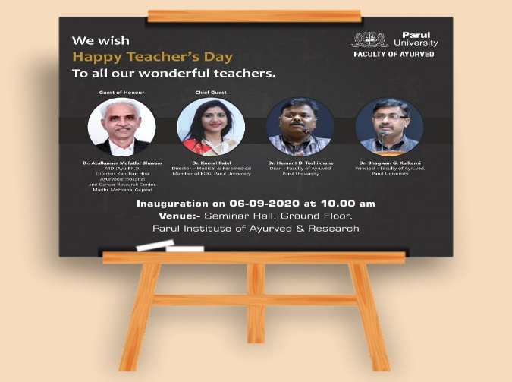 | 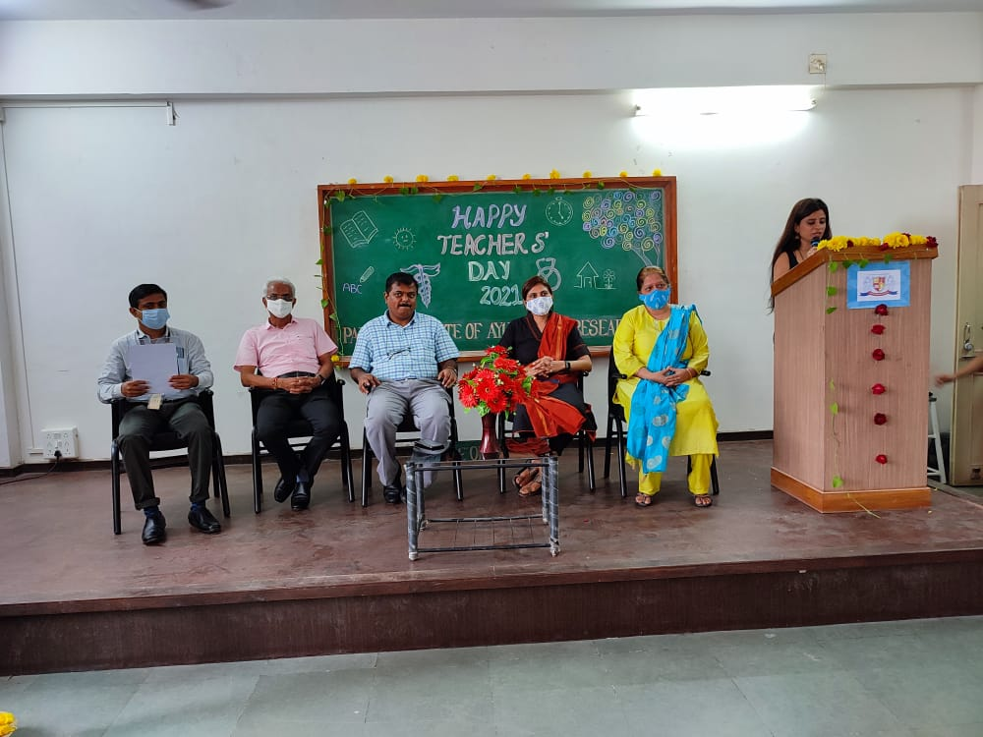

NATIONAL SANSKRIT DAY – 2021

On the occasion of National Sanskrit Day Celebration “Samskruta Bhashamrutam 2021”, Department of Ayurveda Samhita & Siddhanta, Parul Institute of Ayurveda, organised National Level online Elocution Competion on the topic “Adhunika Samaye Samskrutasya Mahattvam” on 31.08.2021 from 9:30 AM onwards. The competition was held in both languages, Sanskrit and Hindi, with separate prizes. There were 70 participants from 25 colleges, throughout India, registered and competed. The winners were announced on the same day in the valedictory function held at 3:00 PM.
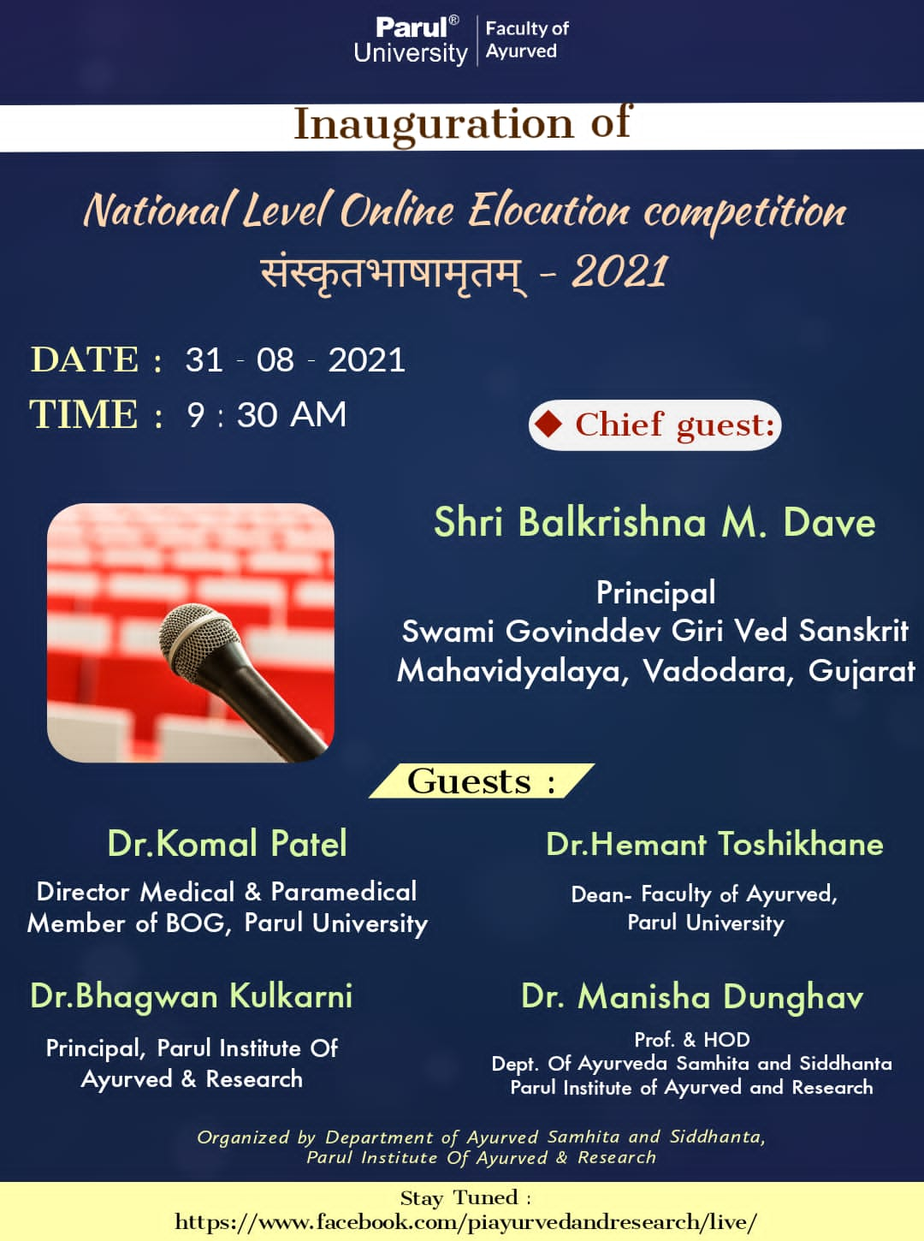 | 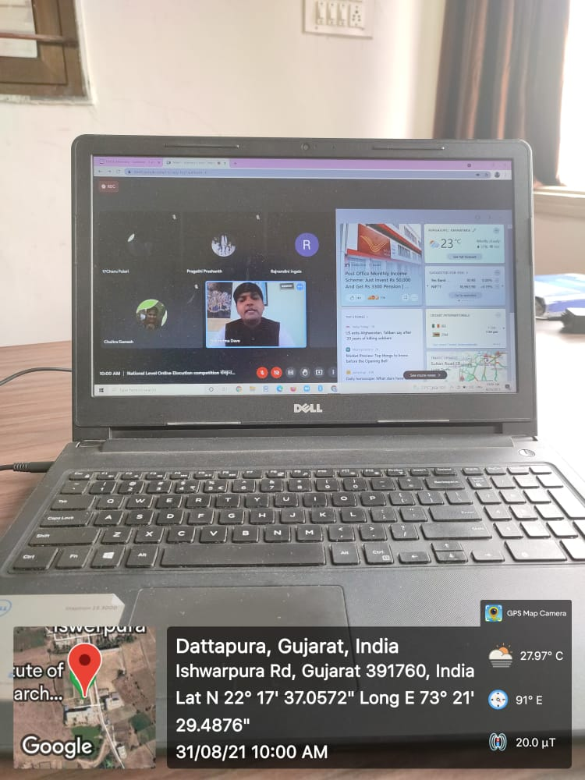
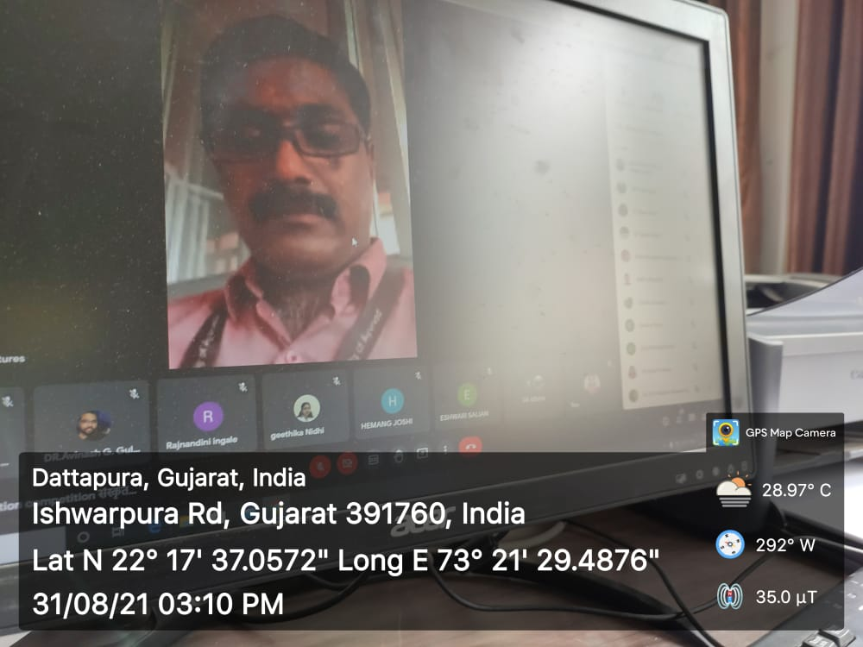 | 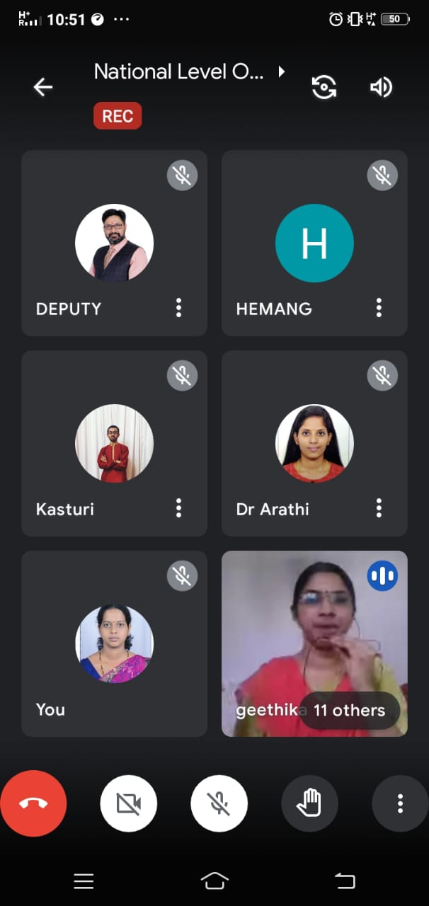

CHARAKA JAYANTI – 2021

“Chraka Jayanti” was celebrated in Parul Institute of Ayurved & Research, organized by Department of Ayurveda Samhita & Siddhanta on 14.08.2021. The event was graced with the presence of Chief Guest Professor Dayanand MS, Dean, Faculty of Goa Business School, Goa and Dr. B.G. Kulkarni, Principal, Parul Institute of Ayurved & Research. The session was innaguarated with lighting up lamp and Charaka Sthavana followed by Pathana of Charaka Samhita.
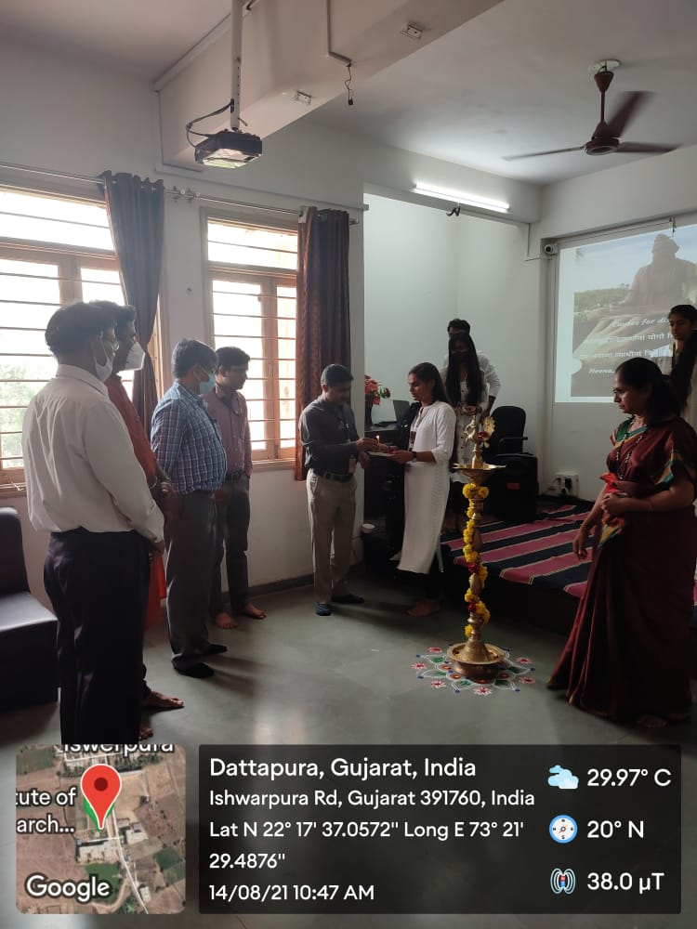 | 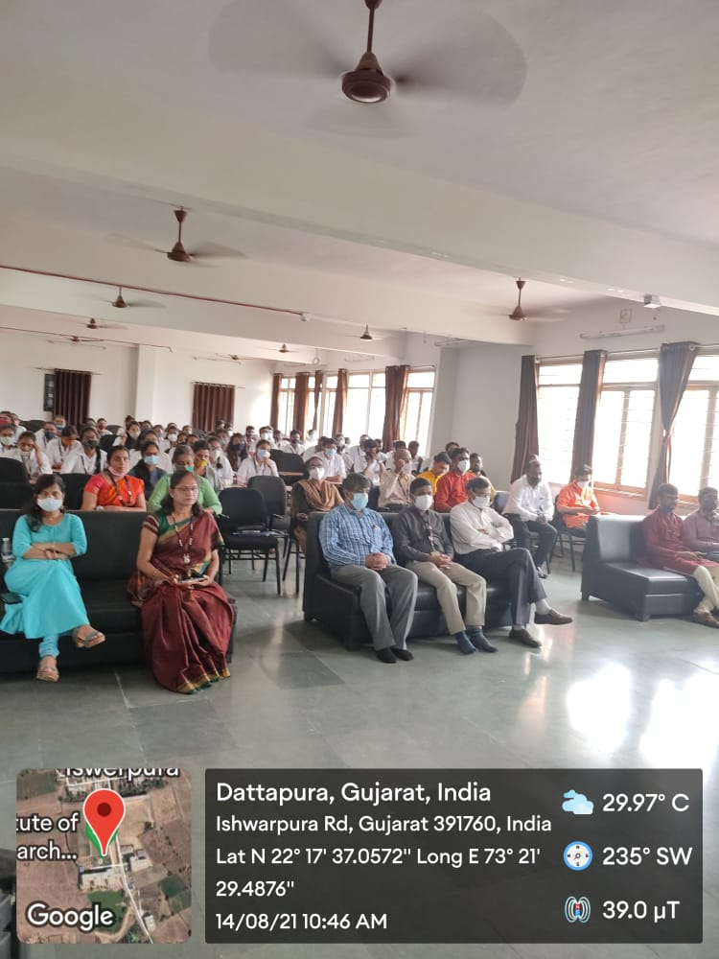
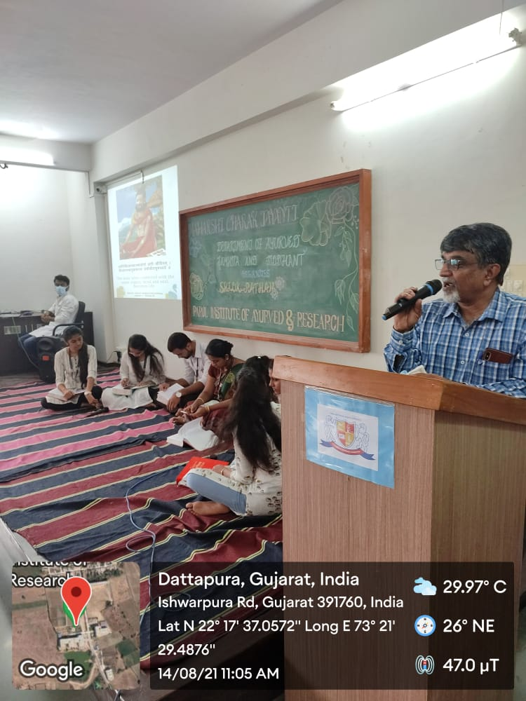 | 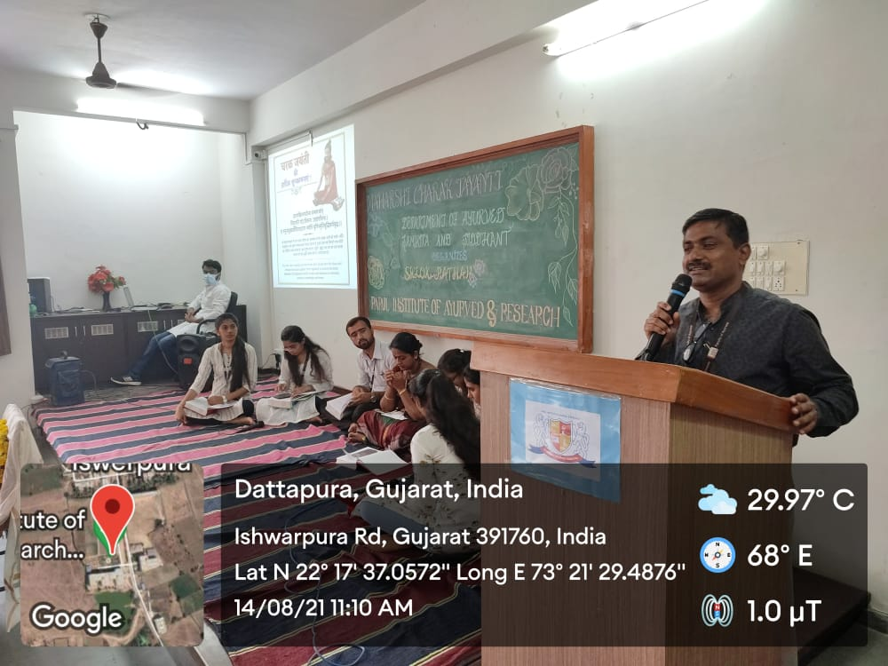

WORLD HEPATITIS DAY – 2021

On the occasion of 'WORLD HEPATITIS DAY' to spread awareness among people of the disease Hepatitis, an Offline National Level Poster Making Competition for Students and faculties from all the recognized Institutes/Universities was organized by Parul Institute of Ayurved and Research, Faculty of Ayurveda in Association with Technical Events Cell, Parul University, on 28th July 2021.
Theme for World Hepatitis Day is “HEPATITIS CAN’T WAIT”.
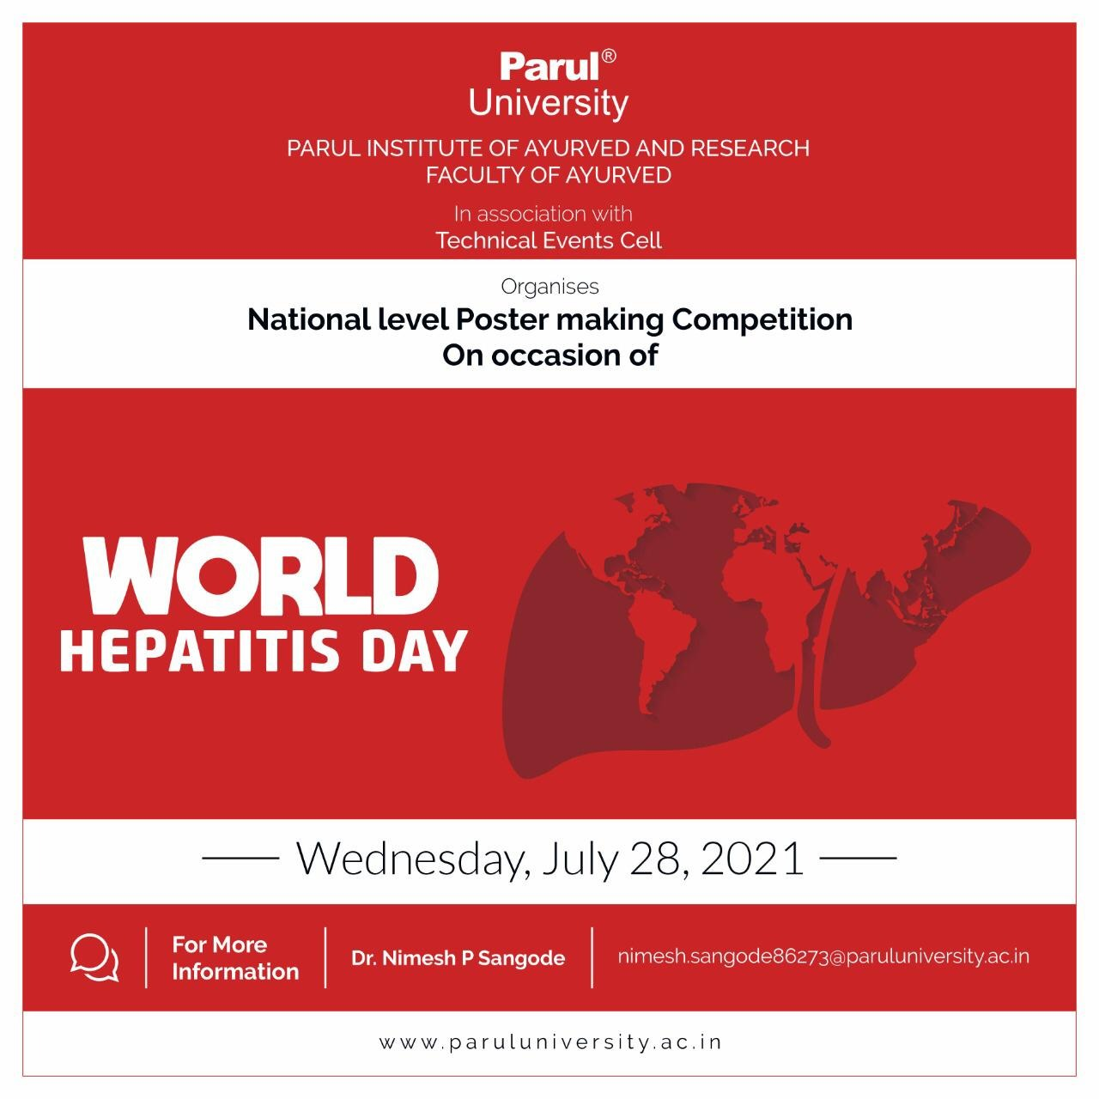 | 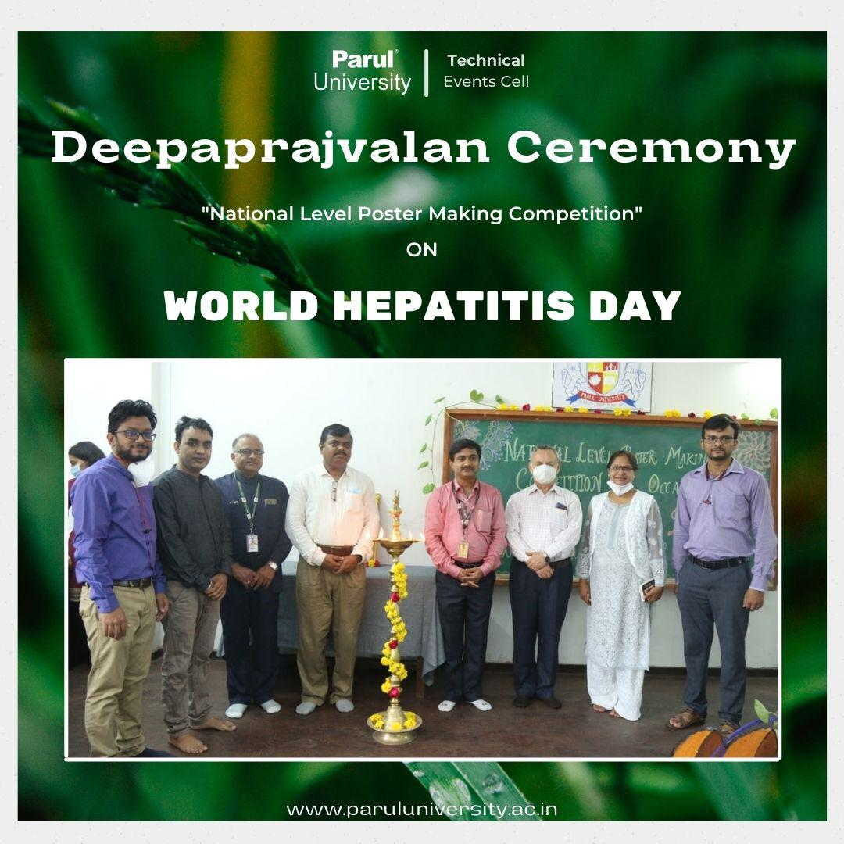
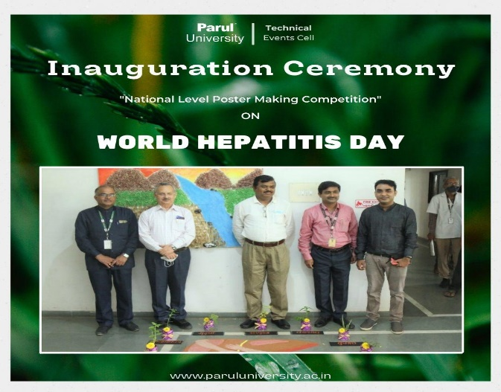 | 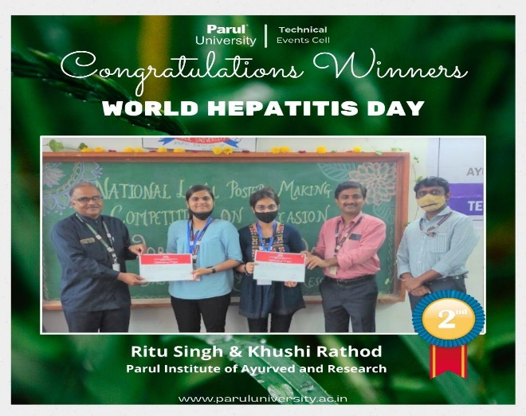

National Doctor’s Day– 2021

On the occasion of National Doctors Day 2021, Parul Institute of Ayurved and Research, Parul university, had conducted a programme for the faculty of Ayurved. The session was graced with the presence of Dr. Komal Patel, Trustee & Director of Medical and Paramedicals; Dr. Hemant Thoshikane, Dean, faculty of Ayurved, Parul University; DR.B.G Kulkarni, Principal, Dr. Panda, Principal, PIHR. The 4th year BAMS students, Sagar Sandigada, Manthan Desai, Yash Acharya, Kunal Karanke, Vishnu Prajapati, Shubham were felicitated and were honored with appreciation certificate for their tireless effort for serving the humanity in the second wave of COVID 19 Pandemic. Also Dr. Divya B, assistant Professor, Department of Panchakarma; Dr. Sangeeta Toshikane, Professor & Head, Department of Panchakarma, PIA; Dr. Ravi Pandya, DYMS, Assistant Professor, Department of Shareera Kriya, PIA were felicitated for their dedication in work.
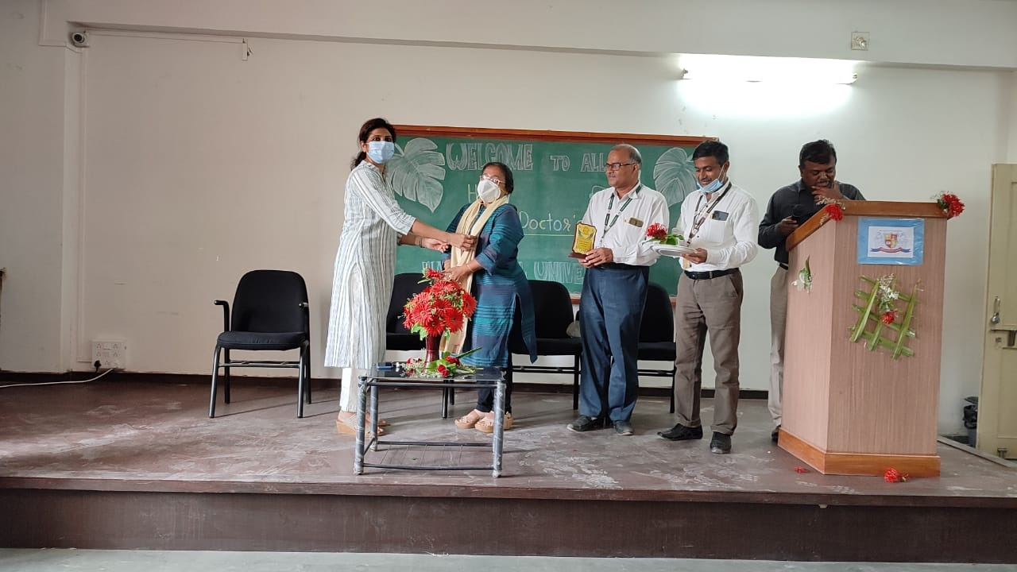 | 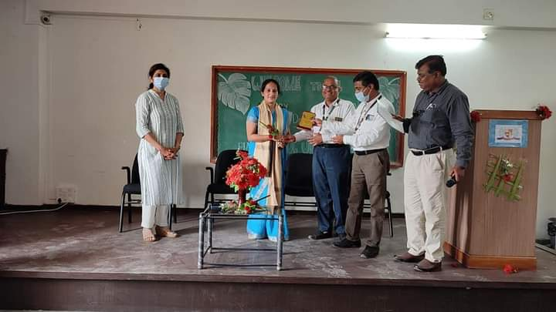
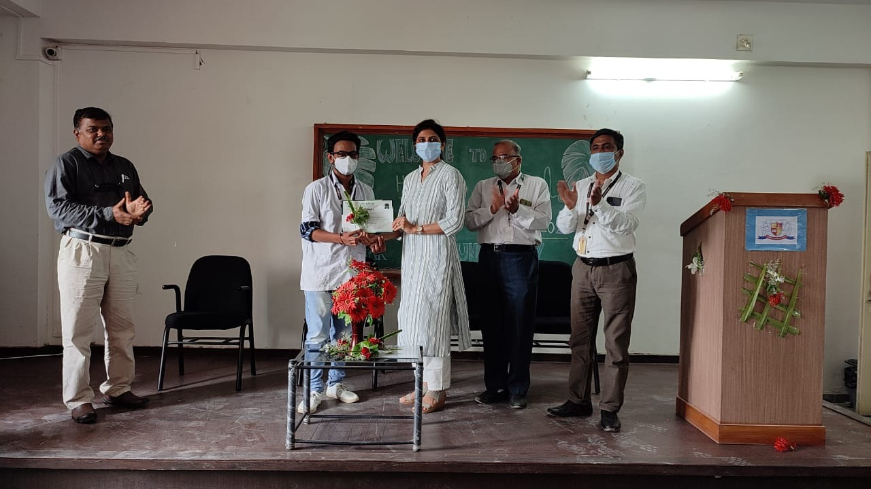 | 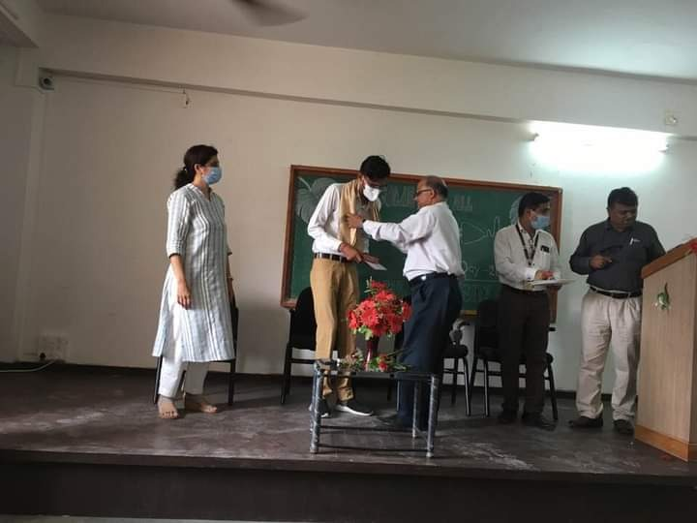

World Yoga Day– 2021

Department of Swasthavrutta, Parul Institute of Ayurved and Research (PIAR) had arranged International Yoga Day celebration on 21.06.2021, with Yoga Sessions according to WHO Protocol at 11:00 AM, the session was Cordinated by Dr. Dhaivat Vora, Dr. Ramen Santra, Dr. Jayasheela M Goni.
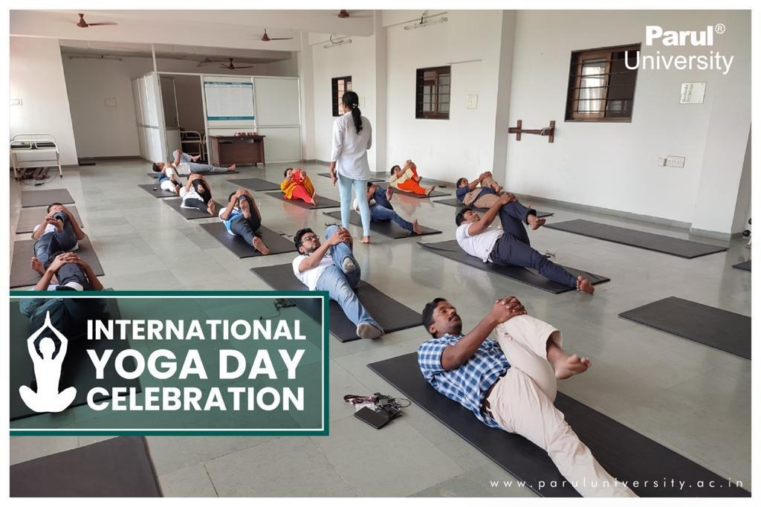

Blood Donation Day– 2021

Department of Roga Nidana & Vikruti Vigyan, Parul Institute of Ayurved and Research (PIAR) had arranged a webinar “World Blood Donation Day” on 14.06.2021 from 09:30 AM - 01:00 PM. The session was graced with the presence of Dr. Komal Patel, Trustee & Director of Medical and Paramedicals; Dr. Hemant Thoshikane, Dean, faculty of Ayurved, Parul University; DR.B.G Kulkarni, Principal. The eminent personalities for the sessions were:
- Dr. Ram Shukla, M.D. (Panchakarma), Principal Investigator, Thalassemia Speciality Clinic, Government Akhandanand Ayurved Hospital , Ahemadabad, on the topic “Rakta Basti – An Alternative Therapy For Blood Transfusion in Thalassemia”
- Dr. Santosh Wanave, MBBS, M.D. (Path) Founder and Director of Disha CRL Laboratories, Mumbai, on the topic “Blood Banking Techniques”
- Dr. Anand Kshite, MBBS, M.D. (Path), Krishna Laboratory and Transfusion Officer, S.B. Bajaj Blood Bank, Pandharpur, on the topic “Blood Banking Techniques”
Moderators for the session were: Dr. Hrishita Dahelikar, Professor & HOD, Dr. Krishna Thorat, Associate Professor, Dr. Swatika Sharma, Assistant Professor, Department of Roga Nidana & Vikruti Vigyan.
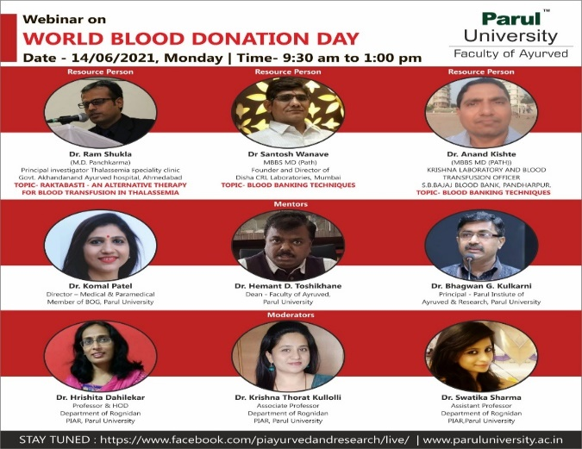

World Environment Day Celebration– 2021

On the occasion of World Environment Day 2021, Department of Dravyaguna Vigyan, Parul Institute of Ayurved and Research, Parul university, had conducted a webinar on “Environmental day and Ayurvedic thoughts”, followed with the plantation of 200 new medicinal plants. The session was graced with the presence of Dr. Komal Patel, Trustee & Director of Medical and Paramedicals; Dr. Hemant Thoshikane, Dean, faculty of Ayurved, Parul University; DR.B.G Kulkarni, Principal.
The eminent personalities for the sessions were
- Dr. Vinodkumar TG Nair, BOG of CCIM Government of INDIA; Senior Scientist JNTBGRI, Palode, Kerala - Guest of honour
- Dr. Jayan Damodaran, Professor Dept of Swastavrutha Government Ayurveda College Thiruvananthapuram, Kerala – “Environment day - Ayurvedic thoughts”
- Dr.Priya Sunil Bhide; Pediatric Physiotherapist & Urban waste management expert - “Urban Waste Management”
Moderators for the session were: Dr. Suwarna Meshram, Professor, Dr. Prashanth Krishnan, Associate Professor & HOD, Dr. Bhavin Dhanavade, Assistant Professor, Department of Dravyaguna Vigyan.
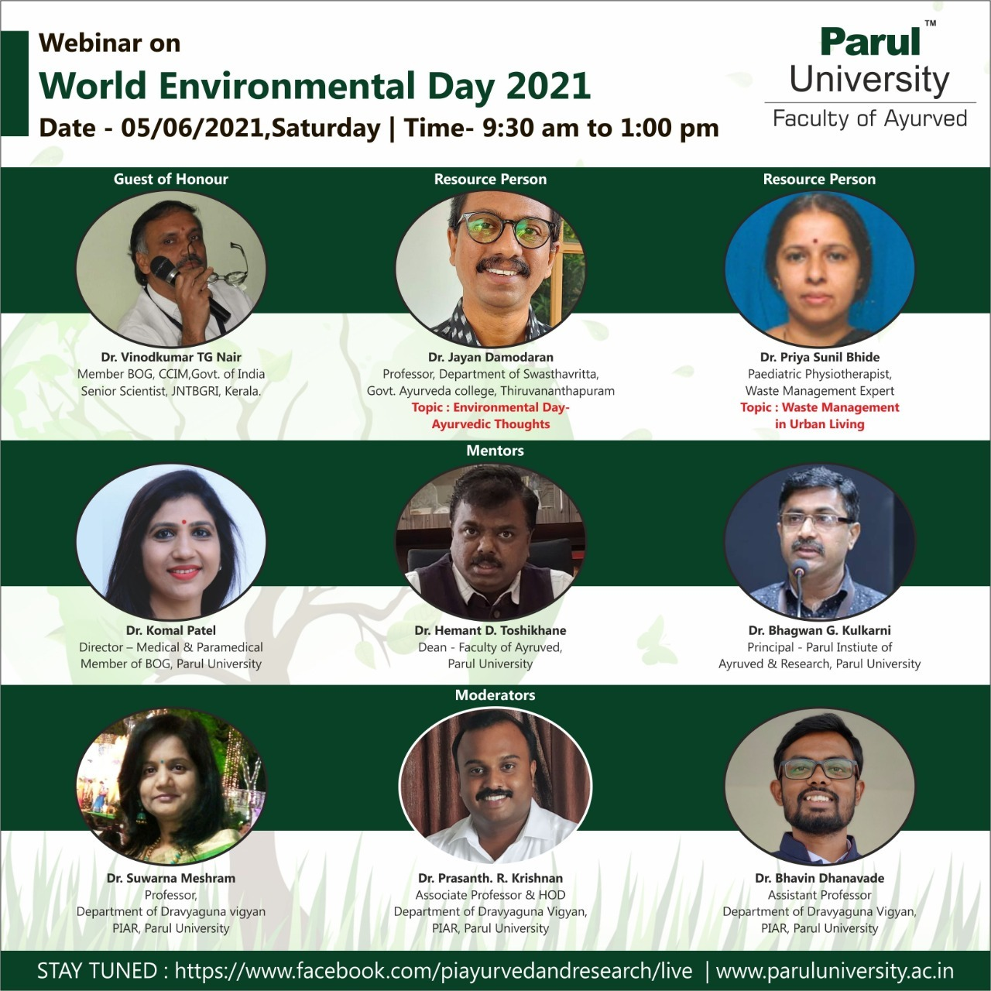 | 