World Health Day
Details about the activity:
Rognidan and Vikriti Vigyan Dept. arranged a Guest lecture on the occasion of World Health Day on 7th April 2022. Second year students attended the guest lecture.
Dr. Swatika Sharma Assistant Professor, coordinated the Session. Dr. Hrishita Dahilekar Professor, welcomed the guest Speaker and expressed the view regarding World Health Day. Dr. Akshay Panchal delivered a guest lecture on “The Role of Diagnostic Investigations in Health Literacy.” Dr. Krishna Thorat, Associate Professor expressed the vote of thanks.
Department of Rognidana, is thankful to the Guest speaker Dr Akshay Panchal Sir, for accepting the invitation & delivering the informative lecture.

Outcome/Feedback
There was a very positive response from all Second-year students who participated enthusiastically in the session taken by Dept of RNVV. PIAR(Ayurveda). More interesting activities in future have been planned.

Geotag Photos
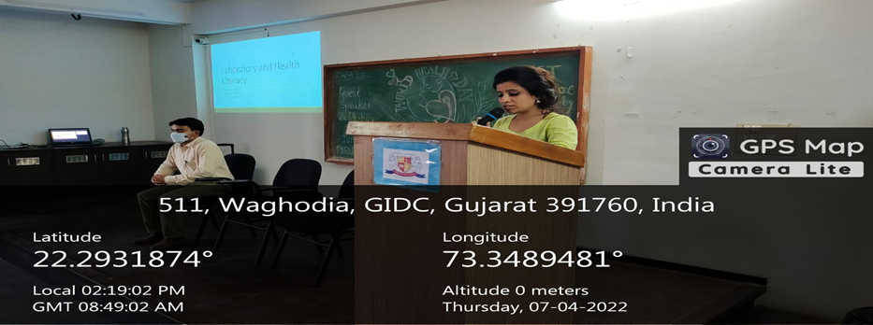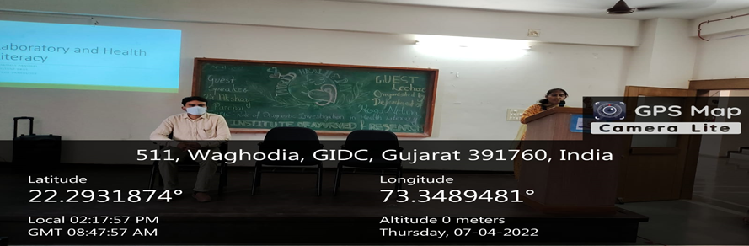

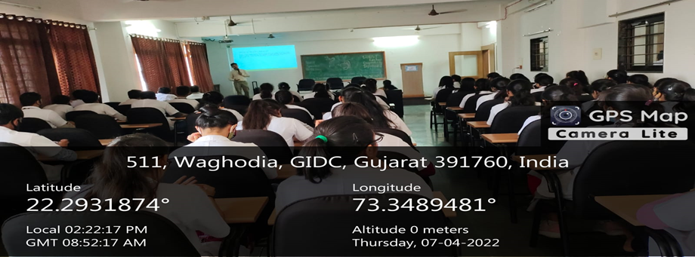 | 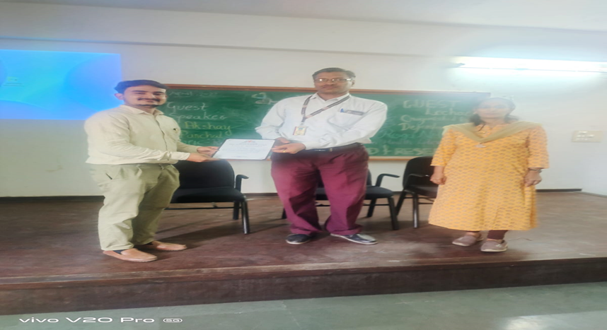
.

World Blood Donor’s Day
PARUL UNIVERSITY Activity Report INSTITUTE Parul Institute of Ayurveda and Research DEPARTMENT Rognidan Evum Vikriti Vigyan ACTIVITY TYPE Celebration of World Blood Donor’s Day DATE 14/06/2022 Duration – 1Hr. YEAR/CLASS SYBAMS No. of Participants 88 FACULTY COORDINATOR Dr. Hrishita Dahilekar, Dr. Krishna Thorat, FACULTY CONTACT DETAILS 9420090602 SPONSORING AUTHORITY -NA- Sponsorship amount: -NAActivity Details: World Blood Donation Camp on the occasion of World Blood Donor’s Day 2022 Details about the activity: On the occasion of World Blood Donor’s Day on 14th June 2022, Rognidan and Vikriti Vigyan Dept. arranged World Blood Donation Camp in collaboration with Parul Sevashram Hospital Blood Bank. Ingaural function was held at Dhanvantari Hall of Parul Institute of Ayurved and Research. Dr. Krishna Thorat, Associate Professor PIA&R coordinated the whole function. Ingaural function started with lamp lightening and Dhanvantari prayer. Welcome speech given by Dr. B. G. Kulkarni Sir, Principal PIA&R. Dr. Hemant Toshikhane sir, Dean Faculty of Ayurved addressed the students and Blood Donor candidates. Dr. Pandya Sir, Principal of PIHR put his expertise views as guest of Honored. Dr. Kore Sir, DYMS of Khemdas Hospital also expressed importance of Blood Donation camp. Dr. Hrishita Dahilekar, HOD Rognidan Dept expressed vote of thanks to all students, Teaching and Non-teaching staff who take active part in Blood Donation. Total 30 candidates from PIAR and PIHR were registered for Blood donation. Outcome/Feedback There was positive response of students and teaching and non-teaching staff which set a good example of awareness regarding Blood Donation.

World Blood Donation Camp on the occasion of World Blood Donor’s Day 2022

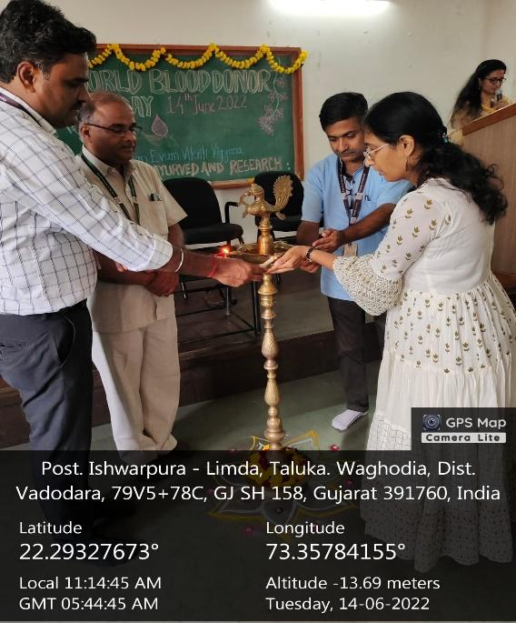 | 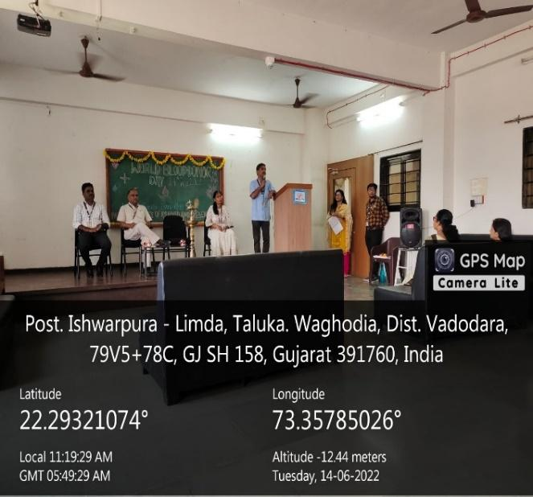

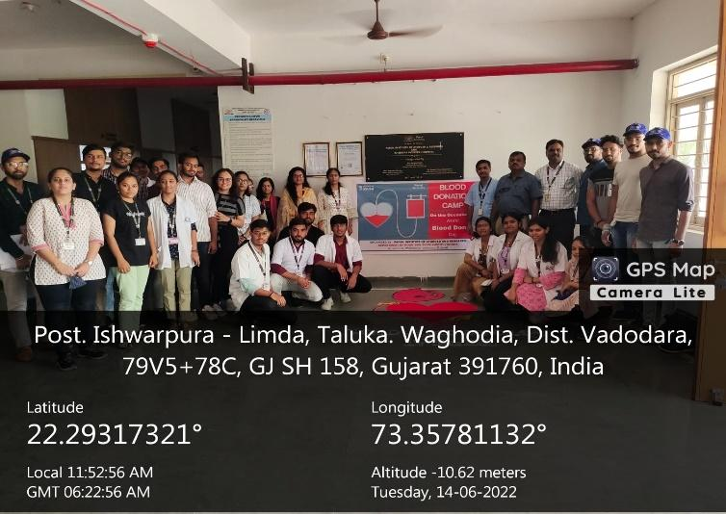
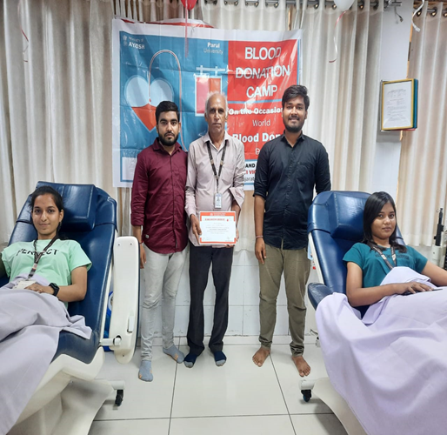

Rognidan and Vikriti Vigyan Dept. arranged a online Guest lecture on the occasion of World Blood Donor Day on 16th June 2022. Second year students attended the guest lecture.
Dr. Krishna Thorat, Associate Professor, coordinated the Session. Welcomed the guest Speaker and expressed the view regarding World Blood donor day. Dr. K.K. Shiromani delivered a guest lecture on “Blood components Therapy.” And finally expressed the vote of thanks.
Department of Rognidana, is thankful to the Guest speaker Dr. K.K.Shiromani Sir, for accepting the invitation & delivering the informative lecture.

.

Geotag Photos With Caption
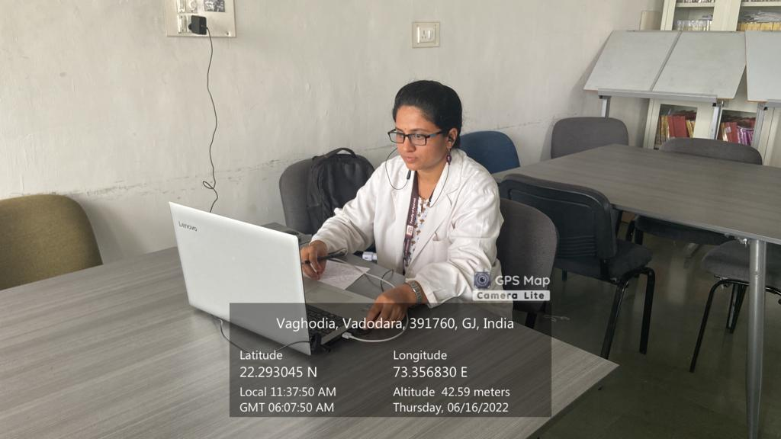
Image 1- Welcome Speech by Dr. Krishna Thorat.

World Environment day 2022

Details about the activity:
As a part of world Environment day 2022 celebration we the department of Dravyaguna vigyan in collaboration with NSS unit PIAR,Parul university have conducted plastic free campus drive and also planted 200 new medicinal plants in our PIAR garden. All the students on of Parul institute of Ayurved and Research and all the NSS volunteers of PIAR have participated in the celebration.
All the students nad the staffs gotr the message about the importance of keeping the environment clean and green also they were educated the importance of reducing the usage of plastics.

Geotagged Photos With Captio

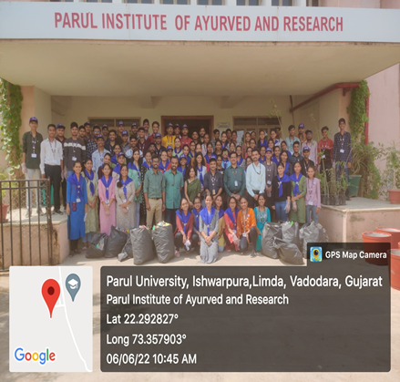 | 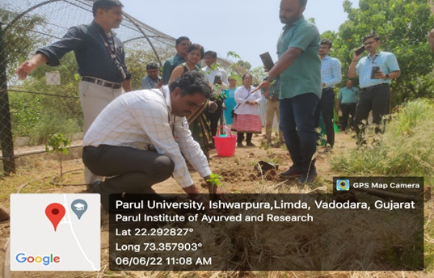

Rheumatology Day

As a part of Rheumatology Day, Dept. of Kayachikitsa, Parul Institute of AyurvedandResearch, Vadodara, Gujarathad organized an awareness campaign in collaboration with Vanseta& Dolia village administrative on 05.03.2022, 10 am to 1.00pm.
Consultants from Khemdas Ayurved Hospital, Teaching Hospital of Parul Institute of AyurvedandResearch delivered awareness speech to the villagers. In Vanseta Village, Dr Shinsha P, Asst prof., Dept. of Kayachikitsa, explain the various rheumatological diseases and need for timely intervention. Dr Dhanya Raj, Asst. prof., Dept. of Kaumarabhritya, explained various rheumatoid diseases seen in children. In Dolia village, Dr Naresh Kore, Prof., dept. of Kayachikitsa, talked about the rheumatological diseases of the elderly people and Dr Shailesh Jaiswal make them aware of the identification signs and symptoms of various joint diseases. Free Medical check-up and screening for rheumatological diseases were also conducted as a part of the Campaign.
The Ward membersof both the villages support the campaigning by arranging venue and coordinating among the villagers.
.
Geotagged Photos With Caption

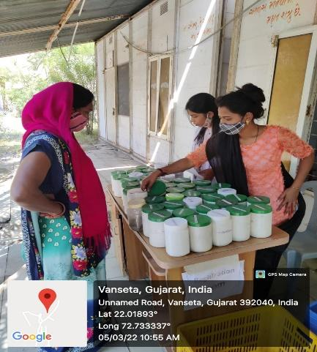  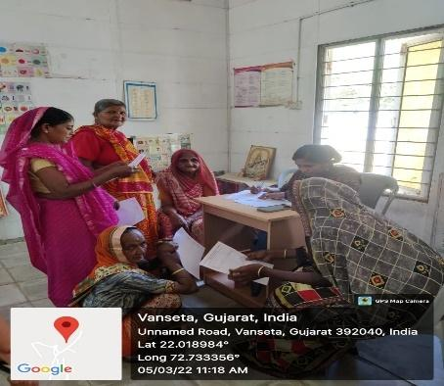 |  | 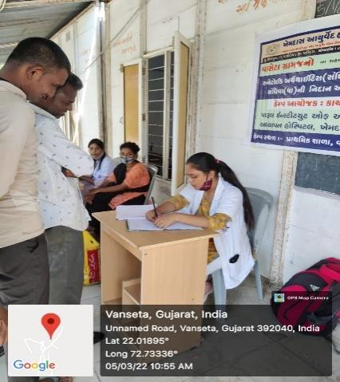  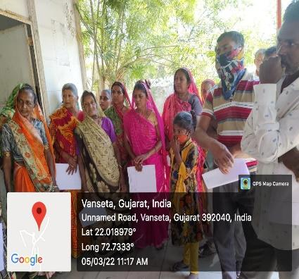 | 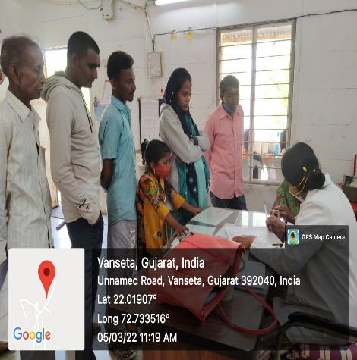  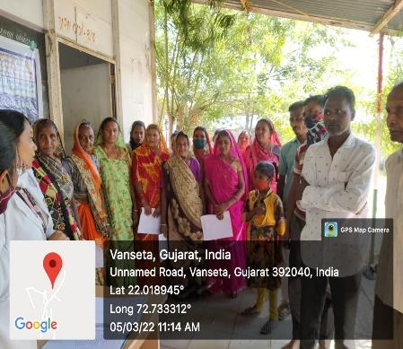

World Leprosy Day 2022

To mark the occasion of World Leprosy Day 2022 and to create awareness against the social stigma of leprosy by promoting the WHO theme ‘united for dignity’. Inter college poster making and presentation competition was organized by department of swasthavritta in coordination with student council. The session was held at morning from 11AM to 1PM. Students from different faculties of Parul University participated enthusiastically in this competition. Winners were declared by Judges Dr. Naresh Kore and Dr. Aparna Bagul. Winners were facilitated by medal and certificate.
Outcome/Feedback
Students from different faculties of Parul University participated in large numbers. Feedback was collected from participants. Student council played very crucial role in the organization of this event.
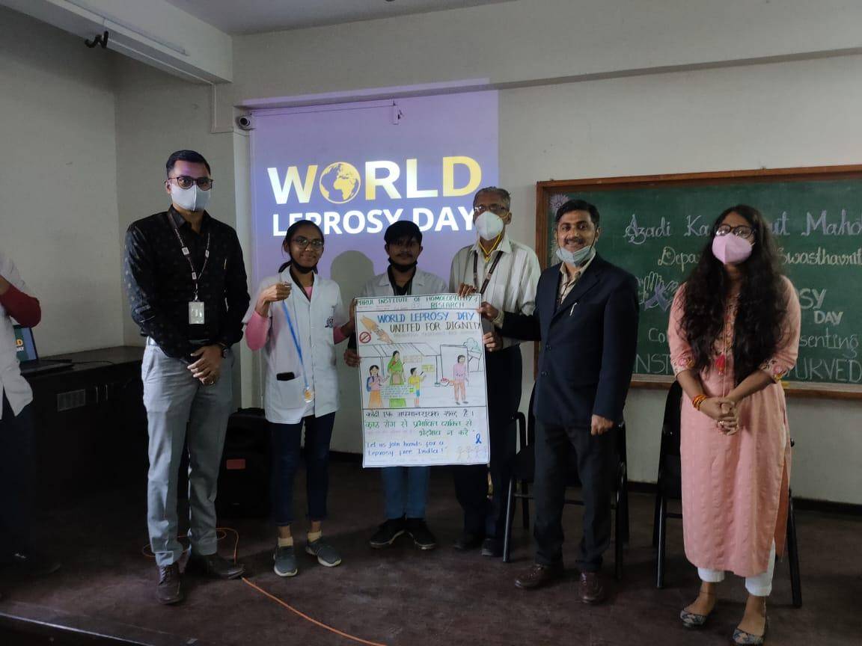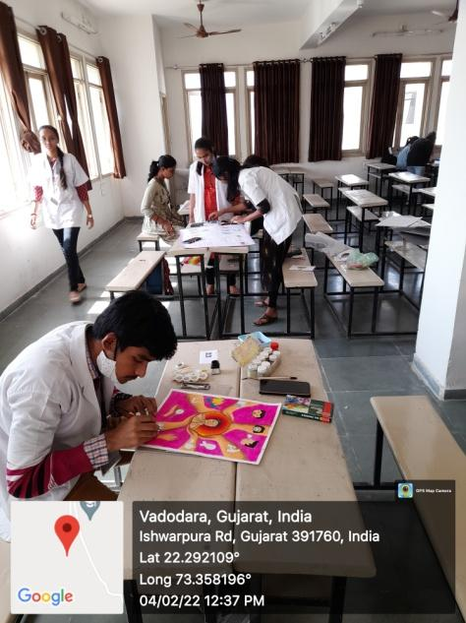

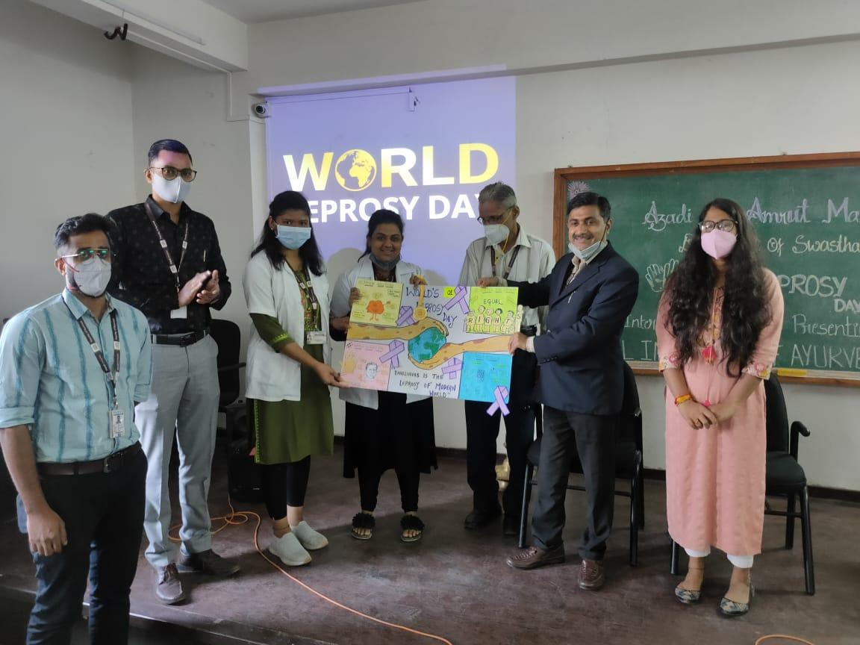

Role and scope of Ayurved in public health

Aim: To educate students on role and scope of Ayurved in public health.
After the global pandemic the public health has become one of the fastest growing sector of health care. In this era the health care demands a holistic approach and Ayurved graduates can utilize this opportunity with their skills and expertise for betterment of society and also have a great career. To enlighten students on the this topic a guest lecture was planned on 12 March 2022 in seminar hall at 11 AM to 12 PM. This session was also telecasted live on YouTube. Guest speaker for this event was Dr. Sudhir Joshi. He explained different initiatives of government to promote Ayurved in masses and to utilize Ayurved graduates for effective public health management. He also explained work done by Ayurved dispensaries in rural area and potential for career in this sector.

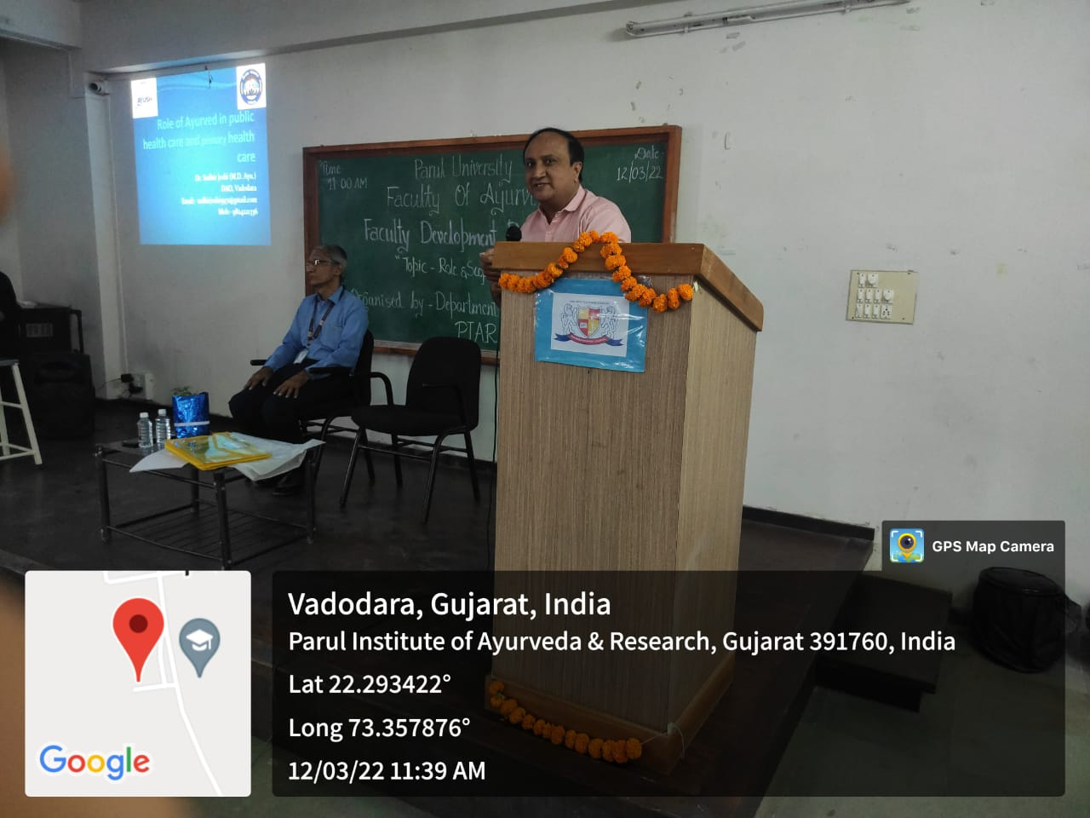
Geotagged Photos With Caption

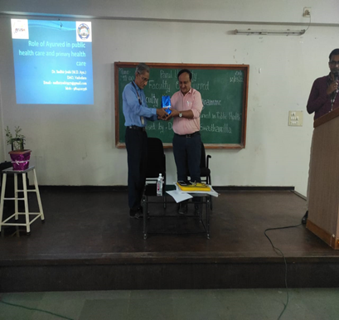
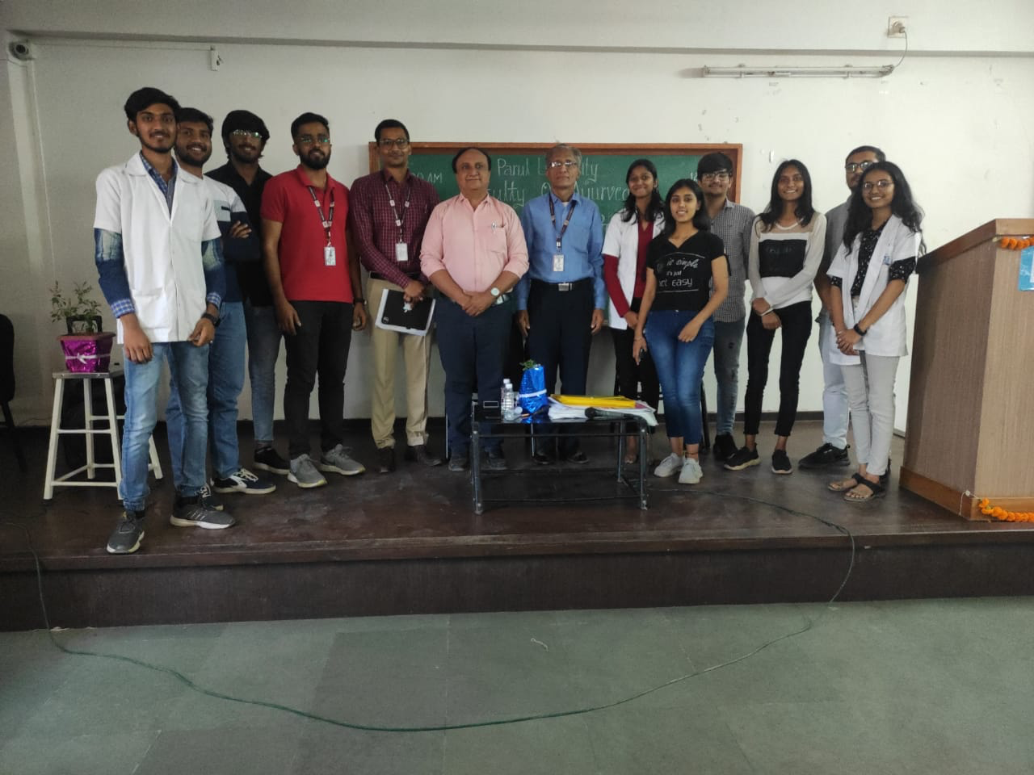
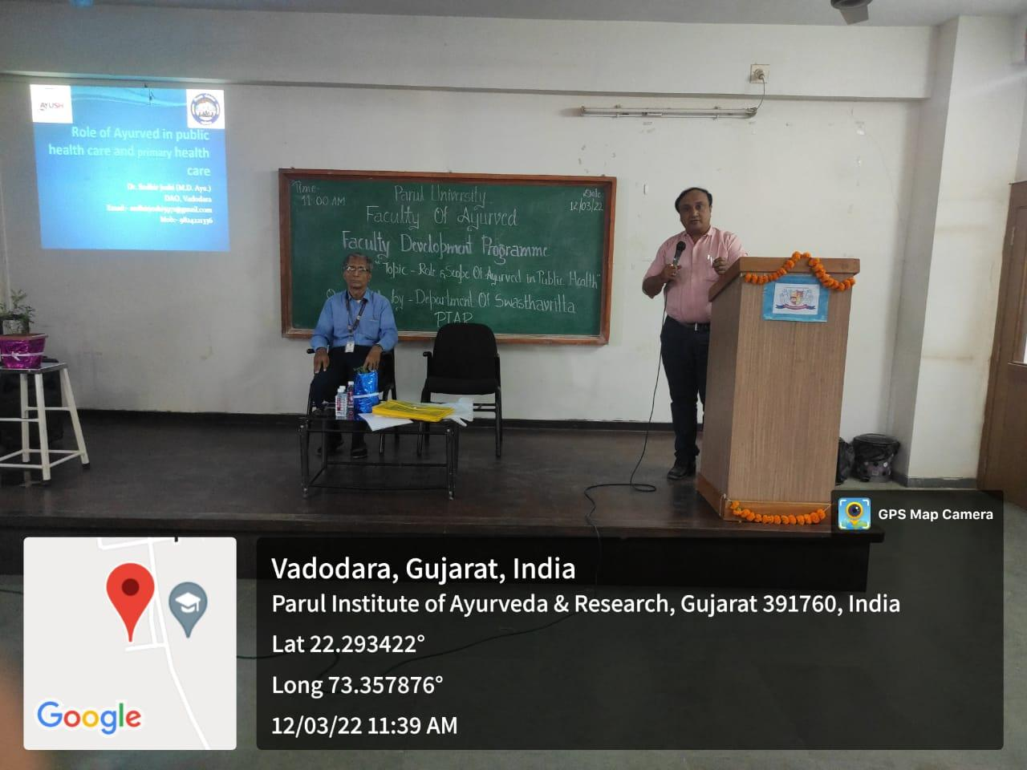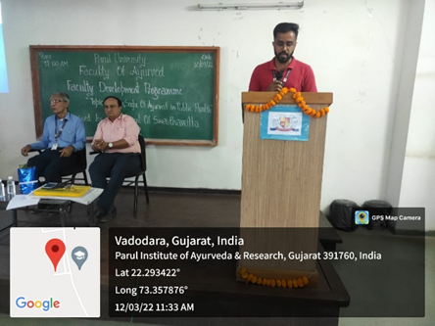

International Womens Day
International Womens Day was observed on 11.03.2022 by the WDC, Parul Institute of Ayurved and Research for the faculties by organising:
A guest lecture by Dr. Pradeep Kinage, on the topic Women's Reproductive Health.

