Expert lecture on Padartha Vignana (Fundamental principles of Ayurveda) – A practical approach
A guest lecture was organised by the Dept. of Ayurveda Samhita and Siddhanta, Parul Institute of Ayurved and Research for the 1st Year BAMS students of both Parul Institute of Ayurved and Research and Parul Institute of Ayurved on 15th March, 2018 at Parul Sevashram auditorium from 10:00 am- 12:30 pm. The topic of the lecture was Padartha Vignana (Fundamental principles of Ayurveda) – A practical approach. The outcome of the guest lecture was that the students got an insight of the concepts in understandable manner and its usage in clinicals. There was a very good response by the students and they said “This session was really helpful as it made the understanding of Padartha Vignana easy and practical.” They look forward for such lectures in future.

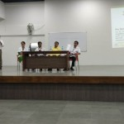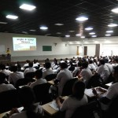

Expert lecture on Ayurvedic (Vedic) understanding of mukha and mukha swasthya
A session was conducted for the 1st year students of PIAR on 20th March 2018 at 3 p.m on occasion of World Oral Health Day to give them an orientation regarding Ayurvedic (Vedic) understanding of mukha and mukha swasthya, importance of dinacharyas pertaining to mukha explained by Ayurveda acharyas, oral hygiene, factors affecting oral health, systemic effects of poor oral health, adverse effects of tobacco and how good oral health equates to
good physical and mental health. The session was conveyed to them by Dr. Eshwari, HOD, Dept of Shalakya Tantra. Proper brushing technique was taught by interaction.
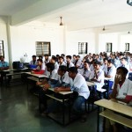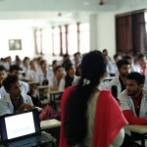

Expert lecture on Mind and its role in Performance
An expert lecture was organised by the Dept. of Kriya Sharir, Parul Institute of Ayurved and Research for the 1st Year BAMS students of Parul Institute of Ayurved and Research on 19th June, 2018 in Lecture Hall No. 1, PIAR from 3:00 pm- 5:00 pm. The speaker for the guest lecture was Dr. Avnish Dave, a Professor and HOD in Department of Physiology, PIMSR, Parul University, Vadodara, Gujarat, who is well known for conducting series of sessions on Stress management.
The programme commenced with Dhanwantari Stuti by the team of students of PIAR. The guest speaker was introduced to the students by Dr. Umesh Yelne, Associate Professor, Dept. of Rachana Sharir and welcomed on to the podium by Dr.Manisha Dunghav, In- charge Principal & HOD, Dept. of Ayurveda Samhita & Siddhanta, PIAR and Dr. Sarita Ohol, HOD, Dept. of Kriya Sharir, PIAR.
After the session, the guest was honoured with garland as a token of respect by Dr. Manisha Dunghav, In- charge Principal & HOD, Dept. of Ayurveda Samhita & Siddhanta, PIAR.
The session was co-ordinated by Assistant Professors Dr. Navoday Raju, Dr. Shyamsundaran K., Dr.Ravi B.Joshi, Mr.Tejas Vyas.This session was very motivational and inspirational as it was aimed at Understanding about Mind and its importance in improving individual Performance.
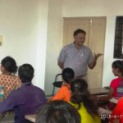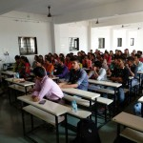

Expert lecture on Sanskrit language for BAMS curriculum
A guest lecture was organised by the Dept. of Ayurveda Samhita and Siddhanta, Parul Institute of Ayurved and Research for the 1 st Year BAMS students January, 2018 at Parul Sevashram auditorium from 10:00 am- 12:30 pm. The speaker for the guest lecture was Dr.Akshar Kulkarni, a renowned Ayurveda Physician,Tilak Vidypeeth,Pune,Maharashtra.Dr. BG Kulkarni, Principal, PIAR elucidated the relevance of the topic chosen and session followed thereafter. The session was co-ordinated by Dr.Shyamasundaran K, Dr. Ravi Joshi and Mr.Tejas Vyas, faculties of PIAR. This session was really helpful as it made the understanding of importance of Sanskrit language for BAMS Curriculum.
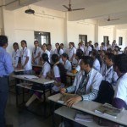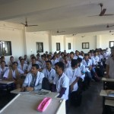

Guest lecture on “To create awareness regarding use of social media to prevent cybercrime”
A Guest Lecture was organised by the WDC Co-ordinator- Dr. Satita ohol, Parul Institute of Ayurved and Research for the students, teachers, consultants, medical officers, on 5th December, 2018 in Lecture Hall No. 3, PIAR from 11.15am- 01:15 pm. Aim of the lecture was “To create awareness regarding use of social media to prevent cybercrime”.
A guest lecture was carried out successfully under the guidance of respected principal Dr. Kulakarni. Programme was anchored by students. Lecture was given by Mr. Manishkumar Jain (Founder of cyber security India). And Mr. Amish Patel. Live demonstrations, videos were shown on misuse of social media, cybercrimes etc. Few of the case studies were discussed. Speech on event was delivered Academic in-charge Dr. Manisha Dunghav.
This program was very informative and useful, as it was about use of social media and cyber security for all present in auditorium.

