EXPERT LECTURE ON “APPLIED ASPECT OF CHARAKA SAMHITA CHIKITSASTHANA IN TODAYS ERA”
A guest lecture was organised by the Dept. of Ayurveda Samhita and Siddhanta, Parul Institute of Ayurved and Research for the III Year BAMS students 22nd November, 2019 at Seminar Hall, ground floor, PIAR, from 10:30 am- 12:30 Noon. The speaker for the guest lecture was Dr.Shivani Sanjeev Gavande, Professor, Department of Kayachikitsa, Bhaisaheb Savant Ayurved Mahavidyalay, Sawantwadi, Sindhudurga, Maharashtra on the topic Applied aspect of Charaka Samhita Chikitsasthana in todays era. The session was interactive with glimpses of Chikitsa Sutra with clinical applicability and insight to understand Charaka Samhita was highlighted.
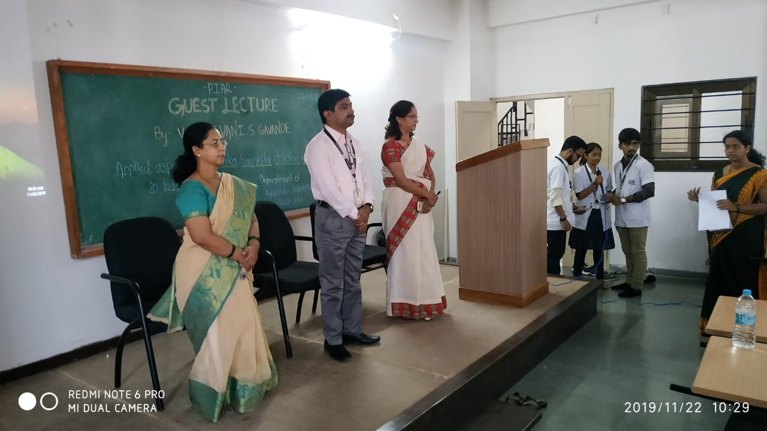 | 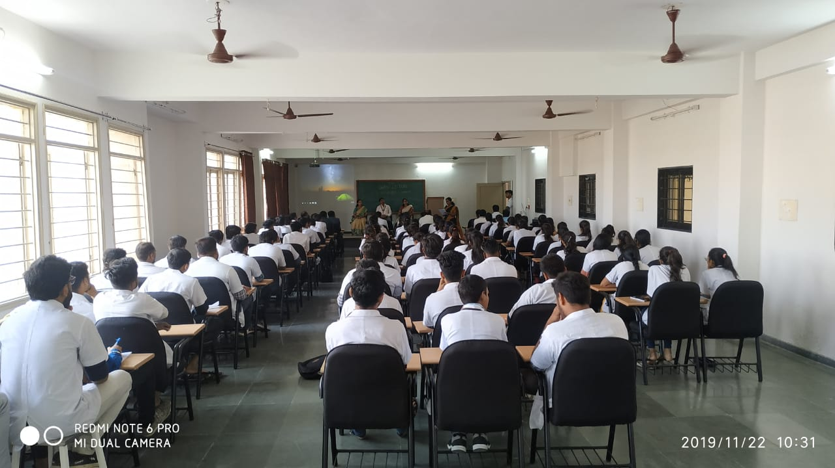

EXPERT LECTURE ON “SENSITISATION TO CLINICAL AYURVED”

Expert Lecture was arranged on on 20.06.2019 for I BAMS Students of Paul Institute of Ayurveda & Research, Ishwarpura, Paul University; on the topic “Sensitisation to Clinical Ayurved” by Dr. Bhanuprakash Joshi, Professor, Lakulesh Yoga University.

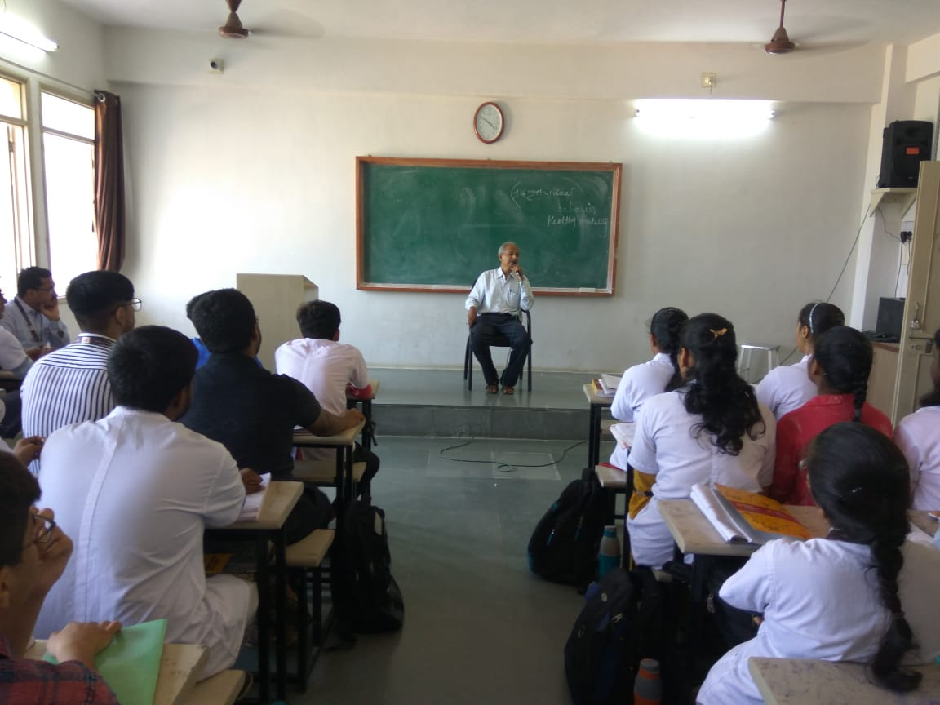 | 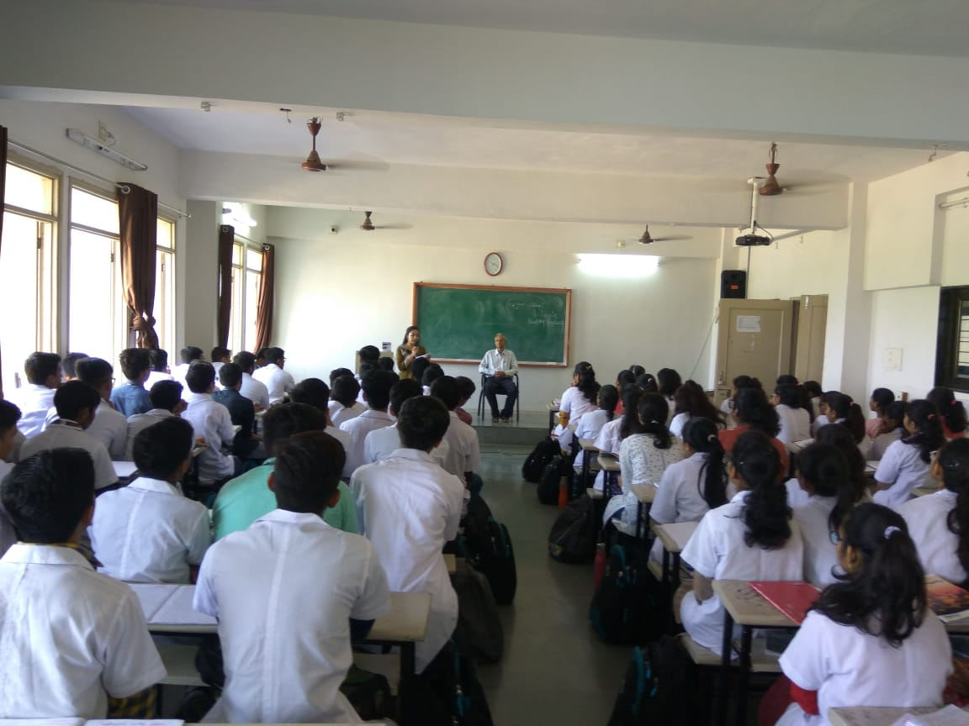

EXPERT LECTURE ON “YOGA IN MODERN AGE”
Expert Lecture on topic “Yoga in Modern Age” by expert Paramadhama Das, Hare Krishna Movement, Vadodara was organised by the Department of Swasthavrutha, Faculty of Ayurveda, PU, on 20.06.2019 Parul University for the students and teachers, on 20.06.2019. Aim of the lecture was to create awareness about the yoga and its benefit in the current era.

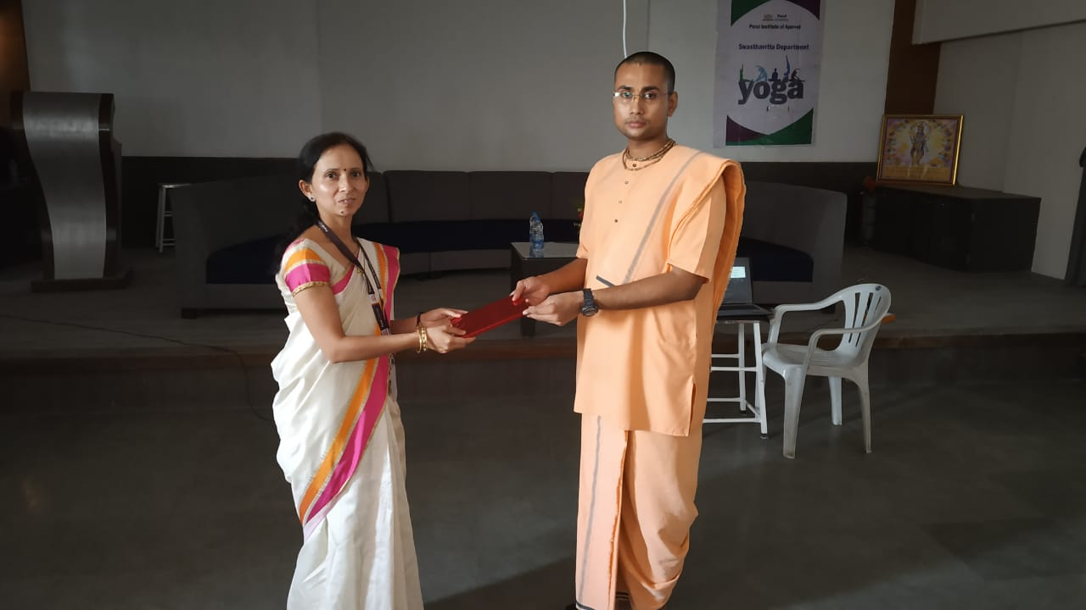 | 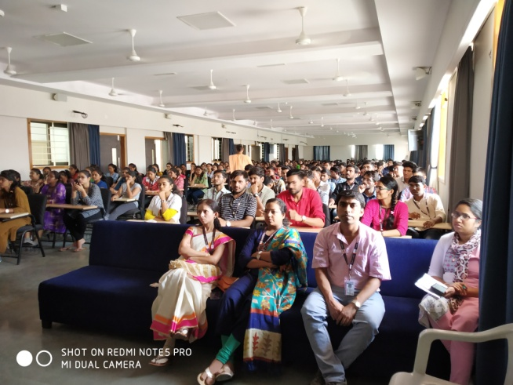

EXPERT LECTURE ON “ PRACTICAL UTILITY OF PADARTHA VIGYAN”
Department of Ayurveda Samhita & Siddhanta organised a Guest Lecture on 28.09.2019 (9.30 AM to 10.30AM) at Lecture Hall 4 in Parul Institute of Ayurveda & Research, Ishwarpura. The topic of lecture was “ Practical Utility of Padartha Vigyan”. The expert who conducted the seesion was Vd. Kadam Amol Shamrao, Principal & Professor Department of Ayurveda Samhita & Siddhanta, Dr. Deepak Patil Ayurveda College & Research Centre, Kolhapur, Maharashtra. The session was interactive and students were benifited with the session. About 85 students were benifited.
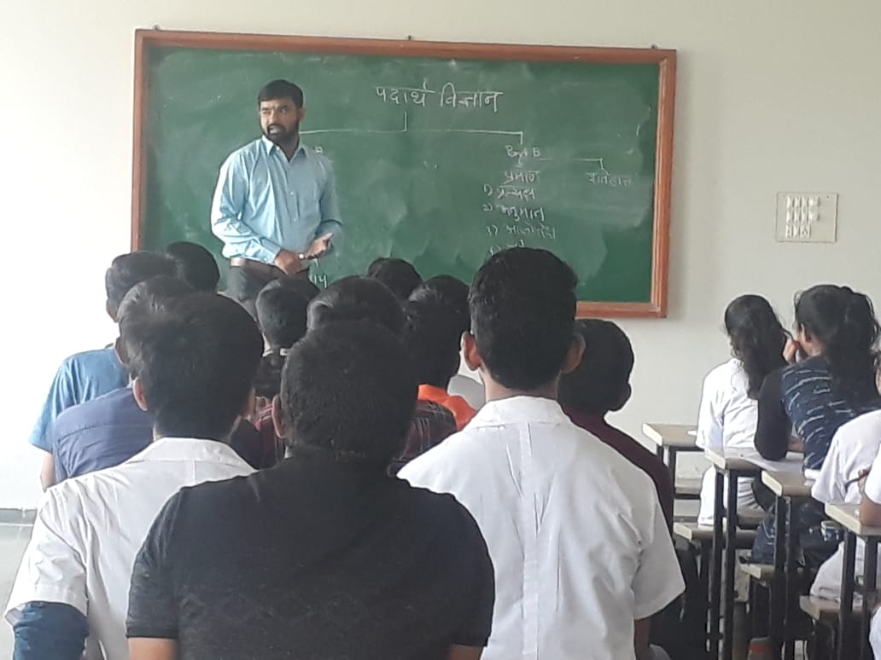 | 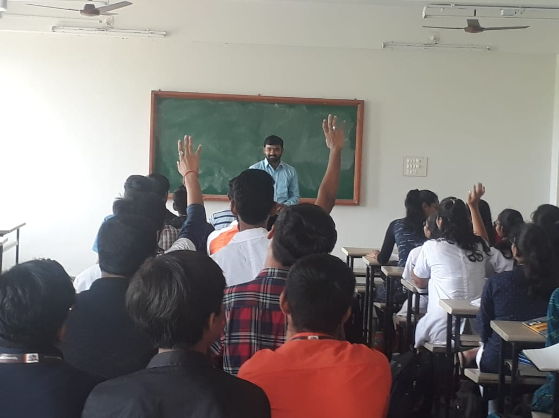

EXPERT LECTURE ON “ ART OF MIND CONTROL”
Expert lecture was arranged by the Department of Ayurveda Samhita & Siddhanta, PIAR, Ayurveda. Sri Param Das Dam Ji, enlightened the minds of the students with a lecture on the topic “ Art of Mind Control” on 26.04.019. 100 Students of first Year BAMS were benifitted.
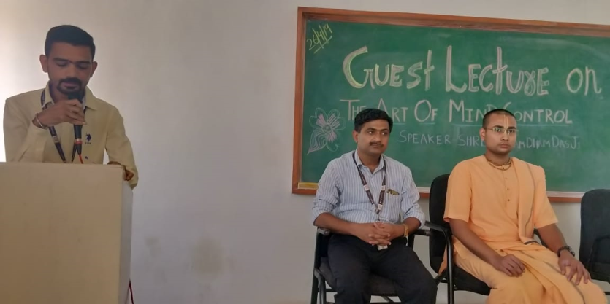

EXPERT LECTURE ON “CLINICAL UTILITY OF VIMANA STHANA OF CHARAKA SAMHITA”
Expert lecture was arranged by the Department of Ayurveda Samhita & Siddhanta , PIAR, Ayurveda. Dr. Vinay Pawar, Associate Professor, Department of Ayurveda Samhita & Siddhanta, DYPU, School of Ayurveda, Nerul, Navi Mumbai, highlighted the topic of “clinical utility of vimana Sthana of charaka Samhita” on 25.04.2019. 125 students of both First and second Year BAMS were benifitted.
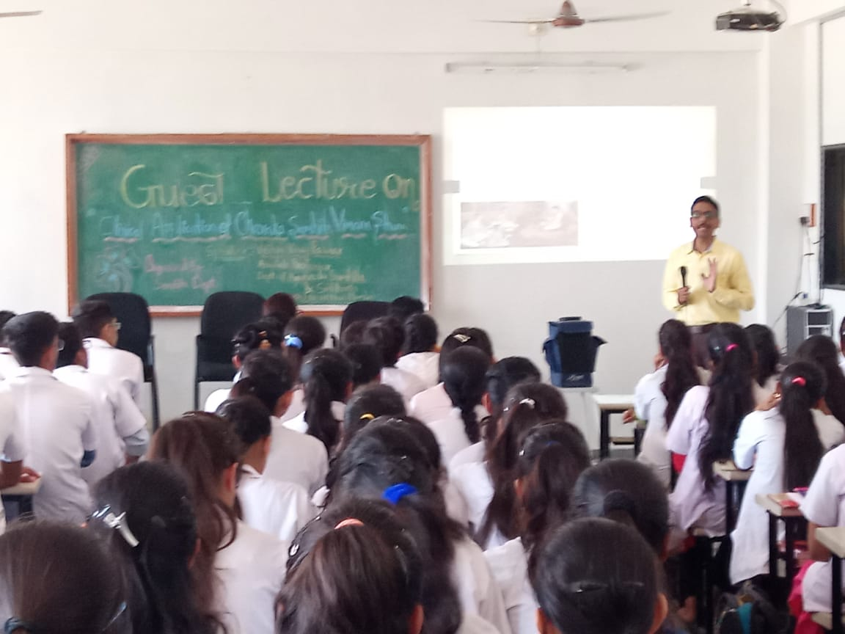

EXPERT LECTURE ON “BASIC PATHOLOGY & IMMUNITY AND IMMUNE DEFICIENT DISORDERS”
Series of Guest lecture was arranged by the Department of Roga Nidana & Vikruti Vijnana, PIAR, Ayurveda. Dr. Kirankumar Delwadia, Professor & Head, Department of Pathology PIMSR, delivered guest lecture on the topic “Basic Pathology”, on 09.04.2019 and10.04.2019 and Dr Nisarg Savjiyani delivered guest lecture on the topic “Immunity and Immune deficient Disorders” on 11/04/2019 and and 95 students of Second Year BAMS were been benefitted.
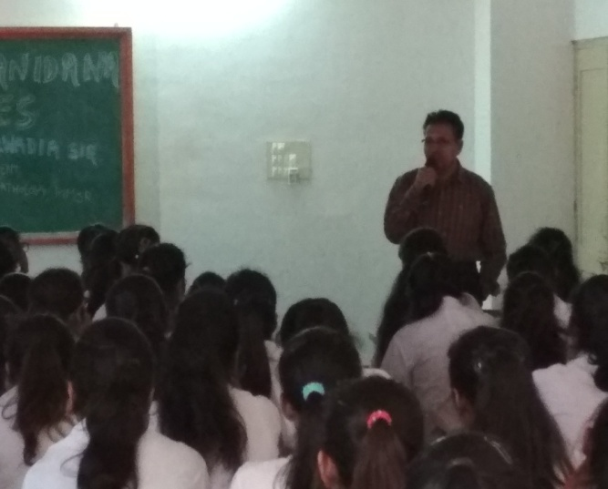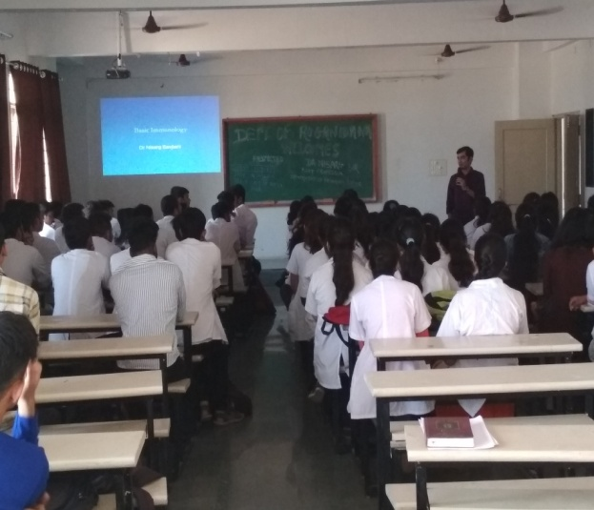
Expert lecture on “Introduction to Rasashastra and Importance of Rasoushadhies”
With the permission of Dr B.G.Kulkarni principal, PIAR, Department of Rasashastra &Bhaishajya Kalpana has conducted Guest Lecturer for II year BAMS students on 11/01/2019 at Lecture Hall No.1, Ground floor Parul Institute of Ayurveda & Research by Dr Prakash Desponded, Professor, BVV Ayurveda College, Bagalkot on the topic “Introduction to Rasashastra and Importance of Rasoushadhies” for 2 hours. In this session Basic principles of Rasashastra, Samskaras mentioned in Rasashastra like Shodhana, Marana etc, Importance of Posology with reference to Rasoushadhies was dealt. The session was very fruitful to motivate the students towards orientation of subject.
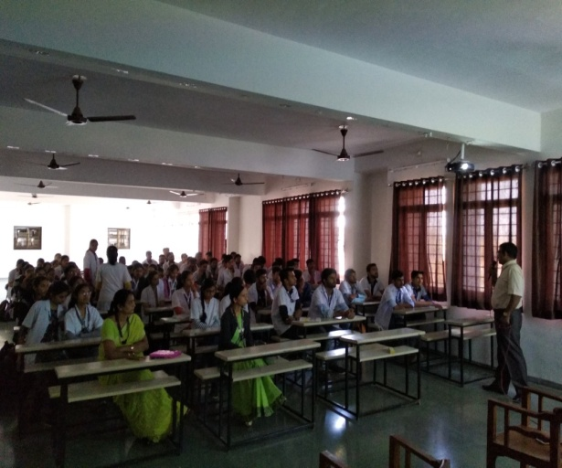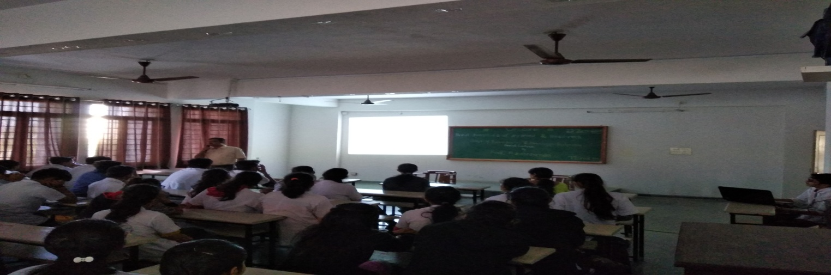
Expert lecture on “Concept of Srotas”
A Guest Lecture on topic “Concept Of Srotas” was organised by the Dept of Kriya Sharir, Parul Institute of Ayurved and Research, Ishwarpura, Parul University for the students and teachers, on 22nd April, 2019 in Lecture Hall No. 1, PIAR from 11.00am- 01:00 pm. Aim of the lecture was to put across the clinical applicability of the concepts of Srotas. Programme was anchored by FYBAMS student Ms Nisha and Dr. Sarita Ohol (Professor and HOD, department of Kriya Sharir, PIAR , Parul University), briefed about an expert Dr. Shruti Phatak (Associate Professor), Dept of Kriya Sharir, DYPU, School of Ayurved, Nerul, Navi Mumbai. Lecture was given by Dr. Shruti D. Phatak. Concepts of Srotas were taught simple ways of envisaging the concepts in authentic manner and its usage in clinical. Speech on event was delivered Academic in-charge Dr. Manisha Dunghav. Speech on event was delivered respected principal Dr. Kulkarni. Vote for Thanks expressed by Academic in-charge Dr. Manisha Dunghav. This session was really helpful as it made the understanding Srotas concept easy and practical.

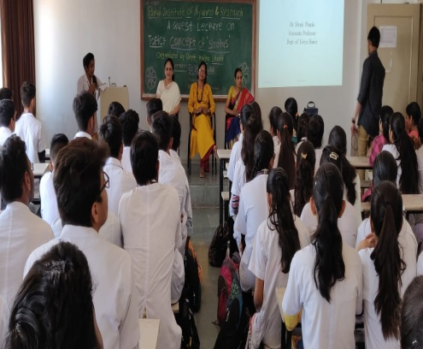 | 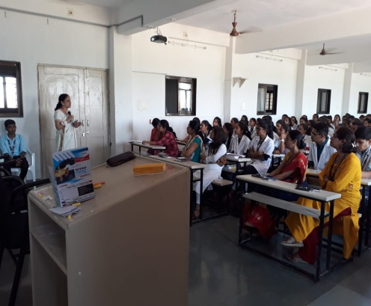 | 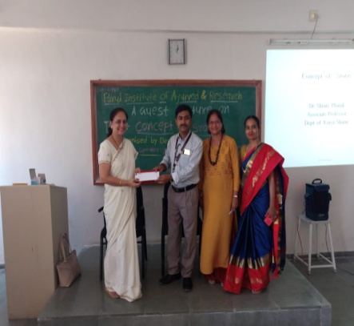

EXPERT LECTURE ON “APPLIED ASPECT OF CHARAKA SAMHITA CHIKITSASTHANA IN TODAYS ERA”
A guest lecture was organised by the Dept. of Ayurveda Samhita and Siddhanta, Parul Institute of Ayurved and Research for the III Year BAMS students 22nd November, 2019 at Seminar Hall, ground floor, PIAR, from 10:30 am- 12:30 Noon. The speaker for the guest lecture was Dr.Shivani Sanjeev Gavande, Professor, Department of Kayachikitsa, Bhaisaheb Savant Ayurved Mahavidyalay, Sawantwadi, Sindhudurga, Maharashtra on the topic Applied aspect of Charaka Samhita Chikitsasthana in todays era. The session was interactive with glimpses of Chikitsa Sutra with clinical applicability and insight to understand Charaka Samhita was highlighted.

EXPERT LECTURE ON “SENSITISATION TO CLINICAL AYURVED”

Expert Lecture was arranged on on 20.06.2019 for I BAMS Students of Paul Institute of Ayurveda & Research, Ishwarpura, Paul University; on the topic “Sensitisation to Clinical Ayurved” by Dr. Bhanuprakash Joshi, Professor, Lakulesh Yoga University.

EXPERT LECTURE ON “YOGA IN MODERN AGE”
Expert Lecture on topic “Yoga in Modern Age” by expert Paramadhama Das, Hare Krishna Movement, Vadodara was organised by the Department of Swasthavrutha, Faculty of Ayurveda, PU, on 20.06.2019 Parul University for the students and teachers, on 20.06.2019. Aim of the lecture was to create awareness about the yoga and its benefit in the current era.

EXPERT LECTURE ON “ PRACTICAL UTILITY OF PADARTHA VIGYAN”
Department of Ayurveda Samhita & Siddhanta organised a Guest Lecture on 28.09.2019 (9.30 AM to 10.30AM) at Lecture Hall 4 in Parul Institute of Ayurveda & Research, Ishwarpura. The topic of lecture was “ Practical Utility of Padartha Vigyan”. The expert who conducted the seesion was Vd. Kadam Amol Shamrao, Principal & Professor Department of Ayurveda Samhita & Siddhanta, Dr. Deepak Patil Ayurveda College & Research Centre, Kolhapur, Maharashtra. The session was interactive and students were benifited with the session. About 85 students were benifited.

EXPERT LECTURE ON “ ART OF MIND CONTROL”
Expert lecture was arranged by the Department of Ayurveda Samhita & Siddhanta, PIAR, Ayurveda. Sri Param Das Dam Ji, enlightened the minds of the students with a lecture on the topic “ Art of Mind Control” on 26.04.019. 100 Students of first Year BAMS were benifitted.

EXPERT LECTURE ON “CLINICAL UTILITY OF VIMANA STHANA OF CHARAKA SAMHITA”
Expert lecture was arranged by the Department of Ayurveda Samhita & Siddhanta , PIAR, Ayurveda. Dr. Vinay Pawar, Associate Professor, Department of Ayurveda Samhita & Siddhanta, DYPU, School of Ayurveda, Nerul, Navi Mumbai, highlighted the topic of “clinical utility of vimana Sthana of charaka Samhita” on 25.04.2019. 125 students of both First and second Year BAMS were benifitted.
EXPERT LECTURE ON “BASIC PATHOLOGY & IMMUNITY AND IMMUNE DEFICIENT DISORDERS”
Series of Guest lecture was arranged by the Department of Roga Nidana & Vikruti Vijnana, PIAR, Ayurveda. Dr. Kirankumar Delwadia, Professor & Head, Department of Pathology PIMSR, delivered guest lecture on the topic “Basic Pathology”, on 09.04.2019 and10.04.2019 and Dr Nisarg Savjiyani delivered guest lecture on the topic “Immunity and Immune deficient Disorders” on 11/04/2019 and and 95 students of Second Year BAMS were been benefitted.
Expert lecture on “Introduction to Rasashastra and Importance of Rasoushadhies”
With the permission of Dr B.G.Kulkarni principal, PIAR, Department of Rasashastra &Bhaishajya Kalpana has conducted Guest Lecturer for II year BAMS students on 11/01/2019 at Lecture Hall No.1, Ground floor Parul Institute of Ayurveda & Research by Dr Prakash Desponded, Professor, BVV Ayurveda College, Bagalkot on the topic “Introduction to Rasashastra and Importance of Rasoushadhies” for 2 hours. In this session Basic principles of Rasashastra, Samskaras mentioned in Rasashastra like Shodhana, Marana etc, Importance of Posology with reference to Rasoushadhies was dealt. The session was very fruitful to motivate the students towards orientation of subject.
Expert lecture on “Concept of Srotas”
A Guest Lecture on topic “Concept Of Srotas” was organised by the Dept of Kriya Sharir, Parul Institute of Ayurved and Research, Ishwarpura, Parul University for the students and teachers, on 22nd April, 2019 in Lecture Hall No. 1, PIAR from 11.00am- 01:00 pm. Aim of the lecture was to put across the clinical applicability of the concepts of Srotas. Programme was anchored by FYBAMS student Ms Nisha and Dr. Sarita Ohol (Professor and HOD, department of Kriya Sharir, PIAR , Parul University), briefed about an expert Dr. Shruti Phatak (Associate Professor), Dept of Kriya Sharir, DYPU, School of Ayurved, Nerul, Navi Mumbai. Lecture was given by Dr. Shruti D. Phatak. Concepts of Srotas were taught simple ways of envisaging the concepts in authentic manner and its usage in clinical. Speech on event was delivered Academic in-charge Dr. Manisha Dunghav. Speech on event was delivered respected principal Dr. Kulkarni. Vote for Thanks expressed by Academic in-charge Dr. Manisha Dunghav. This session was really helpful as it made the understanding Srotas concept easy and practical.

