EXPERT LECTURE PANCHKARMA CERTIFICATE COURCE
Guest lecture was conducted by CEP cell for Panchkarma certificate course by Dr.Hethal on 15.12.2021 at 12:00 Noon – 01:00 PM for fourth year BAMS students.
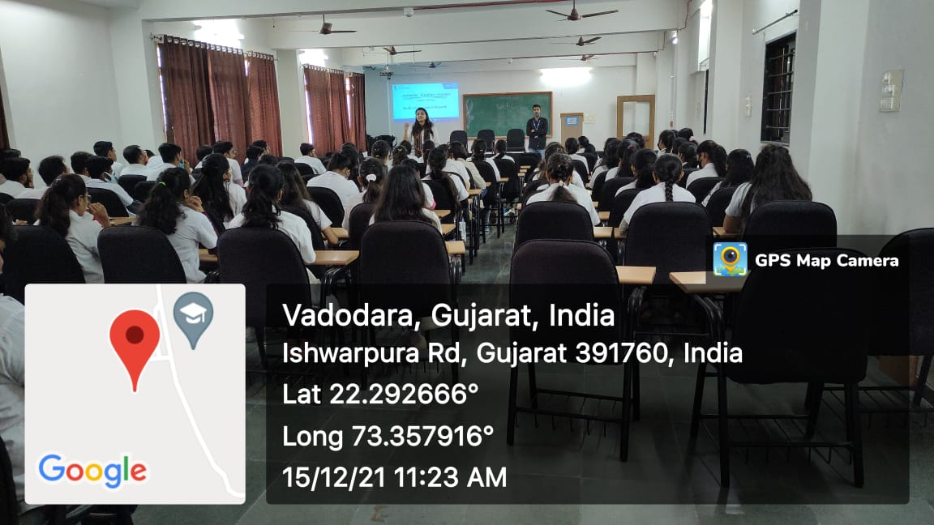

EXPERT LECTURE ON Entrepreneurship and Innovation as Career Opportunity
An expert lecture was organized by Entrepreneurship Development Centre on the topic Entrepreneurship and Innovation as Career Opportunity on 30.12.2021 from 11.15am to 12.15pm at Parul Institute of Ayurved and Research coordinated by Dr. Bhavin Dhanavade.

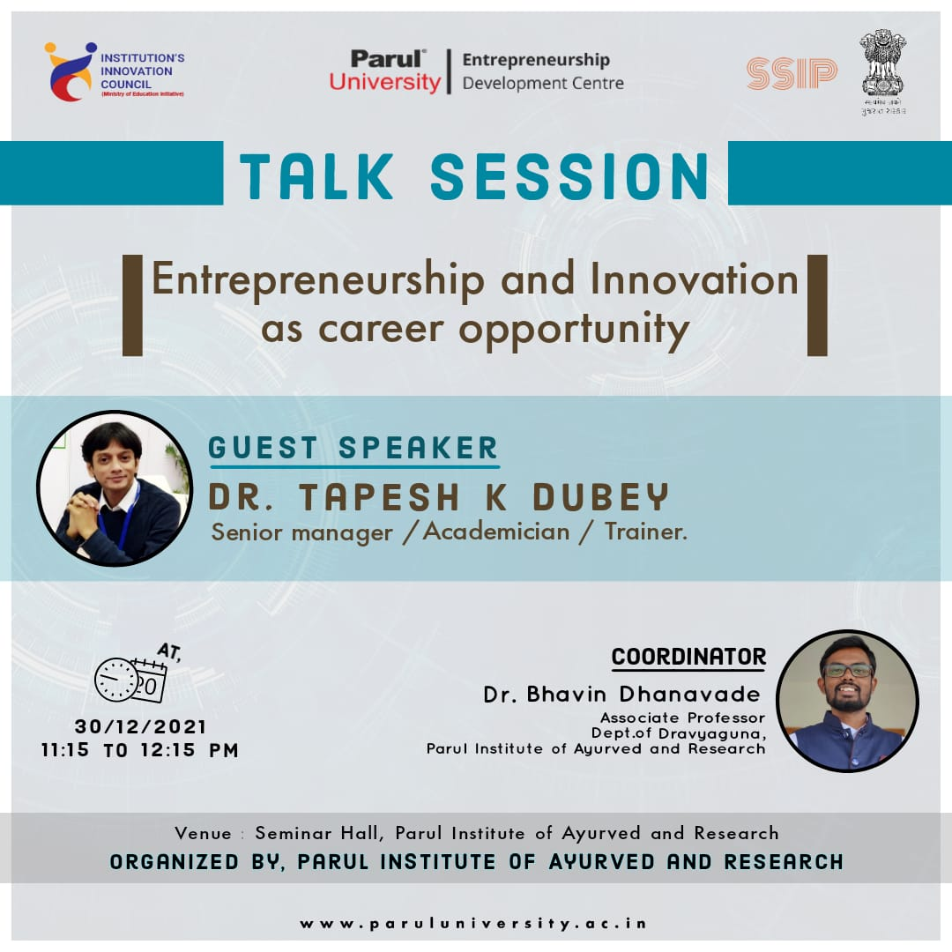
“Memory – Is it malleable?”
Department of Rachana Shareera organised a guest lecture on 18.09.2021 from 12.15 pm – 1.15 pm, for the students of I Year BAMS. The guest lecture was conducted by Dr. Seetharama P Mithanthaya, Professor, Department of Rachana Sharir, J S Ayurveda Mahavidyalaya, Nadiad, Gujarat on the topic “Memory – Is it malleable?” The students were given an insight of the concepts in understandable manner and demonstrated the details of Central nervous system and memory through ppt. The session was coordinated by Dr. B G Kulkarni, Dr. Nimesh P. Sangode & Dr Ravi B Joshi, Department of Rachana Sharir, PIAR.
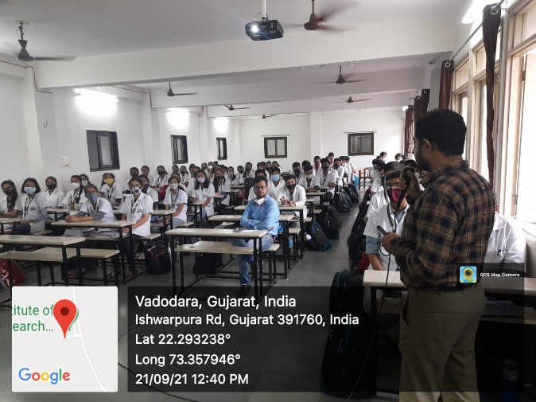 | 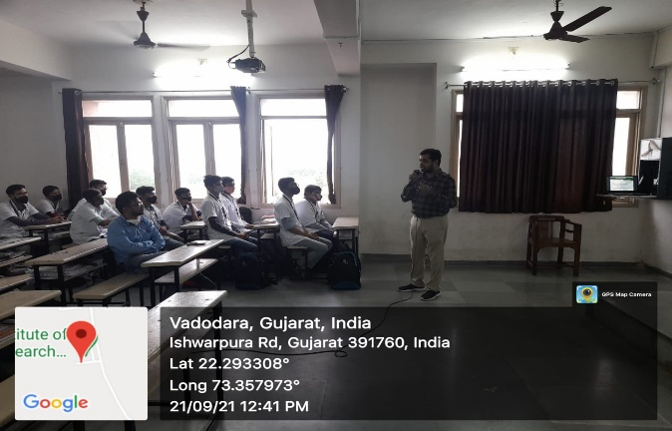

ROLE OF YOGA IN RESPIRATORY DISEASE
Department of Swasthavrutta, Parul Institute of Ayurved & Research (PIAR), has organised a Guest lecture by Dr. Vaibhav Patwardhan, Assistant Professor, Parul Institute of Public HealthParul University, Gujarat on the topic “Role of Yoga in respiratory disease” on 13.07.2021 at 2:00 PM – 3:00 PM onwards for students of III year BAMS.
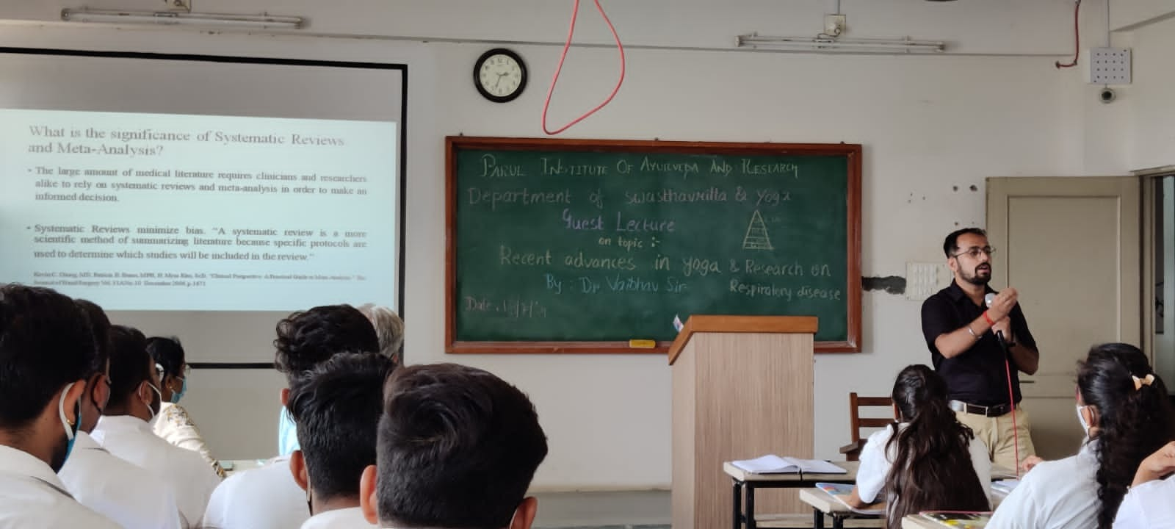 | 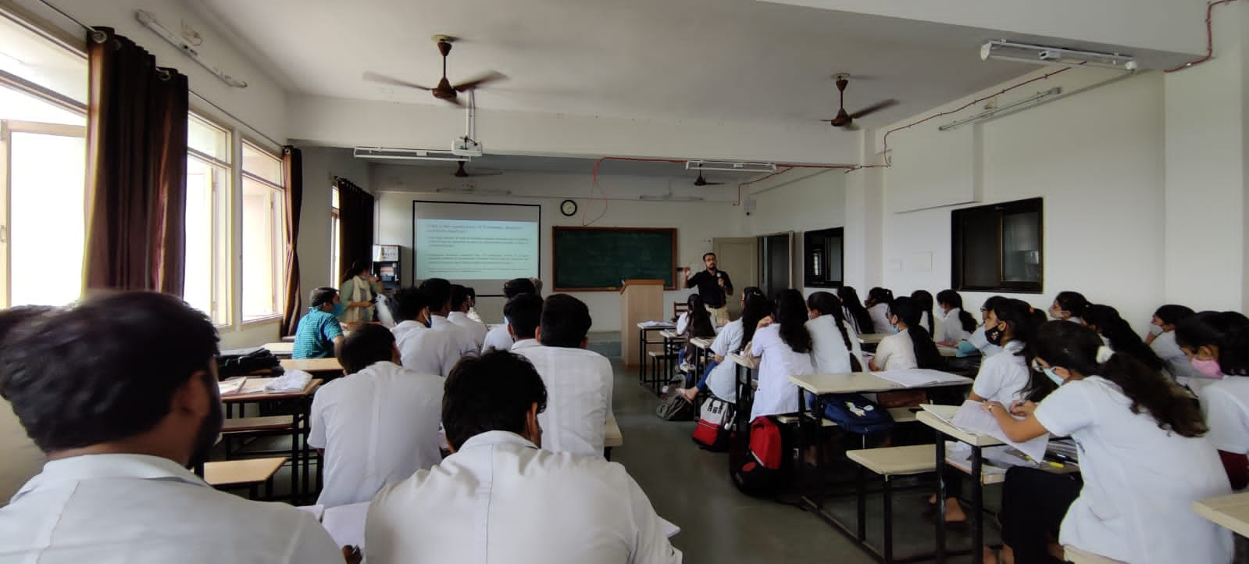

AN EXPERT LECTURE ON HEALTH AND HYGIENE
Department of Swasthavrutha, Parul Institute of Ayurved & Research (PIAR), has organised a Guest lecture by Dr. Vaibhav Patwardhan, Assistant Professor, Parul Institute of Public HealthParul University, Gujarat on the topic “Health and Hygiene” on 30.06.2021 at 04:00 PM – 05:00 PM for students of III year BAMS.
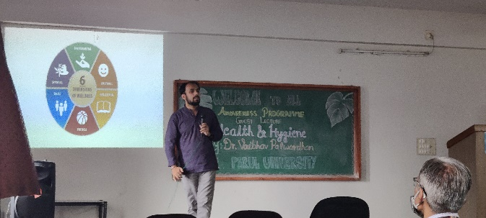

AN EXPERT LECTURE ON THE SCIENCE OF SELF MANAGEMENT
Department of Ayurved Samhita & Siddhanta, Parul Institute of Ayurved & Research (PIAR), has organised a Guest lecture by Shri Param Dhama Das, from Hare Krishna Movement, Ahmedabad, Gujarat on the topic “The Science of Self Management” on 26.06.2021 at 9:15 AM onwards for students of I year BAMS.
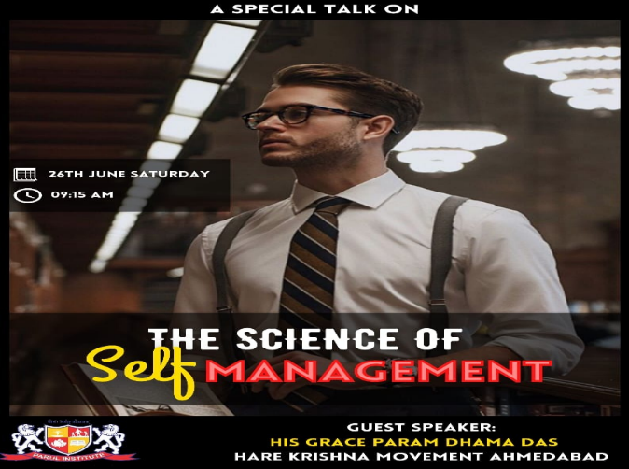 | 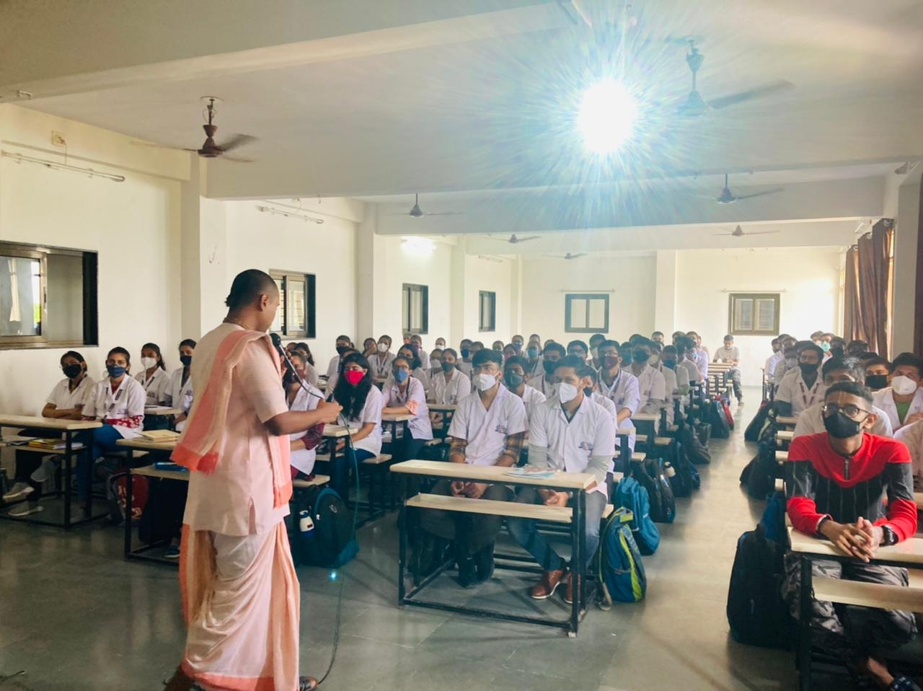
AN EXPERT LECTURE ON CASE STUDY ON KLAIBYA – DIAGNOSIS AND TREATMENT
Department of Kayachikitsa organized a Guest Lecture on the topic “Case study on Klaibya – Diagnosis and Treatment” on 19.03.2021 by Dr. Subhash Chandra Bose, Professor and Head Dept of Post Graduate Studies in Kayachikitsa, JSS Ayurved Medical College and Hospita, Mysuru, Karnataka.
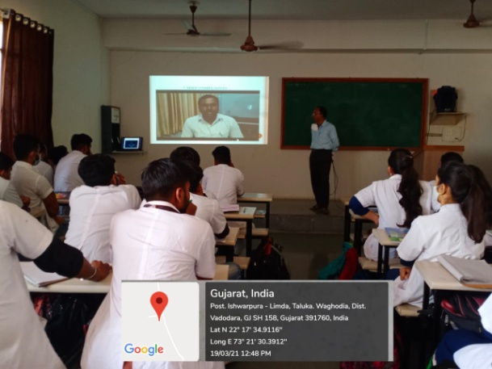

AN EXPERT LECTURE ON CLINICAL EXPERIENCE IN OBSTETRICS AND GYNAECOLOGY
Department of PTSR organized a Today Department of PTSR conducted a Guest lecture on the topic “Clinical experience in Obstetrics and Gynaecology” on 17.03.2021 by Dr Vaishali Dave, Assistant professor, Department of PTSR, J S Ayurveda College, Nadiad, Gujarat .
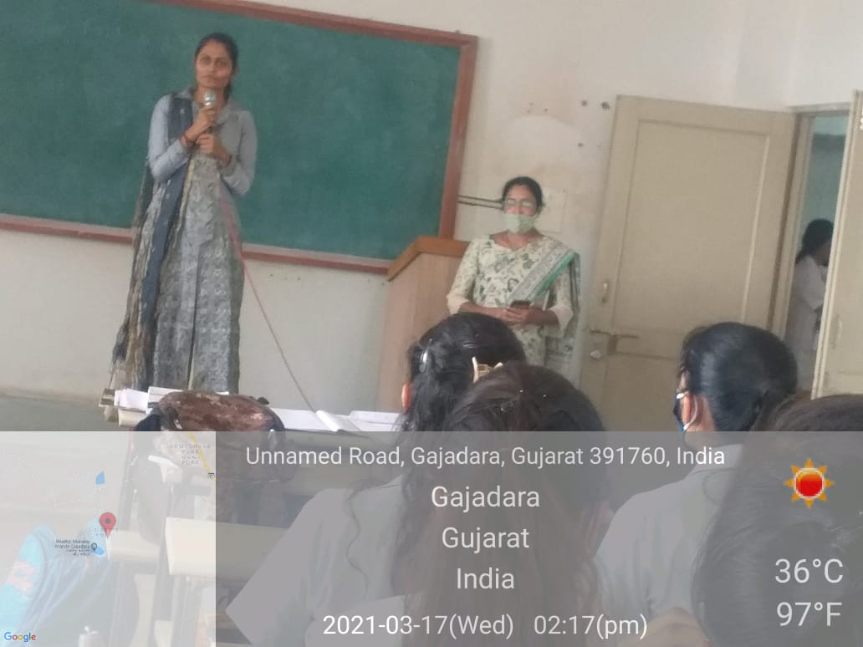 | 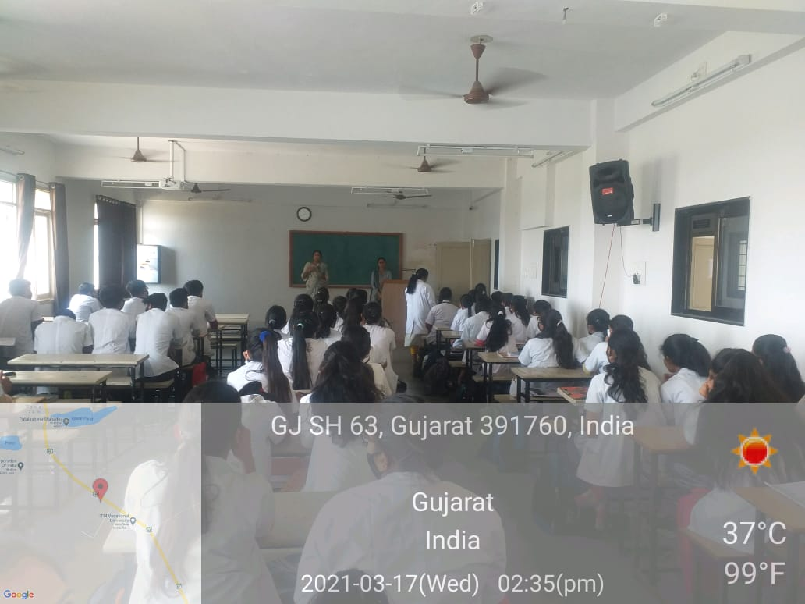

AN EXPERT LECTURE ON HOLISTIC APPROACH IN THE MANAGEMENT OF COMMON ANO – RECTAL DISORDERS
CME was organized for all the faculties on the topic “Holistic Approach in the Management of Common Ano – Rectal Disorders” on 02.03.2021 by Dr. Sameer.
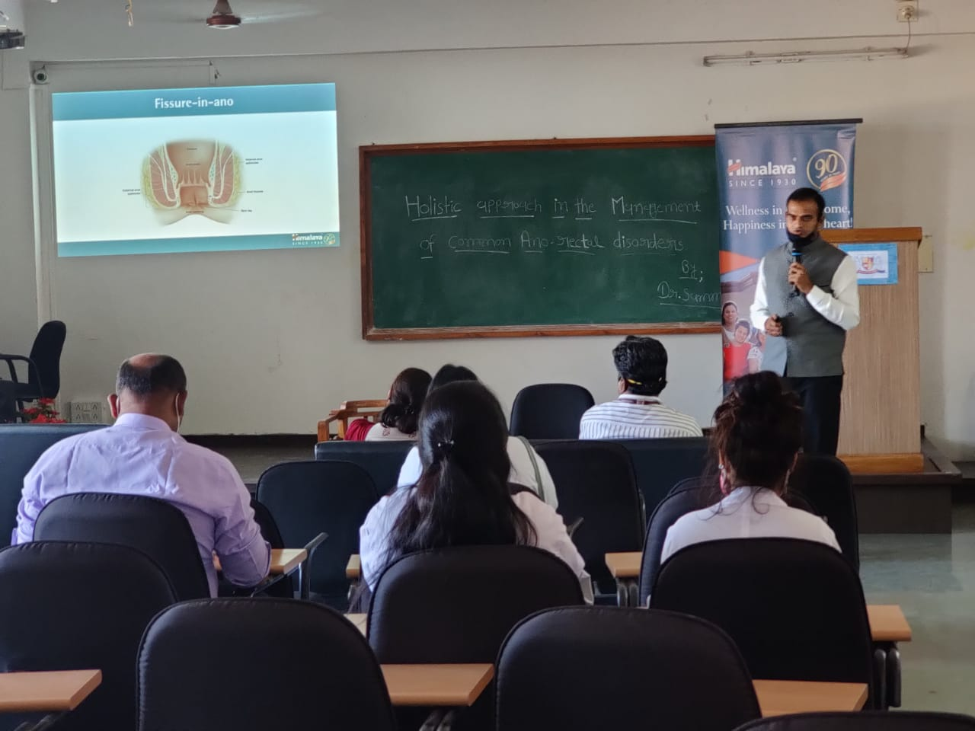 | 