EXPERT LECTURE ON UNDERSTANDING OF VATAVYADHI
An expert by Dr. Chetan M, Professor, Department of Ayurveda Samhita & Siddhanta, SDM College of Ayurveda and Hospital, Hassan, Karnataka on the topic "Understanding of Vatavyadhi" was organised by Department of Ayurveda Samhita and Siddhanta on 03.01.2022, at 4:00 PM for 3rd Year BAMS.

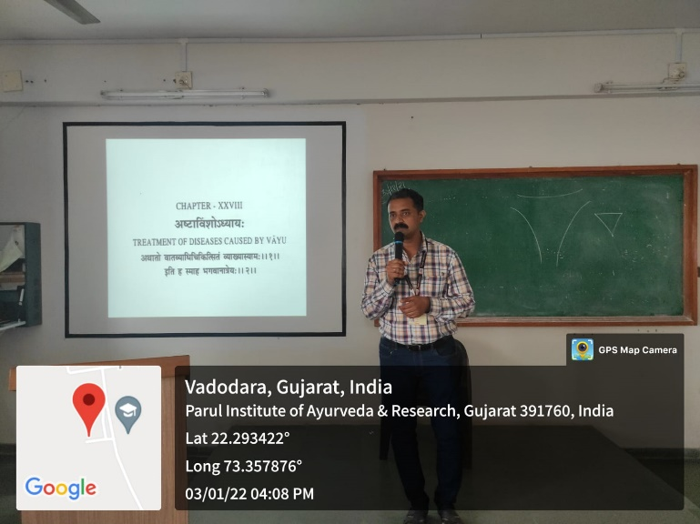

- Department of Ayurveda Samhita & Siddhanta, has organised a Guest lecture on the topic “The role of Vaidya in Clinical Practice” by Dr. Manisha Dunghav, Professor, Department of Ayurved Samhita & Siddhanta, Vasant Prabha Ayurveda College, Vadnagar, Mehasana, Gujarat, Karnataka on 23.03.2022 for students of III year BAMS.
- Entrapreunarship Development Cell, organized a Guest lecture on the topic “The Health and Social Awareness of Deaddiction” on 03.03.2022, by Sunil Kumar, I.A.S., Director of Prohibition And Excise Department, Gujarat.
- Department of Ayurveda Samhita & Siddhanta, organised a Guest lecture on the topic “Nadi Pariksha” on 30.09.2022, by Vd. Amit Pal, Practicioner, Vada, Maharashtra for II year BAMS students.
- Department of Ayurveda Samhita & Siddhanta, organised a Guest lecture on the topic “The Science of Self Management” by Amogh Virya Das, from Hare Krishna Movement, Ahmedabad, Gujarat on the topic on 30.06.2021 for students of I year BAMS.

- Department of Kaumarabhritya organised a Guest lecture on the topic Red Flag Signs under 5years for Growth and development Failure by Dr. Hardik Dave, Assistant Professor, Department of Paediatrics, PIMSR, PU on 17.11.2022 for students.

For celebrating the Children’s Day conducted expert session on “Red Flag Signs under 5 years for Growth and development Failure”
On the occasion of Children’s Day, Department of Kaumarabhritya was conducted Guest Lecture. The programme commenced with Dhanwantari Stuti by the students team of PIAR. The guest speaker was welcomed to the dais along with the Principal, PIAR, Dr. Sreevisakh T S, Asso. Professor & HOD, Dept. of Kaumarbhritya, PIAR.
Dr. BG Kulkarni, Principal, PIAR elucidated the relevance of the topic chosen and session followed thereafter.The session was coordinated by Dr. T.S. Sreevisakh and Dr. Pina Patel, Dr Dhanya Raj faculties of PIAR.
Photos
