Guest lecture Series on clinical applications of Rasaushadhies

Under the Guidance of Dr B. G. Kulkarni Principal, PIAR & Dr Anitha H., HOD, RSBK, PIAR. Department of RSBK, Faculty of Ayurveda, Parul University has conducted guest lecture series on clinical application of Rasaushadhies for five days from 15th to 19th June, 2020 by inviting renowned speaker. All the Staffs coordinated in the successful conduction of guest lecture series. The guest speakers enlightened all the viewers on significant E- platform.

S.N. | Title of webinar | Guest Speaker | Date of webinar | Time | Co-ordinator
1 | Management of Malignancies of GIT with Rasaushadhies. | Dr. M. Gopi krishna | 15-06-2020 | 11:00 am | Dr Anitha H
2 | Role of Rasaushadhies in Cardiovascular Diseases | Dr Ravindra Angadi | 16-06-2020 | 11:00 am | Dr Abhiram S
3 | Role of Rasaushadhies in pain management. | Dr. Sasikumar Nechiyil | 17-06-2020 | 11:00 am | Dr Jayprakash N
4 | Rasaushadhies in the management of Neurological Disorders | Dr Pradeep Agnihotri | 18-06-2020 | 11:00 am | Dr Rakesh B
5 | Insight into Arka kalpana & its applications | Dr Vinay Kadibagil | 19-06-2020 | 11:00 am | Dr Anitha H.

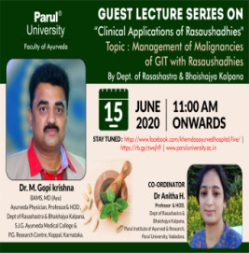 | 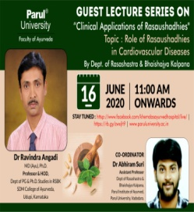 | 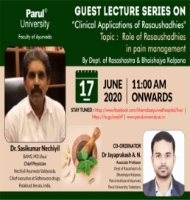 | 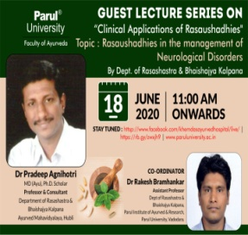 | 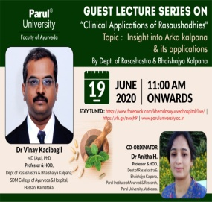

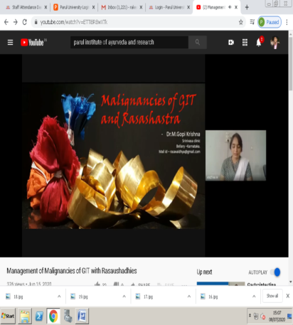 | 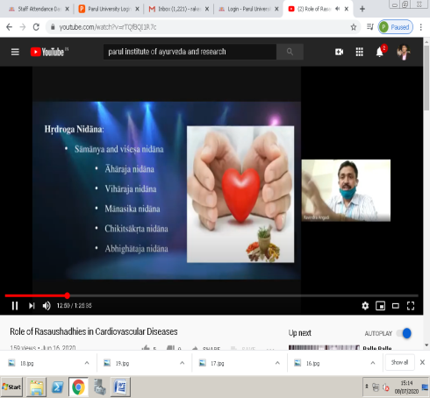 | 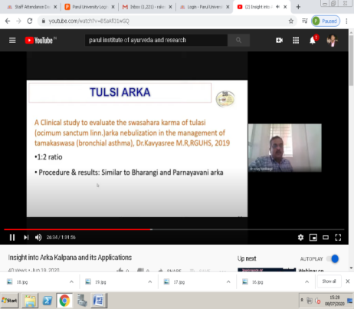

AN EXPERT LECTURE ON “Shat Kriya Kala – Applied aspects”
Prof. Dr. Sarita Ohol, Head, Department of Kriya Sharir, PIAR, coordinated the
session. Dr Akshar Kulkarni, Asso. Prof. Department of Kriya Sharir, PIAR & Dr N.R. Navoday Raju, Asst. Prof. Department of Kriya Sharir, PIAR actively involved in the arrangements of webinar. The webinar enlightened the students and was well appreciated by teachers & students. Department of Kriya Sharir, PIAR is thankful to the Guest speaker Dr Kalpana Sathe madam for accepting the invitation & delivering the webinar. Dept of Kriya Sharir expresses its heartfelt gratitude towards the President, Managing Trustees of Parul University & Dr. Hemant Toshikhane sir, Dean, Faculty of Ayurved, Parul University, Dr. B. G. Kulkarni sir, Principal, PIAR, Vadodara, Gujarat for support & motivation. Department of Kriya Sharir also thanks the technical support team of Parul University.

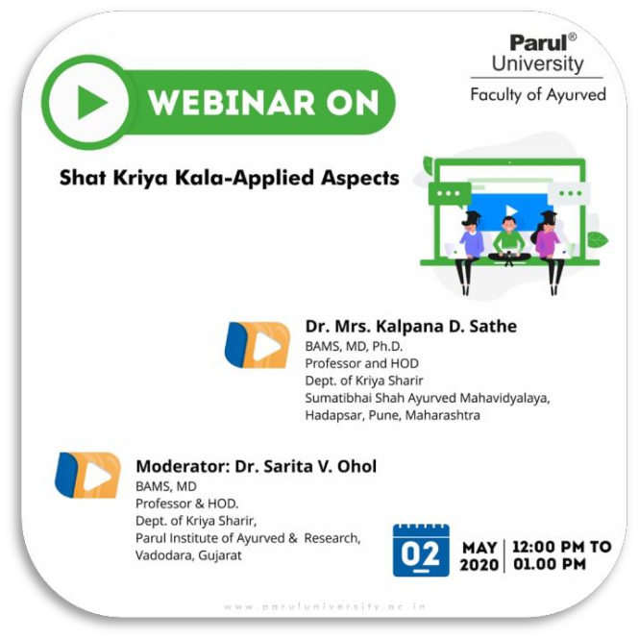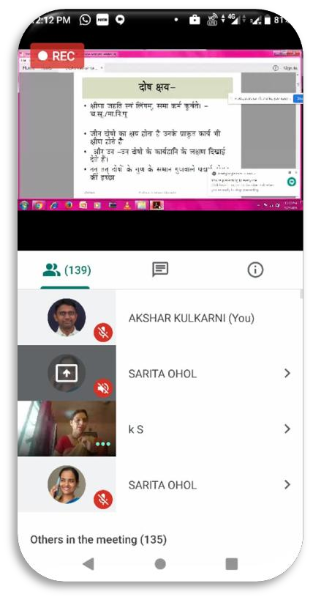
AN EXPERT LECTURE ON “FACILITY BASED MANAGEMENT OF SEVERE ACUTE MALNUTRITION (SAM)”
A guest lecture was arranged by the Department of Kaumarabhritya, PIAR, Ayurveda.on 03.03.2020 from 11:15 AM to 12:30 PM.Dr. Aarti Dalwani M.D (Peadiatrics), Assistant Professor, Dept. of Paediatrics, PIMSR,Vadodara delivered guest lecture on the topic “Facility Based Management of Severe Acute Malnutrition (SAM)”. The event was coordinated by Dr.SudhirkumarPani(Professor & Head Department ofKaumarabhritya), Dr.T.S.Sreevisakh and Dr.Jigna R. Kalaraandabout 10 consultants65 students of Third Year BAMS were benifitted.
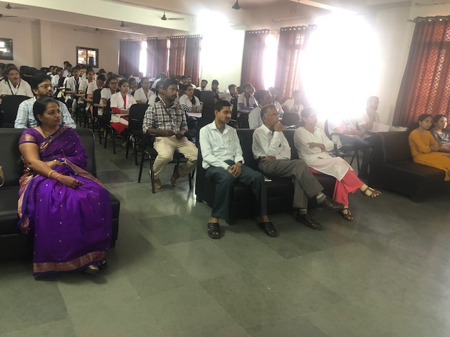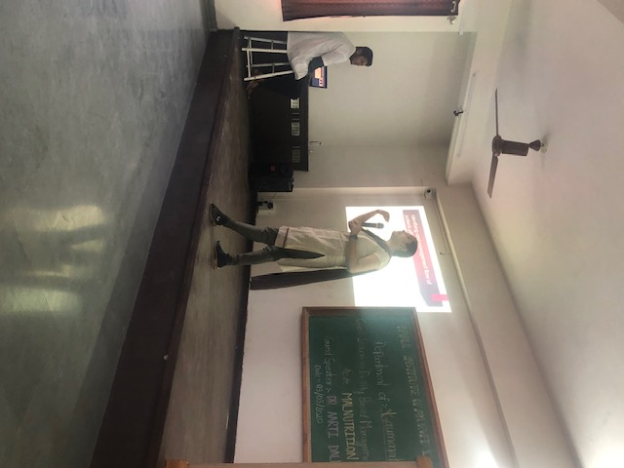

EXPERT LECTURE REGARDING THE CELLULAR ADAPTATION AND ITS CLINICAL IMPORTANCE
A guest lecture was arranged by the Roga vigyana evum vikruti vigyana department on 18/2/2020. Dr Ashish Jawarkar, Assistant professor, PIMSR, PU was the expert speaker on the topic cellular adaptation and its clinical importance for the second year BAMS student PIA&R. It was organized by Dr. Hrishita Dahelikar and Dr. Swatika Sharma.
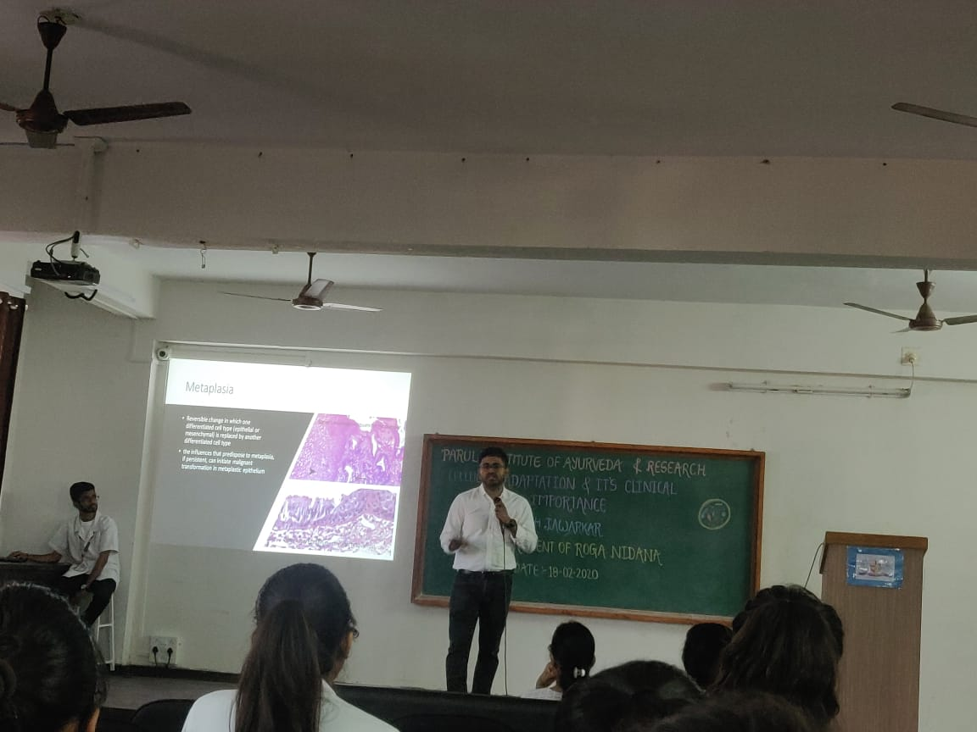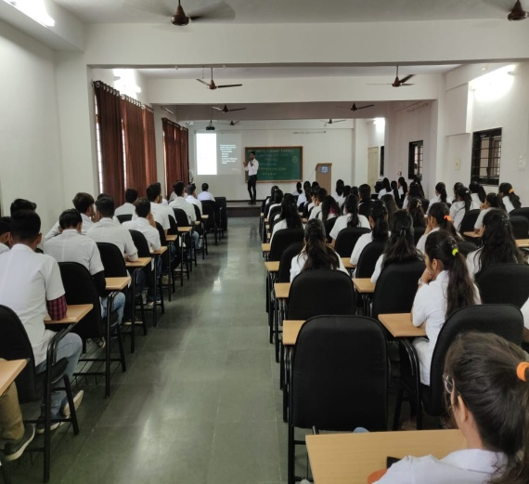

EXPERT LECTURE ON “AYURVEDIYA GARBHASAMSKAR- CONCEPT OF BETTER PROGENY”
A guest lecture was arranged by the Department of Prasuti Tantra & Stree Roga, PIAR, Ayurveda. Dr. Mansi Modi, Medical Officer (Ayu), Government Ayurved College, Vadodara delivered guest lecture on the topic “Ayurvediya Garbhasamskar- concept of better progeny”, on 29.01.2020 from 11:00 AM to 1:00 PM. The event was coordinated by Dr. Jayasheela M Goni, Professor & Head Department of Prasooti Tantra & Stree Roga and 87 students of Third Year BAMS were benifitted.
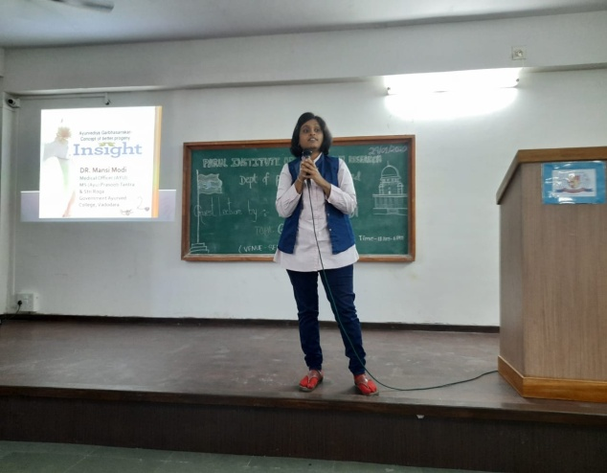 | 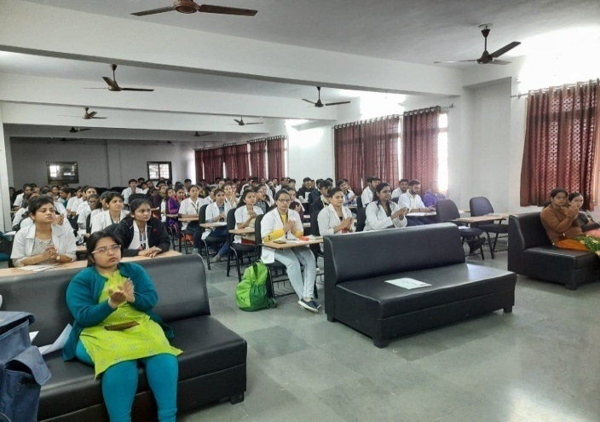

EXPERT LECTURE ON “RASOUSHADHIES IN CLINICAL PRACTICE.”
A guest lecture was arranged by the Department of RSBK. The programme commenced with Dhanwantari Prayer. Stage was shared in the event by Guest Speaker Dr Rakesh salve, Associate Professor, Manjushri Research Institute of Ayurvedic Science,Gandhinagar and Dr. Anitha.H, HOD, RSBK, PIAR. Guest welcome and introduction was done by Dr Prasanna Mathad,HOD, Agadatantra, PIAR. Guest Speaker honoured with Memento and Dr Anitha.H talked few words on relevance of Rasaoushadhi in Clinical Practice. Then intellectual and informative talk was delivered by the eminent Guest speaker which included glimpses of Samhitas and use of different Rasaoushadhi in varied clinical conditions followed by interactive session with gathering. The event was concluded by vote of thanks by Dr Rakesh. Brahmankar, Assistant Professor, RSBK.

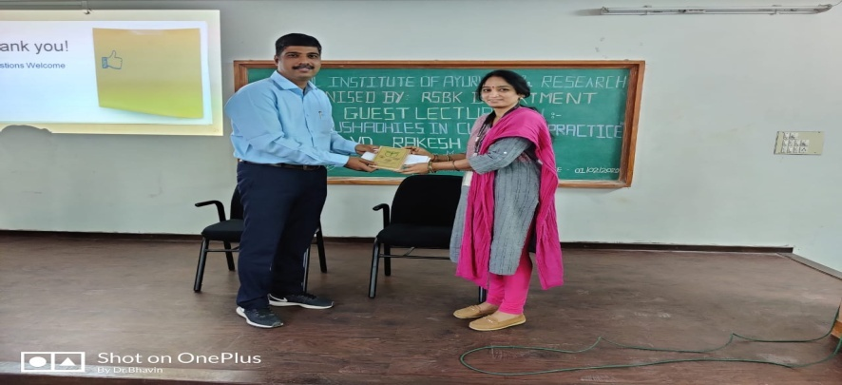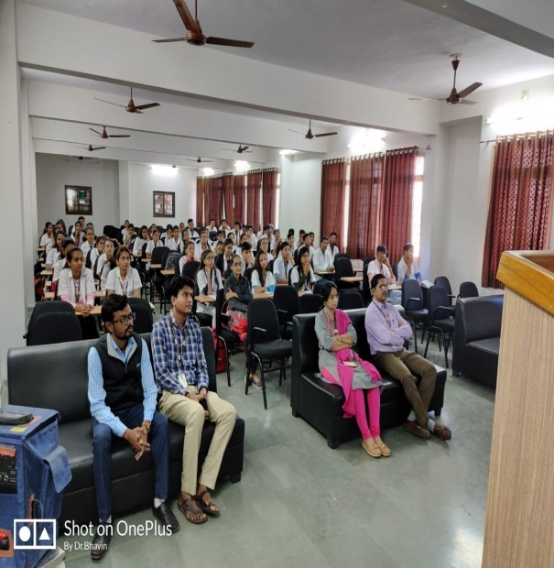
EXPERT LECTURE ON “COURTS OF INDIA”
A guest lecture was arranged by the Department of Agada Tantra & Vyavahara Ayurveda, PIAR, Ayurveda. Dr. Akil Saiyed, Dean, Director of PIL, delivered guest lecture on the topic “Courts of India”, on 28.01.2020 from 11:00 AM to 1:00 PM. The event was coordinated by Dr. Prasanna Mathad, Professor & Head Department of Agada Tantra & Vyavahara Ayurveda and about 93 students of Third Year BAMS were benifitted.
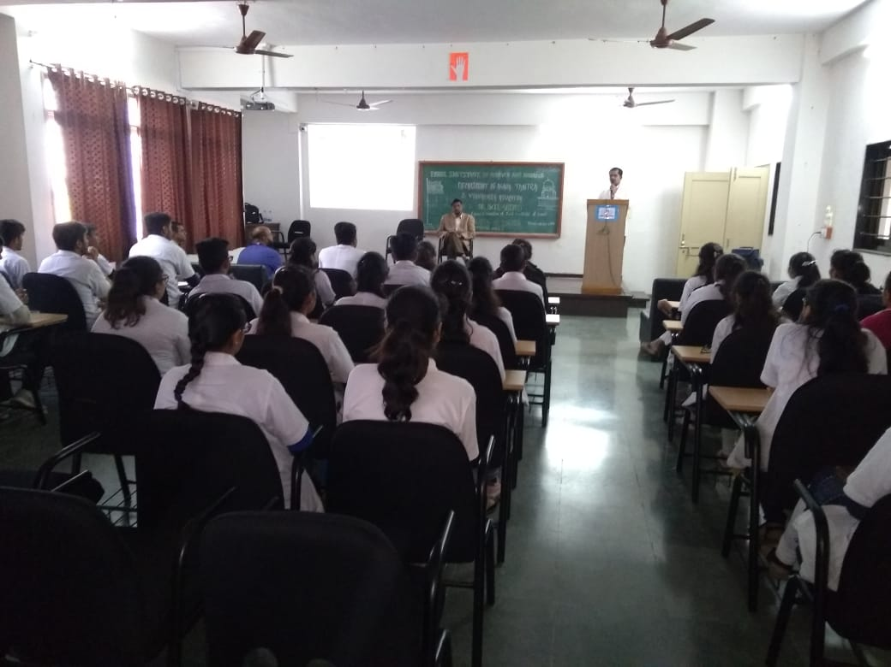 | 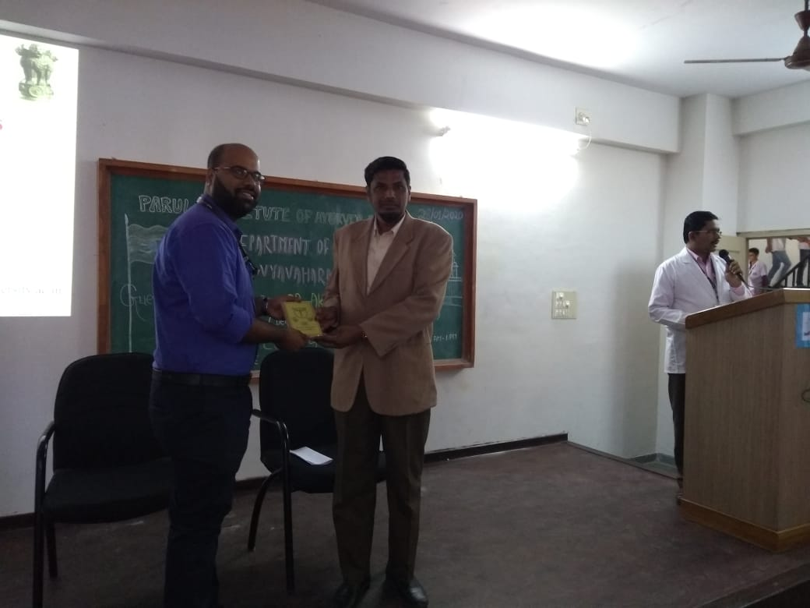

EXPERT LECTURE ON ANALYTICAL METHODS IN IDENTIFICATION OF HERBAL AND HERBO-MINERAL DRUGS”
A guest lecture was arranged by the Department of Rasa Shastra & Bhaishajya Kalpana, PIAR, Ayurveda. Dr. Chakraborthy Principal, Parul Institute Of Pharmacy and Research, Parul University, delivered guest lecture on the topic “Analytical Methods in identification of Herbal and Herbo-Mineral Drugs”, on 25.01.2020 from 11:00 AM to 1:00 PM. The intellectual and informative talk was delivered by the eminent Guest speaker which had glimpses of all basic to latest technology and instruments used in drug quality assessment followed by interactive session with gathering. The event was coordinated by Dr. Anitha H, Professor & Head Department of Rasa Shastra & Bhaishajya Kalpana and about 95 students of Second Year BAMS were benifitted.
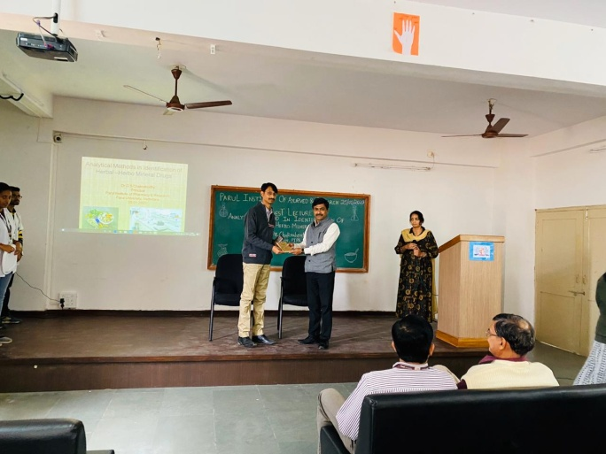 | 