PARUL INSTITUTE OF AYURVED & RESEARCH
DAY CELEBRATION 2025
“PLEDGE FOR THE PLANET” ON WORLD ENVIRONMENT DAY
The Department of Dravyaguna Vigyan, Parul Institute of Ayurved and Research, celebrated World Environment Day 2025 by organizing an Oath Taking Ceremony on 5th June 2025 at the Herbal Garden of the institute. The event was designed to highlight the theme of taking responsibility for the planet and promoting eco-conscious behaviour among students of Ayurved—particularly the 2nd Professional BAMS batch, who are deeply engaged in the study of medicinal plants and environmental concepts as part of Dravyaguna Vigyan.
The programme commenced at 11:00 a.m., welcoming faculty members, student participants, and environmental enthusiasts to the green and serene environment of the Herbal Garden. The Herbal Garden served as an ideal venue, symbolizing the close relationship between Ayurveda and nature. Surrounded by various medicinal plants and trees, the ambience reinforced the significance of conserving the natural world that forms the foundation of Ayurvedic healing.
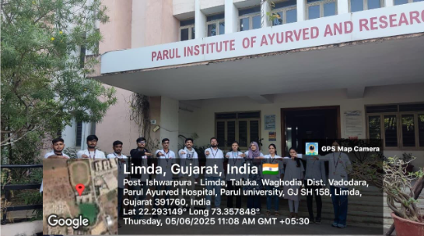
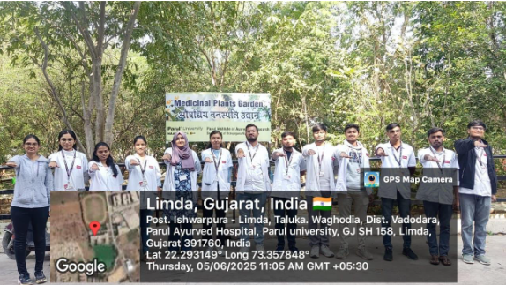

“PLANT4MOTHER” ON WORLD ENVIRONMENT DAY
On the occasion of World Environment Day 2025, the Department of Dravyaguna Vigyan at Parul Institute of Ayurved and Research organized a meaningful and environmentally driven event—a Plantation Drive titled “Plant4Mother.” The event was held on June 5th, 2025, at 11:00 a.m. in the Herbal Garden of the institute and witnessed enthusiastic participation from Dravyaguna postgraduate scholars and faculty members.
The Herbal Garden, enriched with an extensive collection of medicinal plants, served as the perfect venue for this event. The serene greenery and well-maintained plant beds created a conducive atmosphere for the plantation activity and reinforced the Ayurvedic ideology of living in harmony with nature. The plantation drive aimed to bring scholarly understanding into practical action by encouraging PG students to contribute to environmental sustainability.
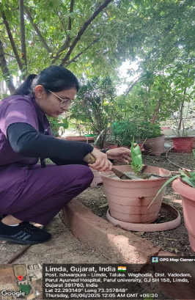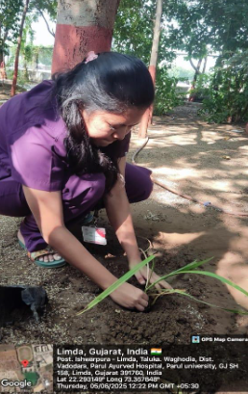

TEACHER DAY CELEBRATION
The Department of Roganidana evum Vikriti Vigyan in collaboration with the STUDENT COUNCIL OF PIAR celebrated Teachers’ Day on 8th September 2025 with great enthusiasm and reverence. The program began with the lighting of the lamp and Saraswati Vandana, followed by a welcome address by the STUDENT COUNCIL OF PIAR coordinator highlighting the significance of the day and remembering the contributions of Dr. Sarvepalli Radhakrishnan. Students expressed their gratitude through songs, poems, speeches, and a short skit performed by STUDENT COUNCIL OF PIAR volunteers depicting the guiding role of teachers in shaping lives. An interactive session provided a platform for students to share their experiences and teachers to give motivational insights.The recreational games were arranged for faculties which they enjoyed well. Faculty members were felicitated with flowers and mementoes as a token of appreciation, and the event concluded with a vote of thanks by the Head of the department. The celebration fostered a spirit of respect, gratitude, and inspiration among students while strengthening the teacher–student bond.
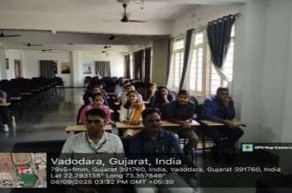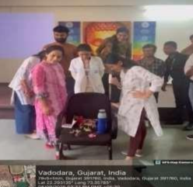

SHARIR ARTVENTURE 2025 – AN INTERDISCIPLINARY PAINTING COMPETITION - ORGAN DONATION DAY CELEBRATION
- Students were invited to submit paintings based on anatomical and health-related themes.
- Many participants focused on organ donation awareness as part of their creative work, making the event more meaningful.
- The competition was conducted in two phases:
- Submission Phase: Entries were collected before the deadline.
- A total of 186 participants from various parts of India registered and submitted their paintings, showcasing immense enthusiasm and creativity.
- Judgement & Result Declaration: Expert judges evaluated the paintings on creativity, anatomical relevance, clarity of message, and artistic execution. Results were announced on 13th September 2025.
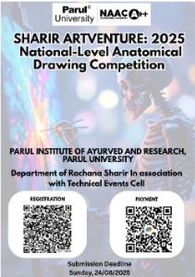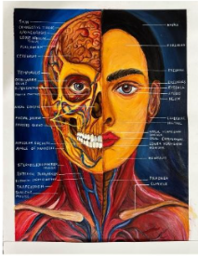
INSPIRATIONAL TALK ON THE OCCASION OF GANDHI JAYANTI
On the occasion of Gandhi Jayanti, the Department of Kriya Sharir, Parul Institute of Ayurved and Research, organized a commemorative event on 3rd October 2025 from 11:00 AM to 1:00 PM at the Ground Floor, PIAYR.
The program was led by Dr. Mariya Husain, Associate Professor & In-Charge, Department of Kriya Sharir, and coordinated by Dr. Priyanka Solanki, Dr. Shulbha Bhosle, and Dr. Kajal Senghani under the valuable guidance and support of Principal Dr. Bhagawan G. Kulkarni.
The celebration began with an introduction by Dr. Priyanka Solanki, who warmly welcomed the Principal, faculty members, and postgraduate students. She highlighted the relevance of Gandhi Jayanti as a day of reflection and gratitude toward Gandhiji’s lifelong pursuit of peace, equality, and simplicity.
