PARUL INSTITUTE OF AYURVED & RESEARCH
WORKSHOPS ORGANISED BY INSTITUTE
02 DAYS TRAINING PROGRAMME ON CCRAS STANDARDIZED PRAKRITI ASSESSMENT SCALE (SPAS) AND AYUR PRAKRITI WEB PORTAL
The Department of Kriya Sharir submitted a requisition to CCRAS, Ministry of AYUSH, for organizing a training workshop for faculty members of Ayurveda. Upon approval, the 4th session of this nationwide training initiative was scheduled at Parul Institute of Ayurved and Research on 12th and 13th February 2025.
The aim was to provide detailed guidance on Prakriti analysis using the SPAS tool and AYUR Prakriti Web Portal under the mentorship of Dr. Jayprakash Ram and Dr. Parth Dave, senior researchers from CCRAS, Ahmedabad.
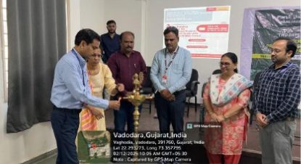 | 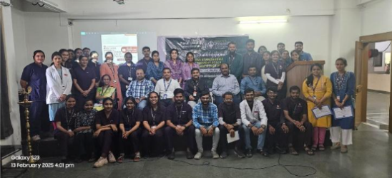

“ANALYTICAL METHODS MENTIONED IN REVISED NCISM SYLLABUS OF DRAVYAGUNA VIGYANA”
The Department of Dravyaguna Vigyana organised a 12-day intensive workshop from 4th March to 15th March 2025, guided by expert Mr. Anuraag Rai, Assistant Professor, School of Pharmacy, Faculty of Pharmacy, Parul University. The sessions were conducted each day from 10:00 a.m. to 2:00 p.m., combining theoretical instruction, visual demonstrations, and interactive discussions.
The workshop commenced with an introductory session highlighting the importance of analytical science in the evaluation and standardisation of Ayurvedic drugs, focusing on its integration into the revised NCISM syllabus. The expert emphasised how modern analytical methods help validate traditional knowledge with scientific precision.

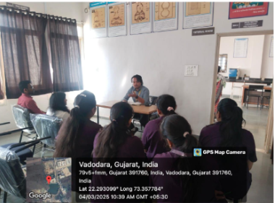
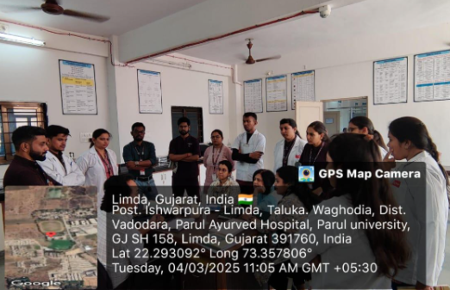
SHRINGAR COSMETIC CONCLAVE -
A NATIONAL WORKSHOP ON COSMETIC PREPARATIONS

A two-day national workshop, Shringar Cosmetic Conclave, was organized by the Department of Rasashastra and Bhaishajya Kalpana, Parul Institute of Ayurved and Research, in collaboration with Parul Institute of Pharmacy. The workshop aimed to provide hands-on training on unique cosmetic formulations, such as Herbal Face Serum, Natural Eye Liner, and Organic Mascara, to faculties, practitioners, and PG and PhD scholars of Ayurveda and Pharmacy institutions.
A book, "Shringar Cosmetic Manual," was inaugurated, covering the preparation and quality control of 24 unique cosmetics
- Participants received a kit containing samples of various cosmetics and a certificate.
- Hair serum, Face serum, Body Butter, Nano Face Pack, Organic eyeliner and mascara were prepared on Day 1.
- Hydrogel, Herbal lipstick and Quality control parameters were done on Day 2.

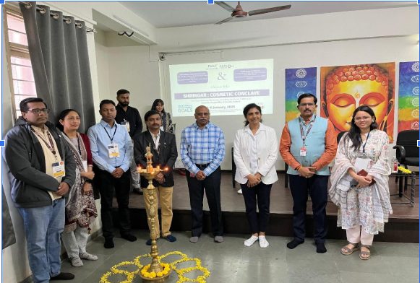 | 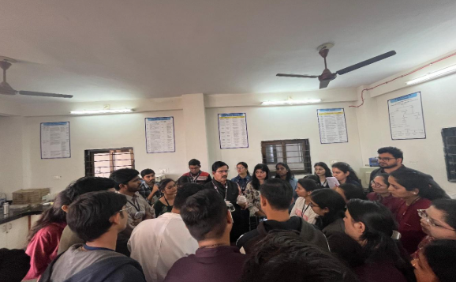

VIVECHANAM 2025 - A NATIONAL WORKSHOP & CONFERENCE ON INSTRUMENTATION & ANALYTICAL TECHNIQUES
VECHANAM 2025 is a National Workshop and Conference focusing on Instrumentation & Analytical Techniques. The event is organized by the Parul Institute of Ayurved and Research (PIAR), a constituent college of Parul University, in co-partnership with various prestigious institutions including the Parul Institute of Pharmacy, Amrita School of Ayurveda, SMBT Ayurved College & Hospital, and Gokul Ayurveda College.
Modern research and quality control laboratories utilize several high-precision techniques to analyze complex herbo-mineral formulations:
- Fingerprinting Technology: High-Performance Thin Layer Chromatography (HPTLC) and Gas Chromatography (GC) are used to create unique "fingerprints" for plants. This helps in identifying the specific species used and detecting any adulteration.
- Chromatographic Techniques: Advanced chromatography is essential for separating and quantifying the individual phytoconstituents within a polyherbal formulation.
- Instrumentation for Minerals: For Rasaushadhis (herbo-mineral drugs), techniques like Scanning Electron Microscopy (SEM) and X-ray Diffraction (XRD) are employed to study the particle size and crystalline structure of Bhasmas
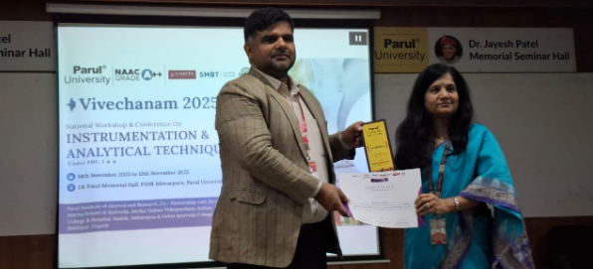 | 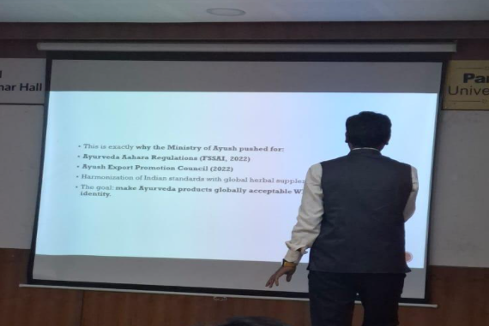

PATHYA DEMONSTRATION BY PG STUDENTS TO UG STUDENTS
The activity was conducted on 23/09/2025 under the Department of Swasthavritta as an integral component of practical training on Ahara Vidhi (dietary rules) and Pathya–Apathya (wholesome and unwholesome diet) concepts. The primary objective was to provide UG students with experiential learning on the preparation and therapeutic significance of classical Pathya Kalpanas that support Swasthasya Swasthya Rakshanam—the protection and promotion of health—as well as their utility in conditions such as Agnimandya, Jwara, Annavaha Srotodushti and other disorders arising from digestive and metabolic imbalance.
During the session, PG students demonstrated multiple traditional Pathya preparations, which included:
- Manda – the light supernatant liquid of cooked rice
- Peya / Yavagu – semi-liquid gruel
- Yusha – pulse-based therapeutic preparation
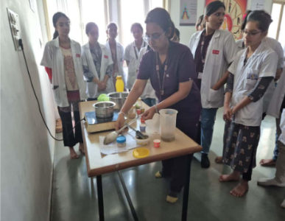 | 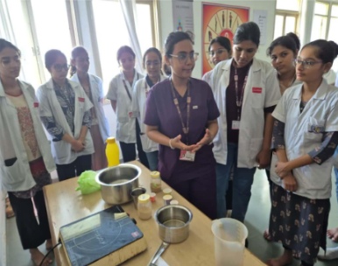

HEALTH AWARENESS TALK TO HOMEOPATHY STUDENTS
The program aimed to demonstrate the importance and practical applications of Ayurveda in maintaining health. A health talk on the “Role of Yoga, Dinacharya, and Ritucharya in Daily Life” on 23/09/2025 was organized under the Guidance of Dr. Archana mam for Homeopathy students to promote an understanding of holistic wellness practices. The session began with an introduction to the importance of Yoga, where the resource person explained how regular practice of Asanas, Pranayama, and Meditation helps improve flexibility, concentration, emotional balance, and stress management. This was followed by a detailed discussion on Dinacharya, highlighting essential lifestyle practices such as morning routines, oral hygiene, physical exercise, proper meal timings, and sleep hygiene, emphasizing their role in maintaining Agni, immunity, and overall health. The talk then covered Ritucharya, focusing on the need to adapt diet and lifestyle according to seasonal variations to prevent Dosha imbalance and seasonal disorders. Practical examples of seasonal diet, clothing, and behavioral guidelines were shared to help students integrate these principles into daily life. The session concluded with an interactive discussion, where students clarified doubts and received guidance on applying Yoga, Dinacharya, and Ritucharya principles both in personal routines and in future patient counselling.
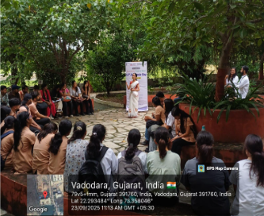 | 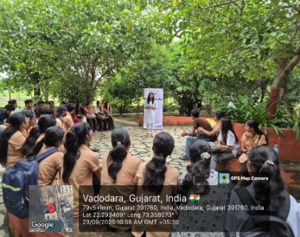

“WORKSHOP ON BASIC NEONATAL RESUSCITATION 2025”
1 day Workshop on Basic Neonatal Resuscitation 2025 in collaboration with Academy of Paediatrics, Vadodara on 23.02, 2025.The program commenced with Dhanwantarí Stuti by the PG student from PrasutiTantra and Stree Roga. The guest speaker was welcomed to the dais along with the Principal, PIAYR. Dr Sreevisakh T S, HOD, PIAYR, Dr Swapnil Raskar, HOD PIA, Dr. BG Kulkarni, Principal, PIAYR clucidated the relevance of the topic and session followed thereafter. The session was coordinated by Department of Kaumarabhritya faculties of PIAYR. This program was conducted for the PG students of Kaumarabhritya and Prasuti Tantra and Stree Roga. Total 30 PG students were attended and got benefitted in this workshop

