PARUL INSTITUTE OF AYURVED & RESEARCH SEMINAR/WEBINAR - 2024
WEBINAR ON NADI PAREEKSHA - BASIC INTRODUCTION
A UG webinar was organized by department of Kriya Sharir on Nadi Pareeksha – Basic Introduction on 21.02.2024. Ayurvedic concept of Nadi Pareeksha and their applied aspects and clinical utility with examples has been explained in detail during the session for the benefit of the participants. Contemporary correlation off the concepts and their daily utility along with clinical applicability was highlight of this session. Dr. Athira 1st year PG Scholar welcomed & introduced the guest. Faculties and students actively participated in the session and interactive session was very much informative to all. Technical support provided by Dr.Bhaskar 1st year PG Scholar, Around 183 participants got benefitted during this session from 1st year senior batch (2022-23), 1st year junior batch (2022-23) & 1st year PG Scholar of Kriya Sharir.

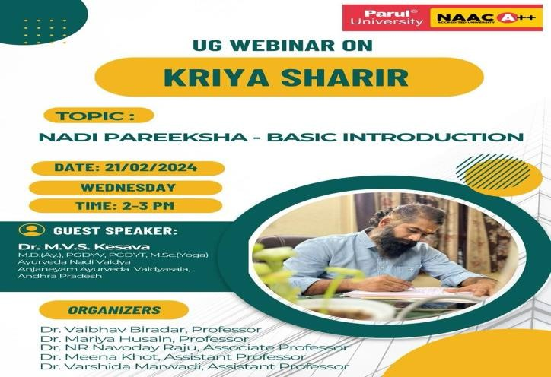 | 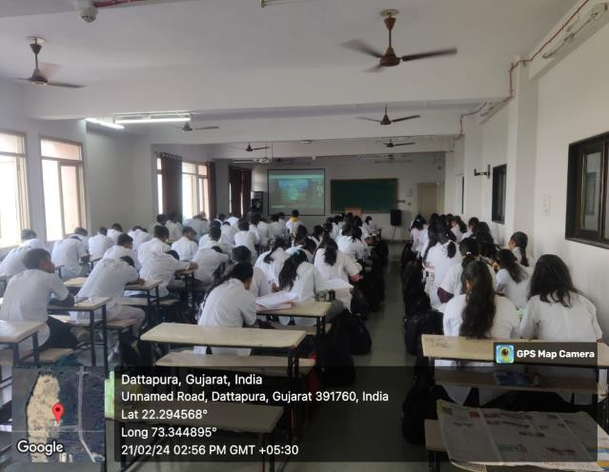

WEBINAR ON UTILITY OF TANTRAYUKTI IN UNDERSTANDING AND INTERPRETATION OF SAMHITA
A UG webinar was organized by department of Ayurveda Samhita & Siddhanta at Parul Institute of Ayurved and Research for all 1st year 2022-23 batch and 1st year 2023-24 Batch and 2nd year BAMS students. The session was conducted on 29.02.2024 on Google meet from 11:15 AM – 12.15 PM. The resource person for the lecture, Dr. Deepa LS. Expressed his views on the topic “Utility of Tantrayukti in Understanding and Interpretation of Samhita”. Madam has given very good insights about various Tantrayukties with referencing of various texts such as Charak Samhita, Ashtang Hridaya.

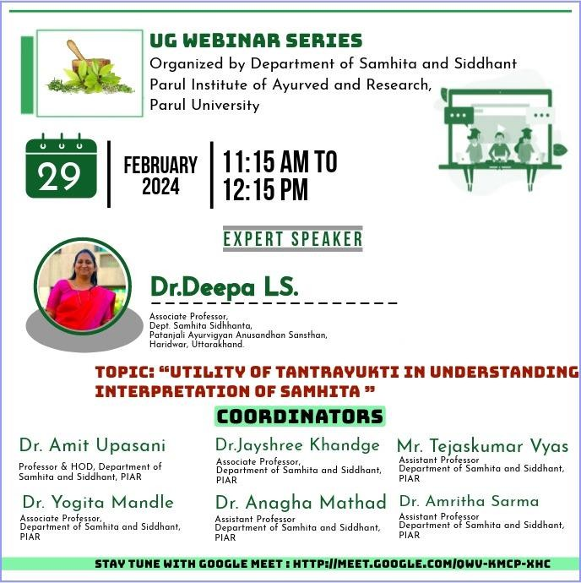 | 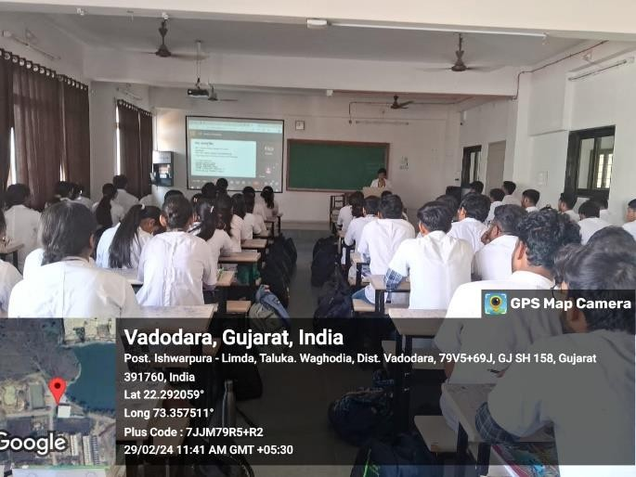

WEBINAR ON INTRODUCTION TO PAREEKSHA

Rognidan and Vikriti Vigyan Dept. arranged a Guest lecture under UG Webinar series on 13th October 2022. Second year students attended the webinar. Dr Helen G Monica, Assistant Professor, welcomed and Dr. Parvathy Sreekumar, Assistant Professor, coordinated the Session. Dr.Chaithanya P.R delivered a guest lecture on “Introduction to Pareeksha”. Dr. Hrishita Dahilekar Professor&HOD, expressed the vote of thanks. Department of Rognidana, is thankful to the Guest speaker Dr Chaithanya P.R for accepting the invitation & delivering the informative lecture

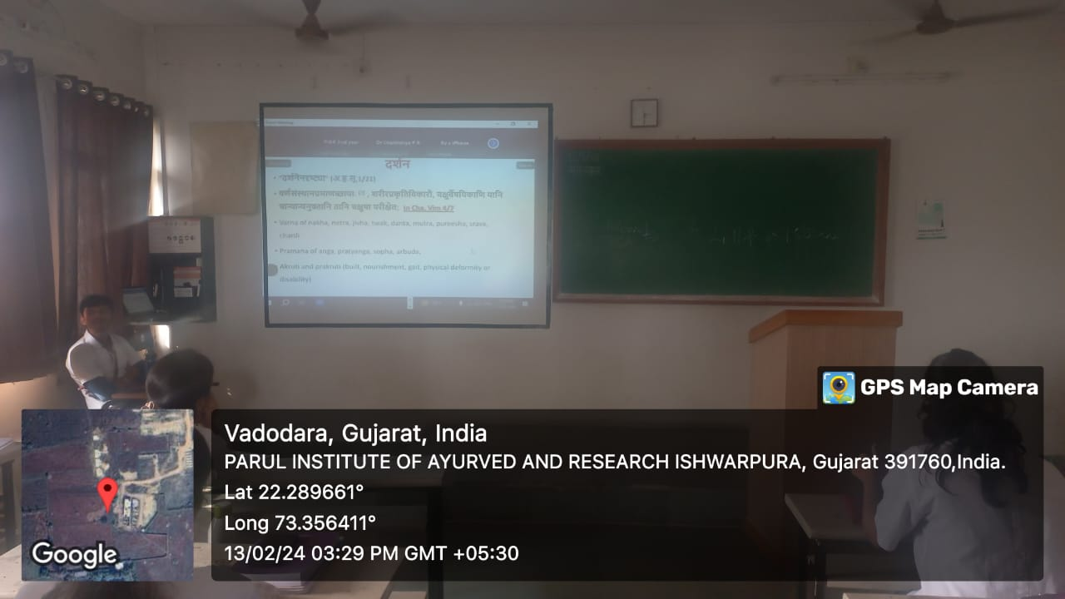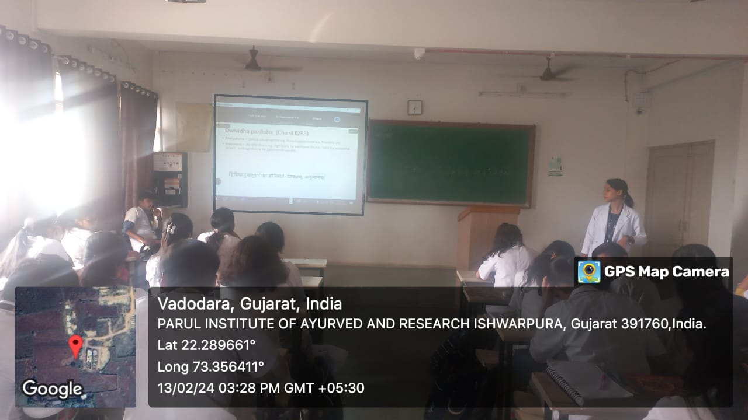

WEBINAR ON HETU VIVECHAN AND IT’S ROLE IN MANIFESTATION OF VYADHI
Rognidan and Vikriti Vigyan Dept. arranged a Guest lecture under UG Webinar series on 6th May 2024. Second year students attended the webinar. Dr Parvathy Sreekumar, Assistant Professor, welcomed and co-ordinated the Session. Dr Chintankumar G Malakiya, delivered a guest lecture on the topic "Hetu Vivechan and it’s role in manifestation of Vyadhi". Dr. Hrishita Dahilekar Professor&HOD, expressed the vote of thanks. Department of Rognidana, is thankful to the Guest speaker Dr Chintankumar G Malakiya, for accepting the invitation & delivering the informative lecture.
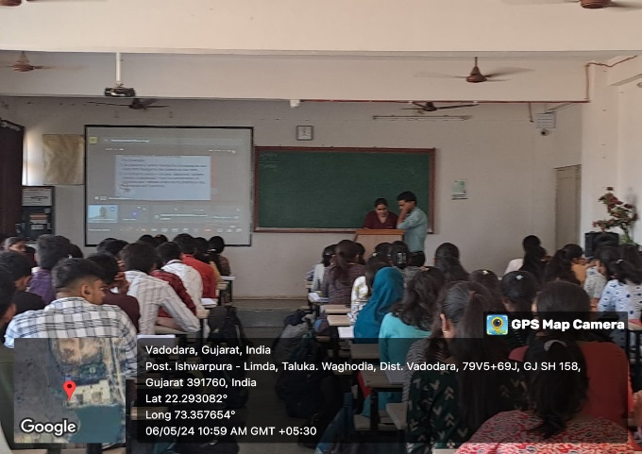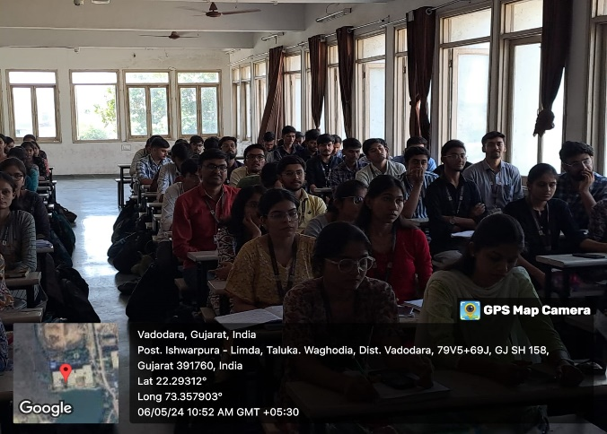
WEBINAR ON CRITICAL ANALYSIS OF NIDANA PANCHAKA OF JWARA
Rognidan and Vikriti Vigyan Dept. arranged a Guest lecture under UG Webinar series on 29th June 2024. Second year students attended the webinar. Dr Aastha Jain ,First year PG Scholar,welcomed and co-ordinated the session. Dr Mahesh Hirulal delivered a guest lecture on the topic “Critical Analysis of Nidana Panchaka of Jwara". Dr. Hrishita Dahilekar Professor& HOD, expressed the vote of thanks. Department of Rognidana, is thankful to the Guest speaker Dr Mahesh Hirulal for accepting the invitation & delivering the informative lecture

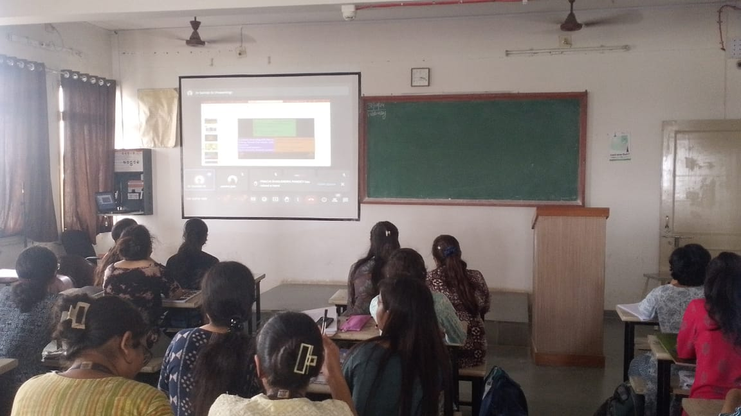
WEBINAR ON UNDERSTANDING OF KAMALA WITH CONTEMPORARY SCIENCE
Rognidan and Vikriti Vigyan Dept. arranged a Guest lecture under UG Webinar series on 31st July 2024. Second year students attended the webinar. Dr Helen G Monica, Assistant Professor, welcomed and co-ordinated the Session. Dr Sathish GI delivered a guest lecture on the topic " Understanding of Kamala with contemporary Science”.Dr. Hrishita Dahilekar Professor&HOD, expressed the vote of thanks. Department of Rognidana, is thankful to the Guest speaker Dr Sathish GI for accepting the invitation & delivering the informative lecture
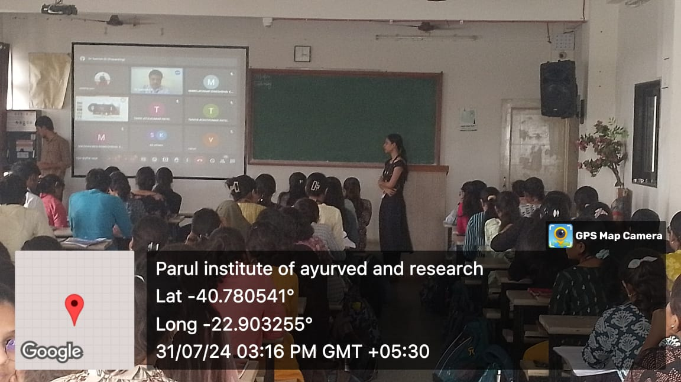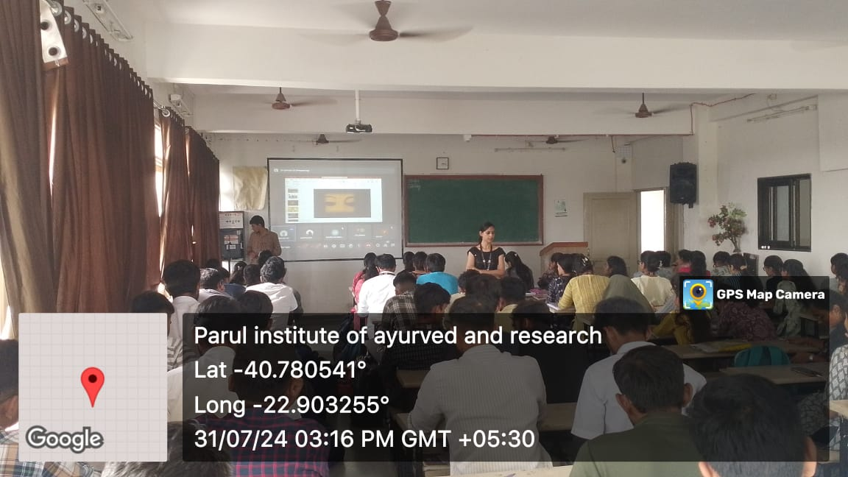

WEBINAR ON NIDANA PANCHAKA OF SHOTHA
Rognidan and Vikriti Vigyan Department arranged a Guest lecture under UG Webinar series on 29th August 2024. Second year students attended the webinar. Dr Helen G Monica, Assistant Professor, welcomed and co-ordinated the Session. Dr Radhika Rani delivered a guest lecture on the topic "Nidana Panchaka of Shotha”.Dr. Hrishita Dahilekar Professor &HOD, expressed the vote of thanks. Department of Rognidana, is thankful to the Guest speaker Dr Radhika Rani for accepting the invitation & delivering the informative lecture

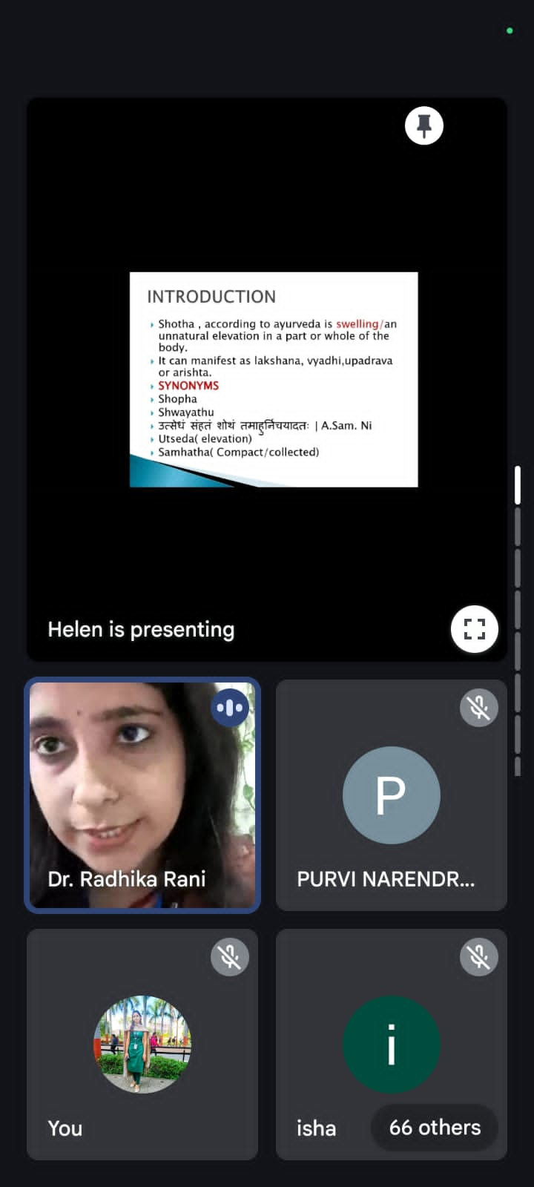
WEBINAR ON NIDANA PANCHAKA OF RAJAYAKSHMA
Rognidan and Vikriti Vigyan Dept. arranged a Guest lecture under UG Webinar series on 1st October 2024. Second year students attended the webinar. Dr Helen G Monica, Assistant Professor, welcomed and co-ordinated the Session. Dr Rijin Mohan delivered a guest lecture on the topic " Nidana Panchaka of Rajayakshma” Dr. Hrishita Dahilekar Professor&HOD, expressed the vote of thanks. Department of Rognidana, is thankful to the Guest speaker Dr Rijin Mohan for accepting the invitation & delivering the informative lecture
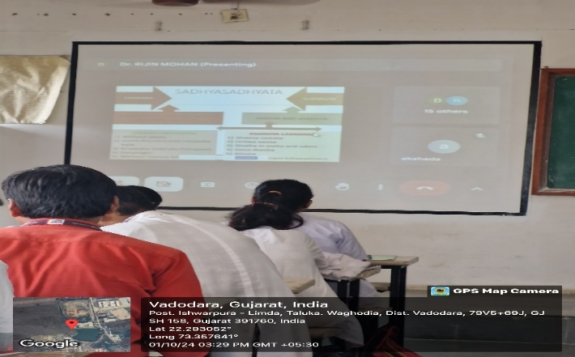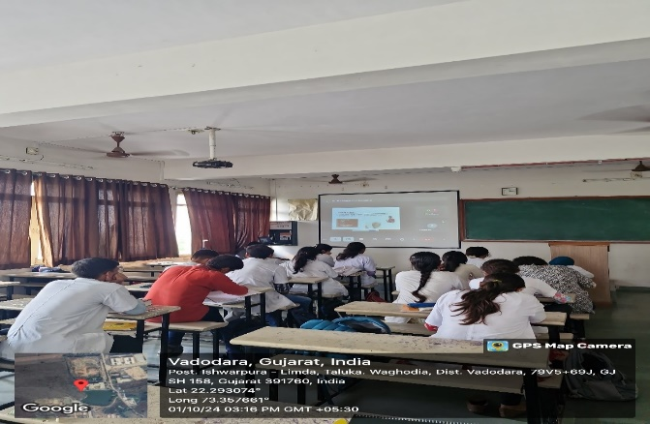
WEBINAR ON DISCUSSION ON ACTIVITY BOOK
Rognidan and Vikriti Vigyan Dept. arranged a Guest lecture under UG Webinar series on 13th January 2023. Second year students attended the webinar. Dr Parvathy Sreekumar, Assistant Professor, welcomed the guest speaker, Dr Nithin R Krishnan delivered a guest lecture on “Discussion on activity book”. Dr. Hrishita Dahilekar Professor&HOD, expressed the vote of thanks.Department of Rognidana, is thankful to the Guest speaker Dr Nithin R Krishnan for accepting the invitation & delivering the informative lecture. All the students got benefitted from this discussion regarding the activity book.
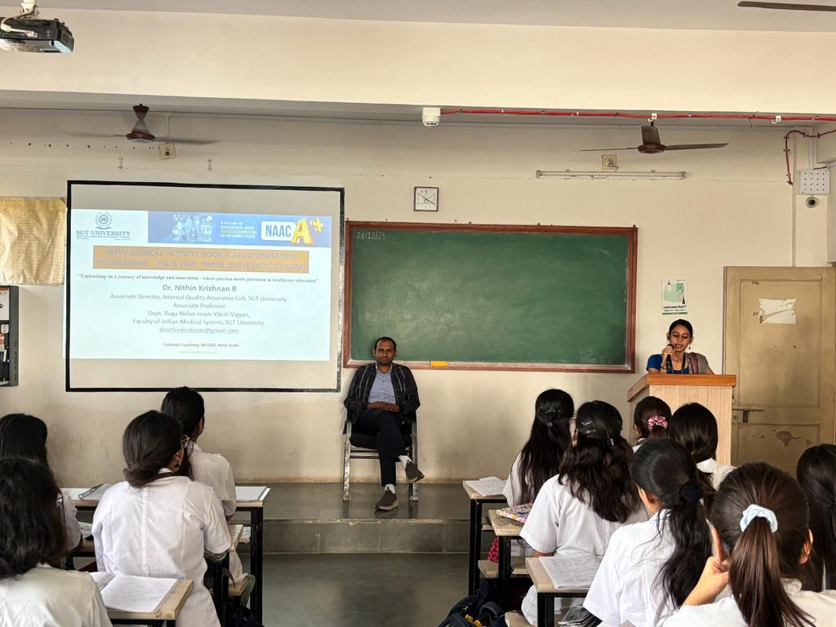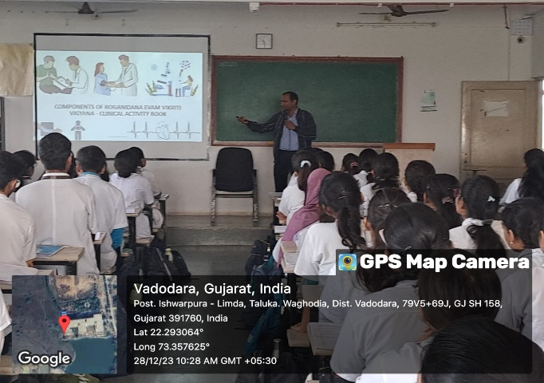
WEBINAR ON HYPOTHYROIDISM-AYURVEDIC PERSPECTIVE
UG WEBINAR was conducted as a part of UG webinar series-2022-23, on the topic “Hypothyroidism-Ayurvedic perspective”, by Dept. of Kayachikitsa, Parul Institute of Ayurved and Research, Vadodara, Gujarat, for the students of Final year BAMS, Parul Institute of Ayurved and Research in online platform, on 10.07.2024 from 10am to 11am. The resource person was Dr Meghana K A MD (Ayu), Assistant Professor, Department of Kayachikitsa, SDM College, Hassan Karnataka.
The program was started on 10am, Dr. Prachi Vishwakarma, Asst. Prof., Dept of Kayachikitsa, PIAR was the moderator. Welcome speech and Introduction of the guest was given by Dr. Prachi Vishwakarma, Assistant Professor, Dept. of Kayachikitsa.
The objectives of the Program were:
- To make the students aware about the etio-pathology of Hypothyroidism.
- To enlighten them diagnosis of Hypothyroidism and its differential diagnosis.
- To know the Ayurvedic perspective of Hypothyroidism.
- To know line of treatment and different drugs used in the management of Hypothyroidism
The speaker has beautifully explained the basic mechanism involved in the development of Hypothyroidism and its various etiologies. The principles of management of Hypothyroidism according to the etiology and differential diagnosis of Hypothyroidism was also explained in the session. Differential selection of medicines considering various pathology and side effects of the drugs, dosage etc, were also detailed by the speaker. Students has shared their various queries regarding seizure management. At the end of the session, Dr. Prachi has delivered vote of thanks on behalf of Dept. of Kayachikitsa

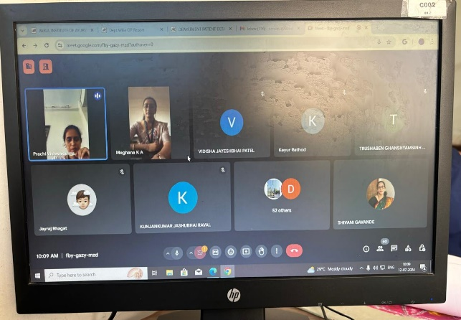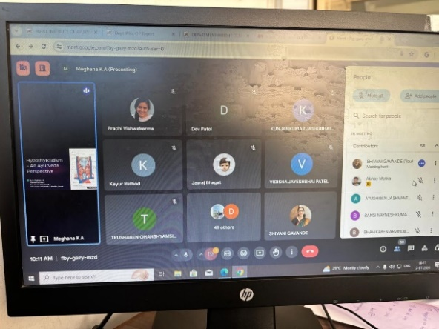
WEBINAR ON BASIC CONCEPT OF RASA PANCHAK
The Department of Dravyaguna, Parul Institute of Ayurveda and Research, conducted a webinar featuring Dr. Sonia Dhiman (Professor & HOD, Dravyaguna Department, CDL College of Ayurveda, Jagadhari) on 13th December from 2:00 to 3:00 PM. The program was anchored by Dr. Kruti Patel. Dr. Sonia Dhiman delivered an expert talk on the basic concept of Rasa Panchak. A total of 80 students attended the session. The vote of thanks was expressed by Dr. Kruti Patel.
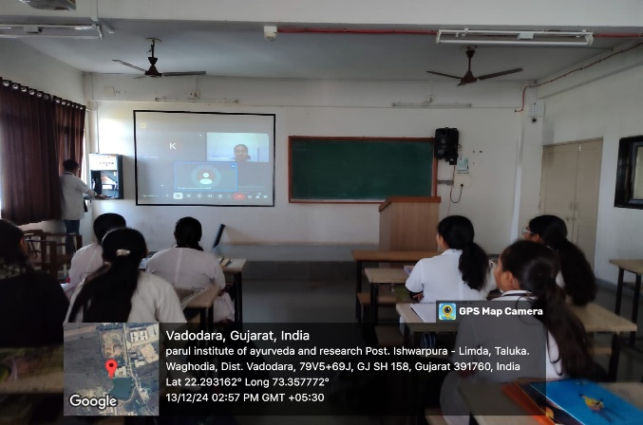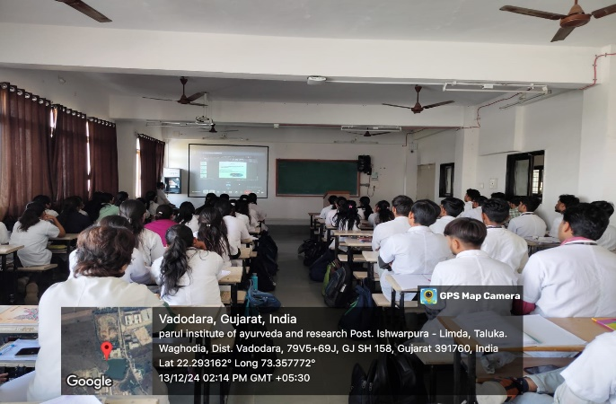

WEBINAR ON CONCEPT OF BALGRAHA IN TODAY’S PERSPECTIVE
Webinar series was conducted on 9th JULY 2024. It was organized by the Department of Kaumarbhritya PIAR. Program was moderated by Dr Nikita Vasava, Assistant professor, KB dept. Timing was 3 pm – 4pm. Topic for the webinar –“Concept Of Balgraha In Today’s Perspective”. Our resource person Dr.Harish Kumar Singhal talked about Balagraha types, diagnosis, investigations, management through Ayurveda, panchakarma procedures etc. Dr.Harish Kumar Singhal given valuable notes from his clinical experience regarding management of Balagraha in today’s concept. All students were benefitted from this webinar. Following the guest lecture the students got more confidence in managing Balagraha through Ayurveda.

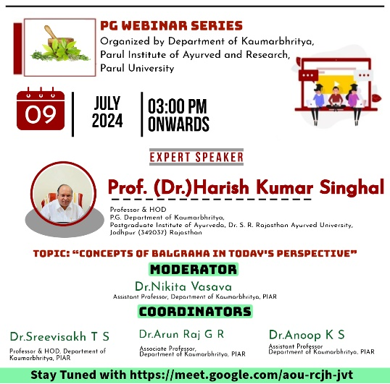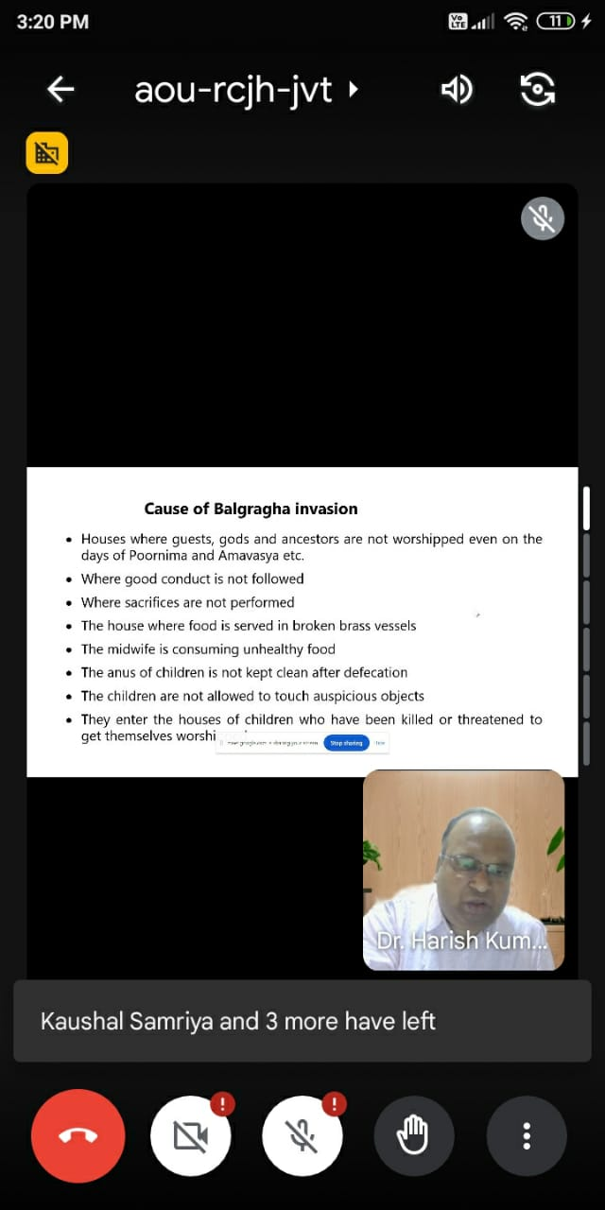

WEBINAR ON AYURVEDIC MANAGEMENT OF CEREBRAL PALSY
Webinar series was conducted on 1st OCT 2024. It was organized by the Department of Kaumarbhritya PIAR. Program was moderated by Dr Anoop.K.Sasikumar, Assistant professor, KB dept. Timing was 3 pm – 4pm. Topic for the webinar –“ Ayurvedic Management of Cerebral Palsy”. Our resource person Dr Ragamala K C talked about Cerbral palsy types, diagnosis, investigations, management through Ayurveda, panchakarma procedures etc.
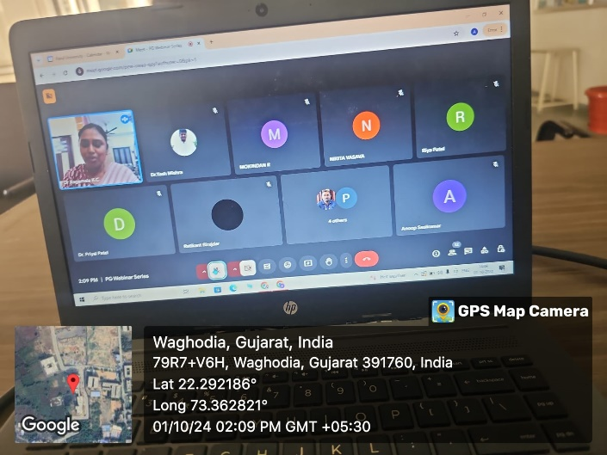
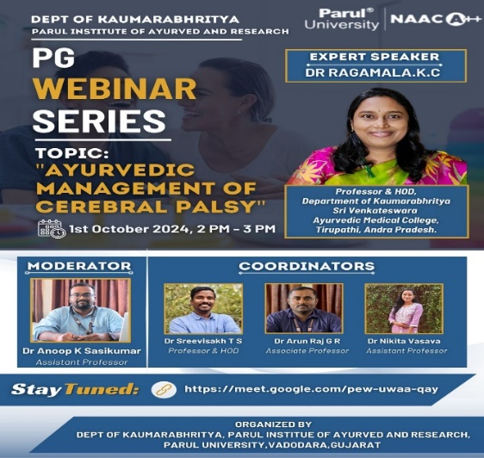
WEBINAR ON INTRODUCTION TO MEDICAL ASTROLOGY
The webinar was conducted for the final year students of Parul Institute of Ayurved and Research on 1st May 2024 at 11.15 am to 01.00pm. The welcoming of the guest speaker was done by Dr Dinesh Patil, Professor, Depart of Panchakarma, PIAYR. After that the session was headed by Dr Atul sir. He beautifully explained about the stana of each planets and what to expect when it does move to another stana which is not of its own. While correlating with Ayurveda, he explained about the diseases which can manifest acc to the different planets. It was a very well informative session. At the end of the session vote of thanks was expressed by Dr Siba Prasad and the session was concluded.
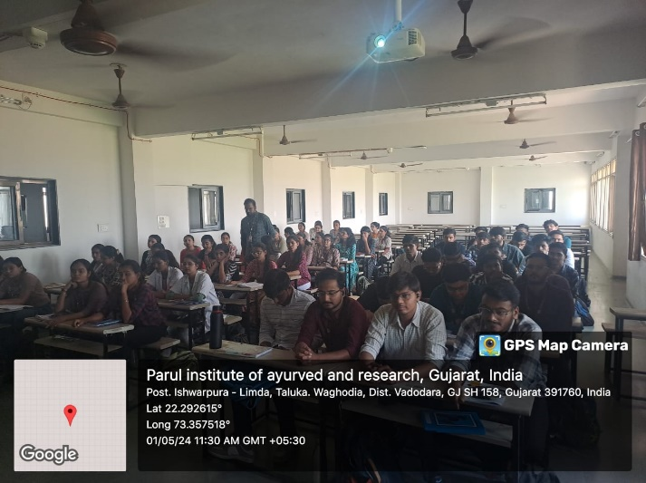
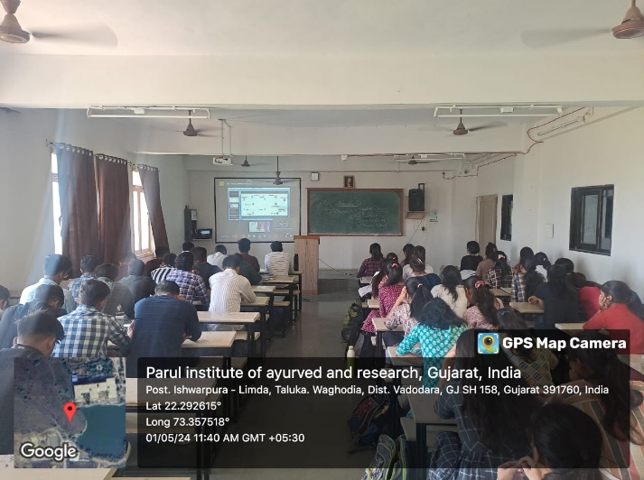

WEBINAR ON CLINICAL IMPORTANCE OF RAJASWALA CHARYA
An online Guest lecture on "Clinical importance of Rajaswala Charya" was organized by the Dept Of Prasuti tantra & Streeroga, of Parul Institute of Ayurved and Research for the students of Fourth year BAMS and PG scholars of Dept of Prasauti tantra Evum Stree Roga on 22-7-2023 in the fourth-year classroom from 10 am onwards
P.G scholars, UG students, academicians and practitioners interested in the topic, including students and teachers joined the link of Google Meet https://meet.google.com/zxe-bvxb-fzs by 10 am on their respective devices. The webinar was also projected on the screen in the classroom PIAYR.
Dr. Manjusha Karkare, Professor of the Department of Prasuti Tantra & Streeroga welcomed the speaker and delivered an introductory speech about the guest speaker Dr Hetal Dave After the welcome address, the speaker delivered her lecture about the importance of Rajaswala Paricharya She shared her experiences of case studies wherein, menstrual problems had been relieved by following the Rajaswala Charya. She shared valuable insights that emphasized the importance of the regime.
The objectives of the program were:
- To emphasize the importance of the Rajaswala Charya amongst the students.
- To share clinical cases involving Rajaswala Charya as a treatment modality amongst students.
Dr. Hetal Dave provided valuable insights about the Ayurvedic management of various menstrual problems that she had treated.

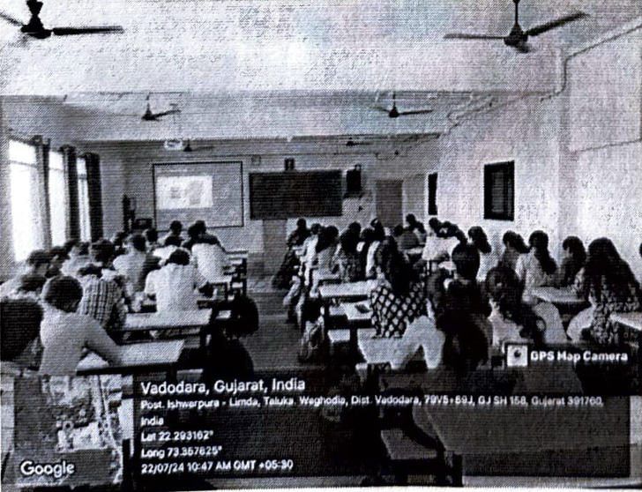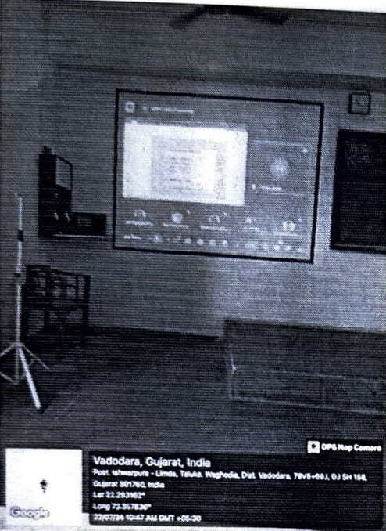

WEBINAR ON INFERTILITY-FROM CLASSICS TO CLINICS
An online Guest lecture on "Infertility-from classics to clinics" was organized by the Dept. Of Prasuti tantra & Streeroga, Parul Institute of Ayurved and Research for the PG students of Department of PTSR and students of Fourth year BAMS of Parul Institute of Ayurved and Research on 18-6-2024 from 10 am to 11 am.
Short CV: The resource person was Dr. Anuradha Roy-Associate Professor, Department of Prasuti Tantra, Faculty of Ayurveda, IMS, BHU, Varanasi-221005, UP.
Details about The Activity: The host, Dr. Manjusha R. Karkare logged into the Google Meet via the link generated earlier at 9,30 am. Participants from across the country and students of the fourth year also logged in at the designated time. The program was started by welcoming the expert speaker and the participants. Dr. Anuradha elaborated on the topic with insightful details and practical takeaways. Her description of various research going on across the globe and at BHU was very inspiring After the question-answer session, a vote of thanks was delivered by Dr. Manjusha Karkare.
The google link for the webinar was: https://mect.google.com/etg-miok-rmh
The objectives of the programme were:
- To bring the knowledge about infertility in the students.
- To develop basic knowledge of identification of causes of infertility in students.
- To develop the basic diagnostic and treatment knowledge of infertility in students
- To impart knowledge and skill in the management of female infertility in students.
- To introduce the students to research concepts related to infertility
Dr Anuradha Roy delivered an informative session on infertility, its major causes, diagnostic and treatment modalities in brief.
Outcome/Feedback
Participants of the webinar gained valuable knowledge about infertility and all its aspects, namely causes, investigations, treatment and research aspects.
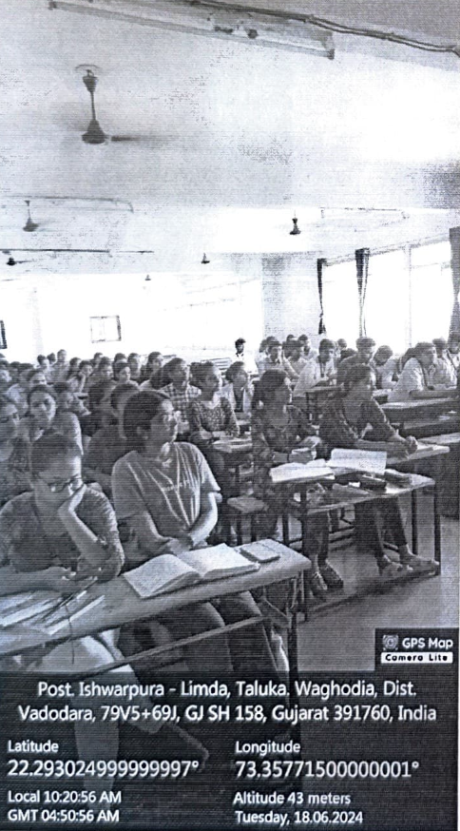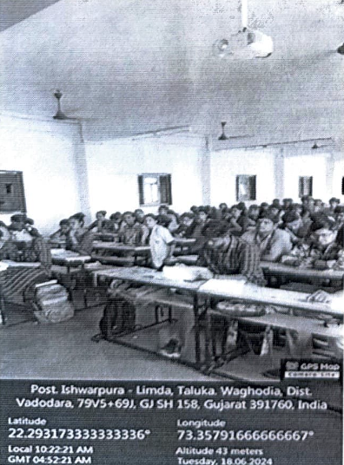

WEBINAR ON UTILITY OF TANTRAYUKTI IN UNDERSTANDING AND INTERPRETATION OF SAMHITA
UG webinar was organized by department of Ayurveda Samhita & Siddhanta at Parul Institute of Ayurved and Research for all 1st year 2022-23 batch and 1st year 2023-24 Batch and 2nd year BAMS students. The session was conducted on 29.02.2024 on Google meet from 11:15 AM – 12.15:00 PM. The resource person for the lecture, Dr. Deepa LS. Expressed his views on the topic “Utility of Tantrayukti in Understanding and Interpretation of Samhita”. Madam has given very good insights about various Tantrayukties with referencing of various texts such as Charak Samhita, Ashtang Hridaya. The session was coordinated by all the faculties of Department of Ayurveda Samhita & Siddhanta; Dr. Amit Upasani, Dr. Yogita , Dr. Jayashree, Dr. Anagha M, Mr. Tejaskumar Vyas, Dr. Amrita Sarma, Dr. Siddharth Roy.
Outcome/Feedback
The overall guest lecture was well appreciated by the students
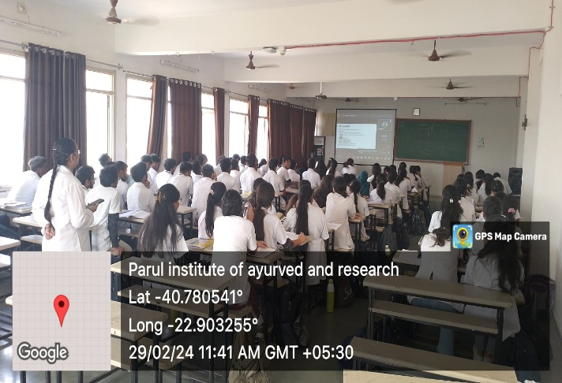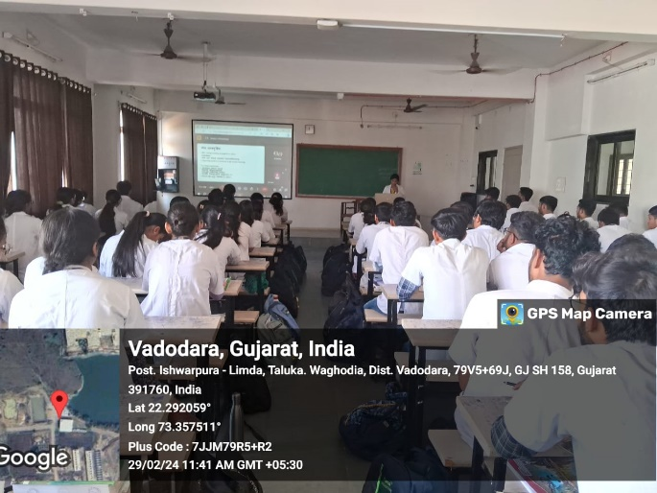

WEBINAR ON NADI VIGYAN A SCIENTIFIC APPROCH TOWARDS CLINICAL SKILL
UG webinar was organized by department of Ayurveda Samhita & Siddhanta at Parul Institute of Ayurved and Research for all 1st year BAMS students. The session was conducted on 20.09.2024on Google meet from 11:00 AM – 12:00 Noon. The resource person for the lecture, Dr Madhav Patade expressed his views on the topic Nadi Vigyan a Scientific Approach towards Clinical Skill. The session was coordinated by all the faculties of Department of Ayurveda Samhita & Siddhanta; Dr. Amit Upasani, Dr. Yogita , Dr. Jayashree, Dr. Anagha M, Mr. Tejaskumar Vyas, Dr. Amrihta Sarma
Outcome/Feedback
The overall guest lecture was well appreciated by the students
