PARUL INSTITUTE OF AYURVED & RESEARCH
SEMINAR/WEBINAR - 2025

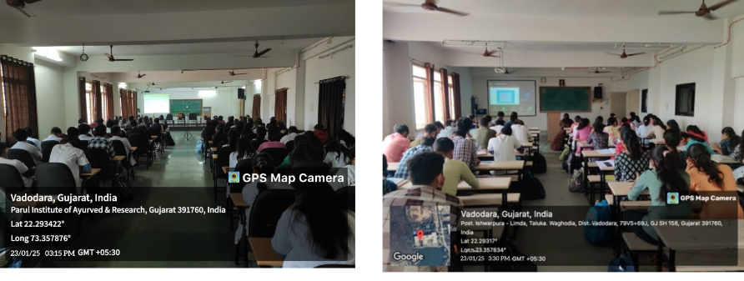
EVALUATION OF CERVICAL CARCINOMA
Webinar on “EVALUATION OF CERVICAL CARCINOMA” was organized by the Dept. Of Prasuti tantra &Streeroga, Parul Institute of Ayurved and Research for the students of FIRST YEAR PG SCHOLARS,Parul Institute of Ayurved and Research in Seminar Hall, on 23.01.2025 from 3 pm to 4 pm. The Webinar started withwelcome address done by Dr Abha L. Ravi, Professor and HOD, Department of Prasuti tantra &amp; Streeroga,PIAR(Ayurved). Session started at 03.05 pm. “Evaluation of cervical carcinoma” was dealt in detail.Question and answer session was allotted. Session was concluded by Vote of thanks.

THE PRACTICAL UTILITY OF BASTI KARMA

As a part of the Webinar Series, the department of Panchakarma, PIAYR organized a webinar for the final year students. The webinar was conducted on 29/01/2025 from 11.00am to 12.00pm. A total of 92 students attended the webinar. The Guest Speaker for the webinar was Dr Aiswarya IV, Assistant Professor, Department of Panchakarma, Amrita School of Ayurveda, Amrita Vishwa Vidyapeetham, Kollam, Kerala. During the webinar, the speaker focused on the practical utility of Basti Karma, the dos and don’ts, precautions to be taken during the administration of Basti and so on. It was a very informative session and the students got benefited from the webinar as they are getting ready to attend their 2nd Internal Exams and Basti being a topic for the exam.The session was coordinated by Dr Nisha Rathva, Assistant Professor, Dept of Panchakarma and Dr Abhilesh VS, Assistant Professor, Dept of Panchakarma, PIAYR and the vote of thanks was delivered by Dr Dinesh Patil, Professor & HOD, Dept of Panchakarma, PIAYR.
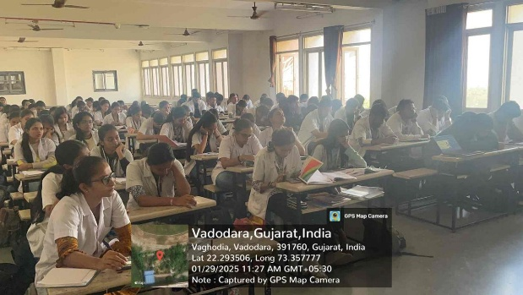 | 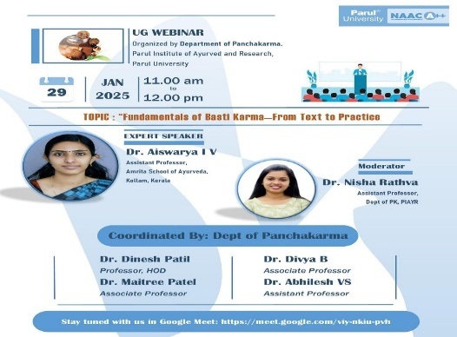

THE PATHOPHYSIOLOGY, EPIDEMIOLOGY, AND VARIOUS TYPES OF OBESITY
A comprehensive presentation was delivered covering the pathophysiology, epidemiology, and various types of obesity, providing students with an in-depth understanding of the condition from both modern and Ayurvedic perspectives. The session highlighted the alarming rise in obesity prevalence globally and discussed contributing factors such as sedentary lifestyles, poor dietary habits, and genetic predisposition. This was followed by an engaging discussion on integrated management approaches,
including modern strategies like calorie restriction and physical activity, as well as Ayurvedic interventions involving Ahara (dietary modifications), Vihara (daily routine), Yoga practices, and Panchakarma therapies for detoxification and metabolic correction. To encourage practical application, students participated in a case-based activity where they created basic lifestyle intervention plans tailored to hypothetical patient scenarios. The session was enriched with visual aids, including informative charts, before-and-after visuals from actual cases, and the WHO classification of obesity, helping students visualize the impact of interventions and understand the clinical grading of the condition effectively.
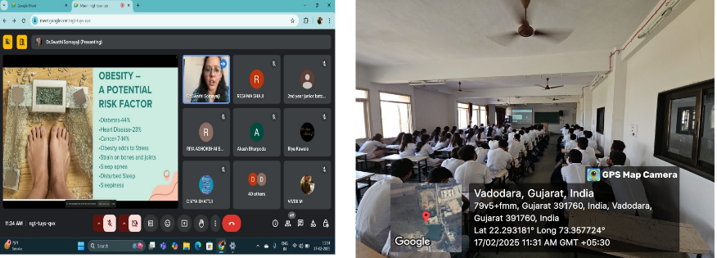
"Types of Immunity
Rognidan and Vikriti Vigyan Dept. arranged a Guest lecture under UG Webinar series on 7th January 2025. Second year students attended the webinar. Dr Parvathy Sreekumar, Assistant Professor, welcomed the guest speaker and coordinated the Session. Dr Aishwarya delivered a guest lecture "Types of Immunity". Dr. Hrishita Dahilekar Professor & HOD, expressed the vote of thanks. Department of Rognidana, is thankful to the Guest speaker Dr Aishwarya for accepting the invitation & delivering the informative lecture.
SEMINAR ON ALPHA MIND
The Department of Kriya sharir successfully organized a seminar on the 12 JUNE, 2025, from 03:00 PM to 04:00 PM, focusing on the transformatic topic “ALPHA MIND.” The session was conducted by Maharshi Gaj Arvind, an expert in spiritual awareness and scientific wisdom. The seminar was aimed at 1st Year BAMS students and pg scholars.
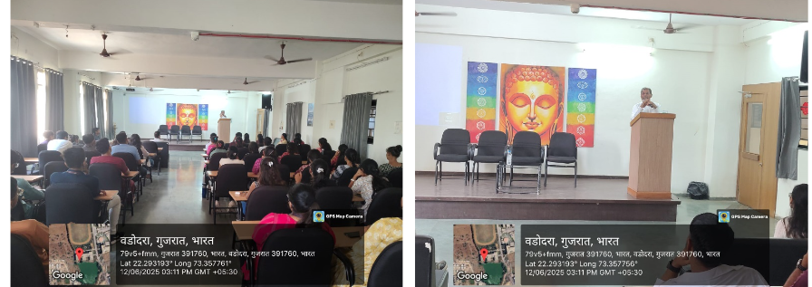

"Nidana Panchaka of Rajayakshma
Rognidan and Vikriti Vigyan Dept. arranged a Guest lecture under UG Webinar series on 11th June 2025, Second year students attended the webinar. Dr Helen G Monica, Assistant Professor, welcomed the guest speaker and coordinated the Session. Dr Divya K delivered a guest lecture on "Nidana Panchaka of Rajayakshma". Dr. Hrishita Dahilekar Professor & HOD, expressed the vote of thanks.Department of Rognidana, is thankful to the Guest speaker Dr Divya K for accepting the invitation & delivering the informative lecture

"Ashta Sthana Pariksha - An Overview".
Rognidan and Vikriti Vigyan Dept. arranged a Guest lecture under UG Webinar series on 29th July 2025. Second year students attended the webinar. Dr Helen G Monica, Assistant Professor, welcomed the guest speaker and coordinated the Session. Dr Vishnu C.P delivered a guest lecture on "Ashta Sthana Pariksha - An Overview". Dr. Hrishita Dahilekar Professor & HOD, expressed the vote of thanks

SROTAS-CONTEMPORARY VIEW
Rognidan and Vikriti Vigyan Dept. arranged a Guest lecture under PG Webinar series on 12th August 2025. All PG students attended the webinar. Dr Helen G Monica, Assistant Professor, welcomed the guest speaker and coordinated the Session. Dr Prashanth Jain delivered a guest lecture on Srotas-contemporary view. Dr. Hrishita Dahilekar Professor & HOD, expressed the vote of thanks. Department of Rognidana, is thankful to the Guest speaker Dr Prashanth Jain for accepting the invitation & delivering the informative lecture
National Seminar "SUSANDNYA 3.0"
The two-day National Seminar "SUSANDNYA 3.0" was organized by the Department of Shalakya Tantra, Parul Institute Of Ayurveda, on 22nd and 23rd September 2025. The event was conducted in association with KLE University, D. Y. Patil University, and MUHS Nashik. The seminar aimed to bridge traditional Ayurvedic wisdom and modern ENT science, emphasizing the theme of Deafness Awareness and Prevention. The program commenced with Dhanwantari Stuti rendered by postgraduate scholars, followed by the welcome address by Dr. Manjiri Keskar. The Chief Guest, Dr. Narayanan Namboothiri, CEO & Chief Physician, Sreedhareeyam Ayurvedic Eye Hospital & Research Centre, Kerala, inaugurated the seminar and addressed the gathering. The Guest of Honour, Prof. Dr. Milind Nikumbh, Pro-Vice Chancellor, MUHS Nashik, shared his valuable insights. Presidential remarks weredelivered by Dr. Komal Patel, Vice-President, Parul University & Dr. Hemant Toshikhane, Dean, Faculty of Ayurveda, Parul University. The session concluded with the Vote of Thanks by Dr. Bhagavan.G. Kulkarni
SCIENTIFIC SESSION DAY-1 AFTERNOON
The first scientific session was chaired by Dr. B. G. Kulkarni Presentations included:
1. Dr. R. B. Bhesaniya - "Deafness Awareness - The Need of the Hour"
2 . Dr. Kayedjohar K . Rathwala - "Deafness Awareness". |
3. Dr. Dr. Narayanan Namboothiri - "success stories in eye care through Ayurveda".
SCIENTIFIC SESSION DAY - 2 (ONLINE)
The second day featured an online national-level scientific deliberation chaired by Dr. Manjusha Rajagopala.
Speakers included:
1. Dr. Savita Angadi - "Allergic Rhinitis - A n Ayurvedic Perspective"
2. Dr. Sangeeta Salvi - "An Integrative Approach t o Deafness"
3 . Dr. Kavita Thorat - "National Programme for Control of Preventable Deafness - A n Introduction".

PAPER PRESENTATION SESSIONThe seminar witnessed enthusiastic participation from across the nation.
* Total Registrations: 198 + All 3rd Professional BAMS Students.
* Offline Presentations (Inside University): 30
* Online Presentations (Outside University): 46
* Total Presentations: 76
Themes covered included:
- Preventive healthcare through Ayurveda
- Clinical efficacy of Ayurvedic formulations
- Role of Ayurveda in hearing loss
- Comparative approaches in SNHL management
- Rasayana Chikitsa and rejuvenation therapies
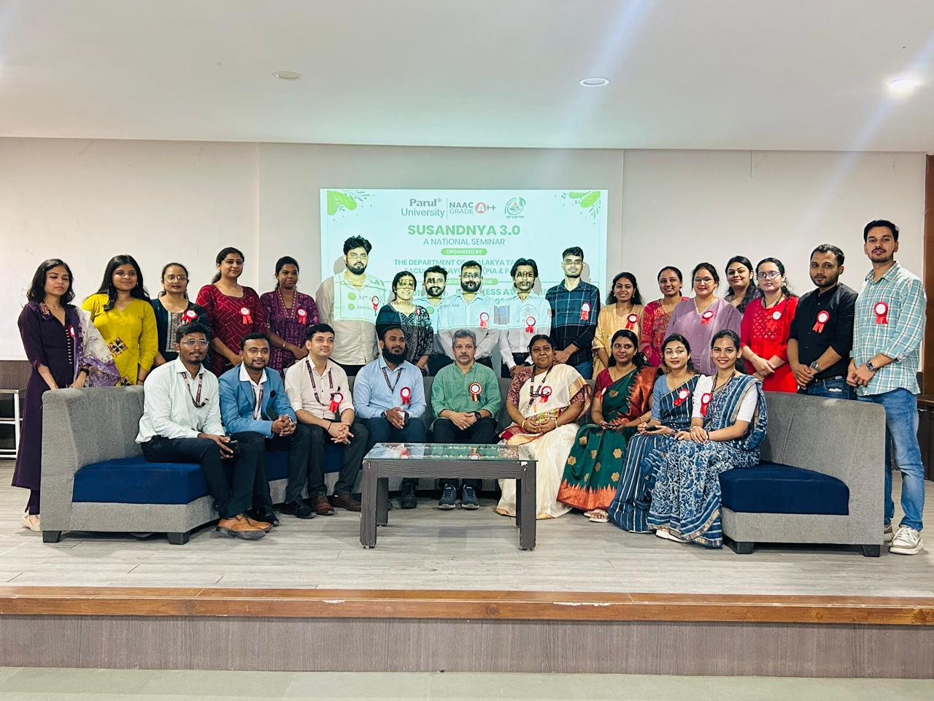 | 