National Seminar on New Dosage form Mahoushadhi 2019

National seminar on New Dosage form Mahoushadhi 2019 was organised by Dept. Of RSBK, Parul Institute of Ayurved & Research on 6th July 2019. Seminar was inaugurated by Dr. Kamlesh Kumar Sharma, EC member CCIM. Dr. Falgun Patel Deputy director training in AYUSH, CCRAS, Provost Dr. M.N. Patel, Registrar, Dr. Vijaykumar, Managing trusty Dr. Komal Patel and Principals of both Ayurved colleges. The scientific sessions were deliberated by Dr. Lakshmikant Dwivedi, Retd. Prof. NIA, Jaipur, Dr. Anand Chowdhary, HOD Pg & Ph.D. studies BHU, Dr. Milind Hukkeri, Professor from koppa. Total 360 delegates were participated.
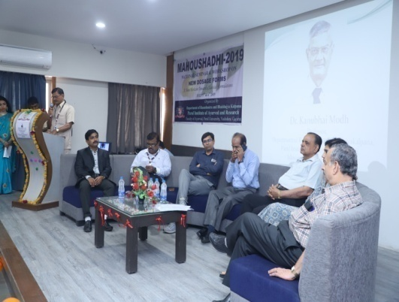 | 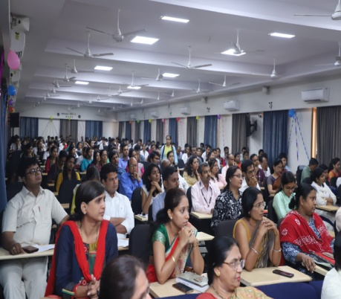 | 