Webinar on Pharmaco-Therapeutics in Ayurveda- A Contemporary Approach

A webinar on Pharmaco-Therapeutics in Ayurveda- A Contemporary Approach was organised by Dept. of Dravyaguna, Parul Institute of Ayurved & Research on 15th October, 2020. Webinar started at 10:00 AM with the introduction and welcome of all guest speakers. Dr.Prasanth.R.Krishnan, Asso. Prof. Department Of Dravyagunar, Coordinated The Session. Prof. Dr. Suwarnameshram, Head, Department Of Dravyaguna, Piar,&Drbhavindhanavade, Asst. Prof. Department Of Dravyaguna, Piar Actively Involved In The Arrangements Of Webinar. The Webinar Enlightened The Students And Was Well Appreciated By Teachers & Students. Department Of Dravyaguna, Piar Is Thankful To The Guest Speaker Dr.Sheelakaralam.B For Accepting The Invitation & Delivering The Webinar. Dept Ofdravyaguna Expresses Its Heartfelt Gratitude Towards The President, Managing Trustees Of Parul University & Dr. Hemanttoshikhane Sir, Dean, Faculty Of Ayurved, Parul University, Dr. B.G. Kulkarni Sir, Principal, Piar, Vadodara, Gujarat For Support & Motivation. Department Of Dravyaguna Also Thanks The Technical Support Team Of Parul University.

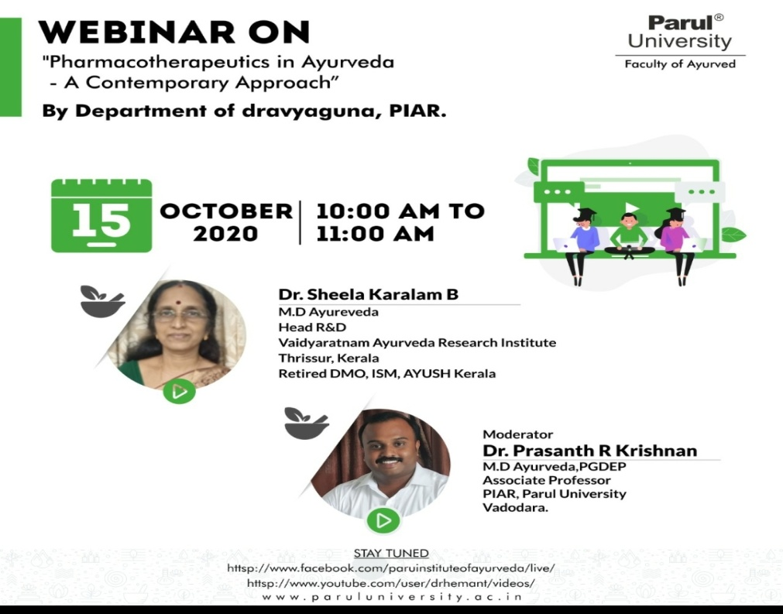 | 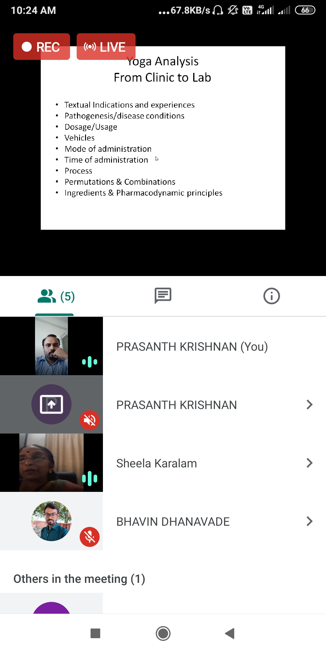

Webinar on Rognidan - Clinical aspect of Nidan Panchak
A webinar on Rognidan - Clinical aspect of Nidan Panchak was organised by Dept. of Rognidan, Parul Institute of Ayurved & Research on 10th October, 2020. Webinar started at 10:00 AM with the introduction and welcome of all guest speakers. Dr. Hrishita Dahilekar, Department of Roga Nidana, PIAR, coordinated the session. Dr Swastika Sharma, Asst Prof. Department of Roga Nidana, PIAR actively involved in the arrangements of webinar. The webinar enlightened the students and was well appreciated by teachers & students. Department of Rognidana, PIAR is thankful to the Guest speaker Dr. Jai Kiran Kini for accepting the invitation & delivering the webinar. Dept of Roga Nidana expresses its heartfelt gratitude towards the President, Managing Trustees of Parul University & Dr. Hemant Toshikhane sir, Dean, Faculty of Ayurved, Parul University, Dr. B. G. Kulkarni sir, Principal, PIAR, Vadodara, Gujarat for support & motivation. Department of Roga Nidana also thanks the technical support team of Parul University.
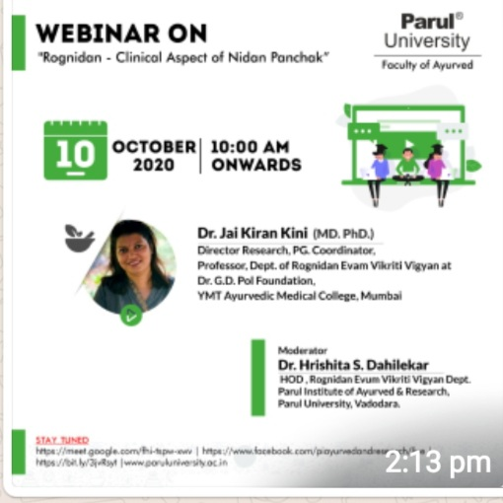 | 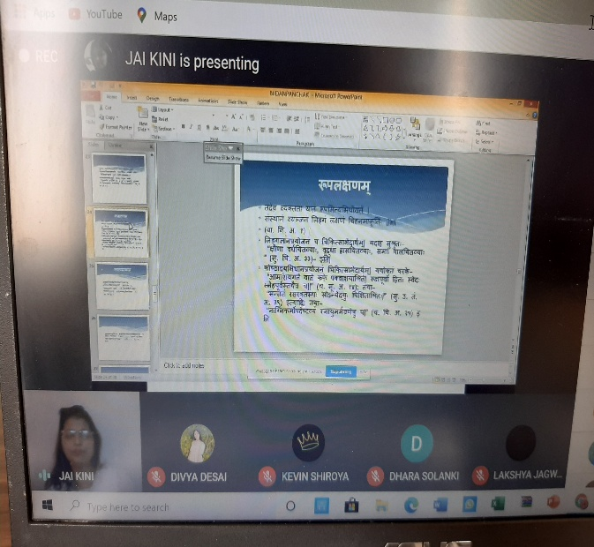

Webinar on Avarana in Clinical Practice

A webinar on Avarana in Clinical practice was organised by Dept. of Ayurveda Samhita & Siddhanta, Parul Institute of Ayurved & Research on 19th September, 2020. Webinar started at 11:10 AM with the introduction and welcome of all guest speakers. Dr. Manisha Dunghav, coordinated the session. Dr Manisha Dunghav, Dr. Arun Vaidya, Dr. Manjula K and Mr. Tejas Vyas actively involved in the arrangements of webinar. The webinar enlightened the students and it was well appreciated by teachers & students.

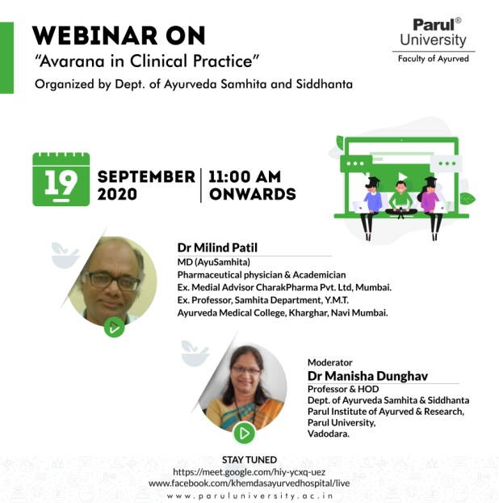 | 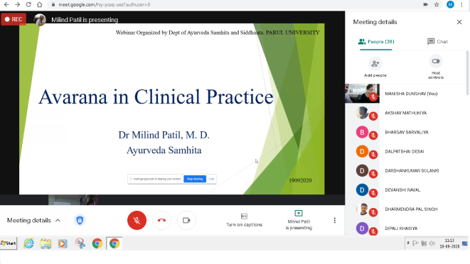

Webinar on Significance of Adharaneeya Vega for Healthy Living

A webinar on Significance of Adharaneeya Vega for Healthy Living was organised by Dept. of Ayurveda Samhita & Siddhanta, Parul Institute of Ayurved & Research on 3rd August, 2020. Webinar started at 11:10 AM with the introduction and welcome of all guest speakers. Dr. Manjula K, coordinated the session. Dr Manisha Dunghav, Professor, Dr Arun Vaidya, Professor and Mr. Tejas Vyas, Lecturer, Department of Ayurveda Samhita & Siddhanta, actively involved in the arrangements of webinar. The webinar enlightened the students and it was well appreciated by teachers & students.
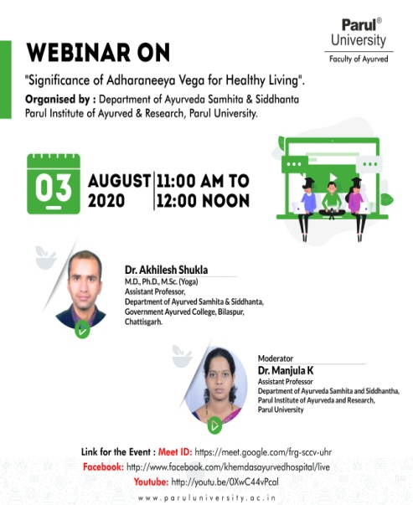 | 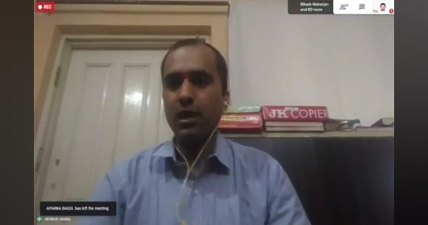 | 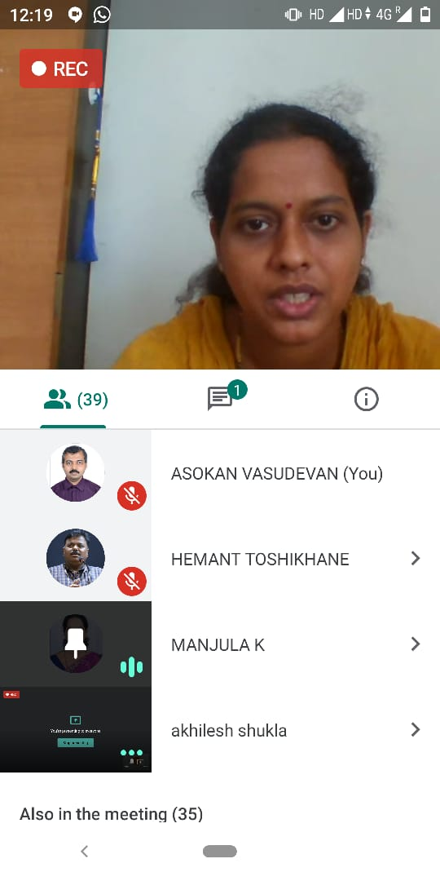

Bheshaj – Pharma Tech-2020
A Nationla Webinar Series on Ayurved Pharmaceutics & Research
Webinar series is initiated from 6th to 11th July with inaugural address by Sri Pralhad Joshi, Sri. Sripad yesso naik, Dr D C Katoch and Dr Komal patel. First day session was delivered by Dr G S Lavekar.
Guest speakers Dr vedula shashibhushana, Dr R V Gudi, Dr Vijayendra Prakash, Dr Srikant and Dr Hardik Soni has delivered on different topics related to GMP, IPR and QAQC
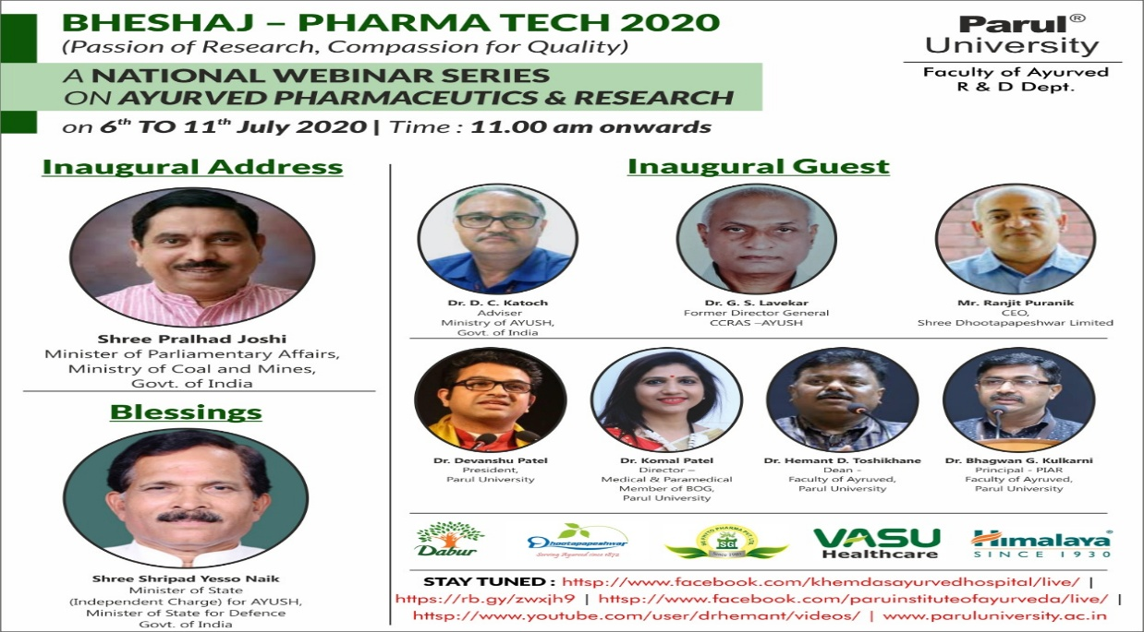
Webinar on Ancient Ayurvedic Method of Preservation of Dead Body and Dissection
A webinar on Ancient Ayurvedic Method of Preservation of Dead Body and Dissection by Dept. of Rachana Sharir Parul Institute of Ayurved & Research on 26th June, 2020. Webinar started at 11:00 AM with the introduction and welcome of all guest speakers. Dr. Nimesh Sangode, Associate Professor, coordinated the session. Department of Rachana Sharir, actively involved in the arrangements of webinar. The webinar enlightened the students and it was well appreciated by teachers & students. Department of Rachana Sharir, PIAR is thankful to the Guest speaker Dr. Kumarswami B. Hiremath for accepting the invitation & delivering the webinar and expresses its heartfelt gratitude towards the President, Managing Trustees of Parul University & Dr. Hemant Toshikhane sir, Dean, Faculty of Ayurved, Parul University, Dr. B. G. Kulkarni sir, Principal, PIAR, Vadodara, Gujarat for support & motivation. We also thank the technical support team of Parul University.
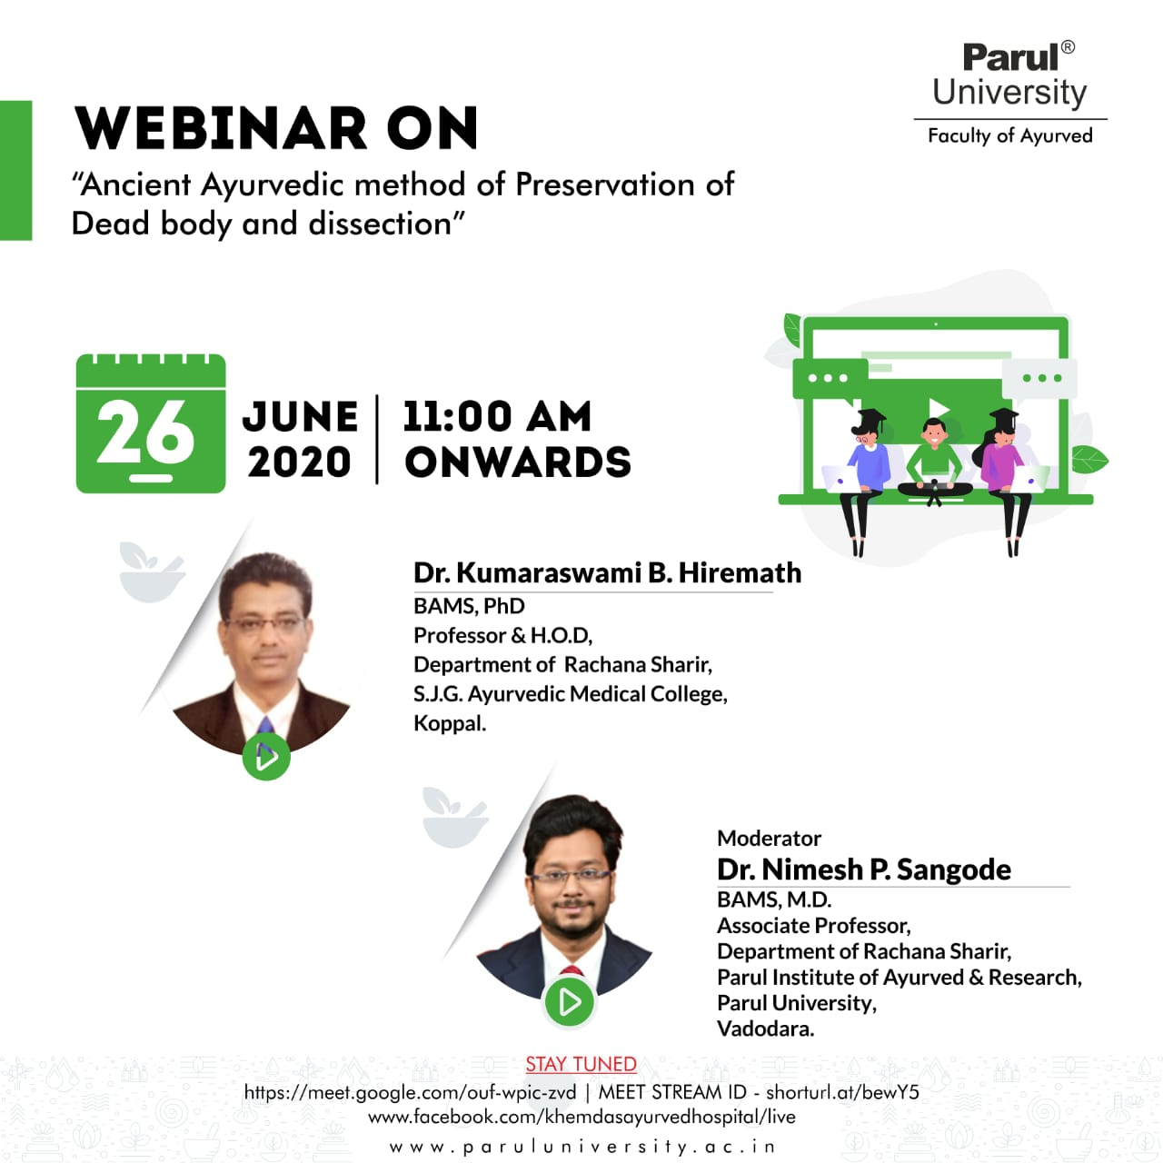 | 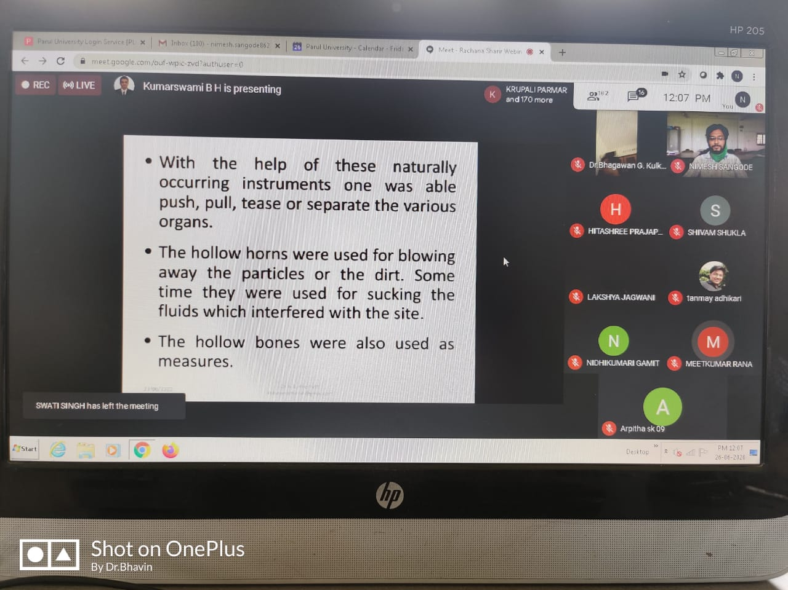
Webinar on Women’s health care & AYUSH guidelines in the present scenario
A webinar on Women’s health care & AYUSH guidelines in the present scenario was organised by Dept. of PTSR, Parul Institute of Ayurved & Research on 1st May, 2020. Webinar started at 4:00 PM with the introduction and welcome of all guest speakers.
Dr. Jayasheela M. Goni, Professor, Department of Prasuti Tantra and Streeroga, PIAR has coordinated the session. Department of Prasuti Tantra and Streeroga, PIAR were actively involved in the organizing and arranging the webinar.

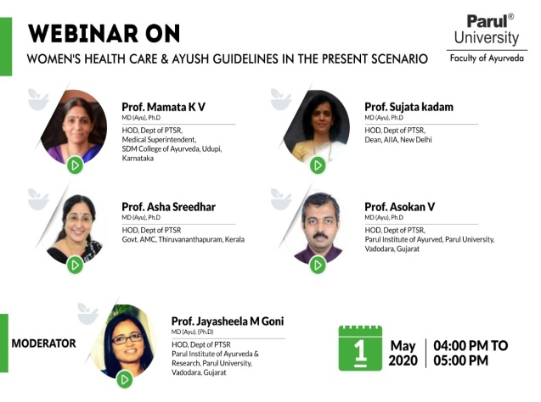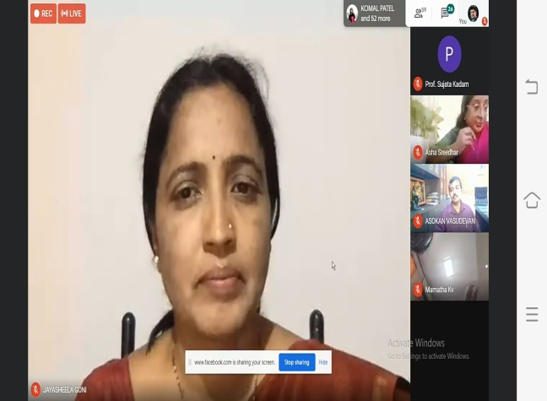

Webinar on Application of ParadiGuna
A webinar on Application of ParadiGuna was organised by Dept. of DravyaGuna, Parul Institute of Ayurved & Research on 6th May, 2020. Prof. Dr. SuwarnaMeshram, Head, Department of Dravyaguna, PIAR, coordinated the session. Dr Prasanth, Asso. Prof. Department of Dravyagunar, PIAR & Dr Bhavin Dhanavade, Asst. Prof. Department of Dravyaguna, PIAR actively involved in the arrangements of webinar. The webinar enlightened the students and was well appreciated by teachers & students. Department of Dravyaguna, PIAR is thankful to the Guest speaker Vd.SharavatiKamblemadam for accepting the invitation & delivering the webinar. Dept ofDravyaguna expresses its heartfelt gratitude towards the President, Managing Trustees of Parul University & Dr. HemantToshikhane sir, Dean, Faculty of Ayurved, Parul University, Dr. B. G. Kulkarni sir, Principal, PIAR, Vadodara, Gujarat for support & motivation. Department of Dravyaguna also thanks the technical support team of Parul University.
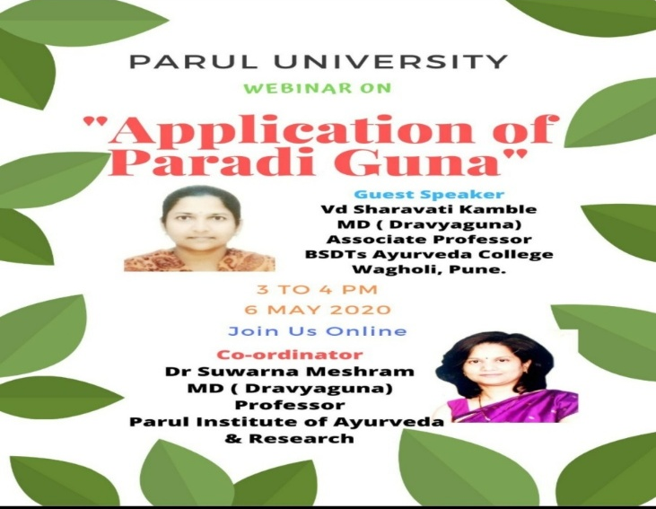 | 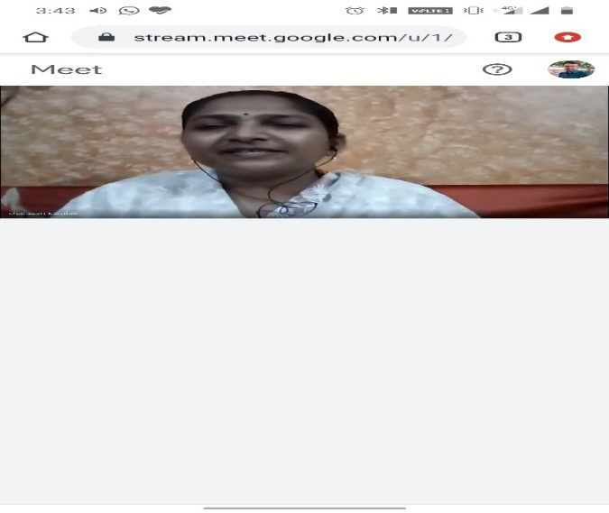

Webinar on Role of Ayush system in mental health boosting for post lockdown condition
.A webinar on Role of Ayush system in mental health boosting for post lockdown condition was organised by Department of Dravyaguna, Parul Institute of Ayurved & Research on 14th May, 2020. Prof. Dr. Suwarna Meshram, Head, Department of Dravyaguna, PIAR, coordinated the session. Dr Prasanth, Asso. Prof. Department of Dravyagunar, PIAR & Dr Bhavin Dhanavade, Asst. Prof. Department of Dravyaguna, PIAR actively involved in the arrangements of webinar. The webinar enlightened the students and was well appreciated by teachers & students. Department of Dravyaguna, PIAR is thankful to the Guest speaker Dr. Sudhir Joshi sir for accepting the invitation & delivering the webinar. Dept of Dravyaguna expresses its heartfelt gratitude towards the President, Managing Trustees of Parul University & Dr. Hemant Toshikhane sir, Dean, Faculty of Ayurved, Parul University, Dr. B. G. Kulkarni sir, Principal, PIAR, Vadodara, Gujarat for support & motivation. Department of Dravyaguna also thanks the technical support team of Parul University.
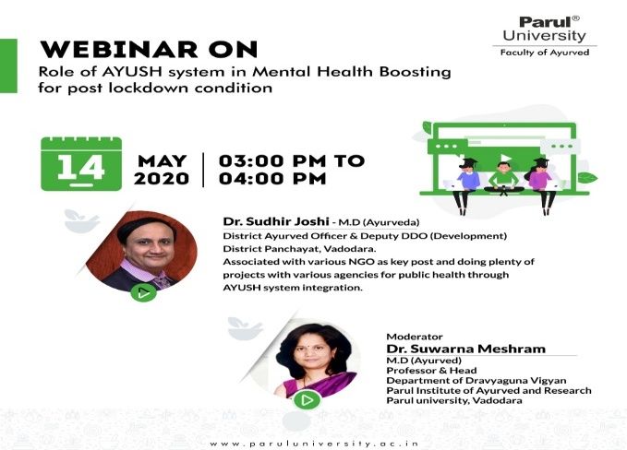 | 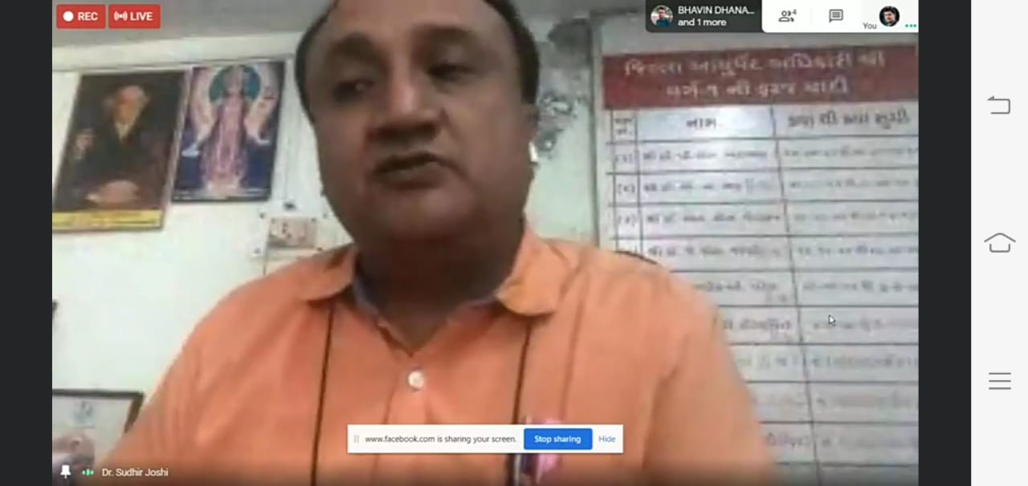

Webinar On Role Vimana Sthana – A novel contribution of Charaka Samhita
A webinar on Vimana Sthana – A novel contribution of Charaka Samhita was organised by Dept. of Ayurveda Samhita and Siddhanta, Parul Institute of Ayurved & Research on 15th May, 2020. Dr. Manjula K, Assistant Professor, coordinated the session. Dr Manisha Dunghav, Professor, Dr Arun Vaidya, Professor and Mr. Tejas Vyas, Lecturer, Department of Ayurveda Samhita, actively involved in the arrangements of webinar. The webinar enlightened the students and it was well appreciated by teachers & students. Department of Ayurveda Samhita, PIAR is thankful to the Guest speaker Dr Priyanka BV, for accepting the invitation & delivering the webinar and expresses its heartfelt gratitude towards the President, Managing Trustees of Parul University & Dr. Hemant Toshikhane sir, Dean, Faculty of Ayurved, Parul University, Dr. B. G. Kulkarni sir, Principal, PIAR, Vadodara, Gujarat for support & motivation. We also thank the technical support team of Parul University.
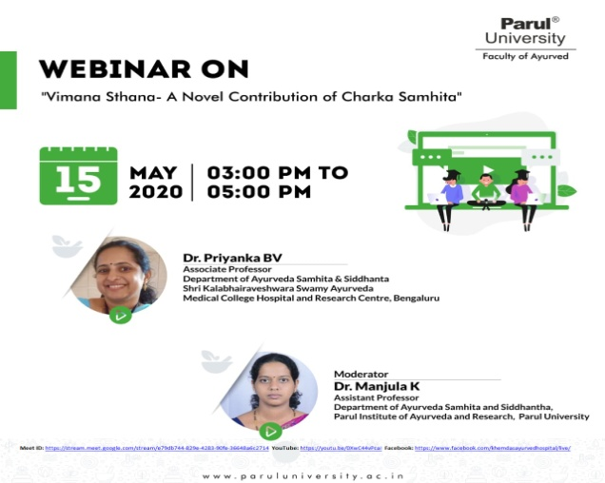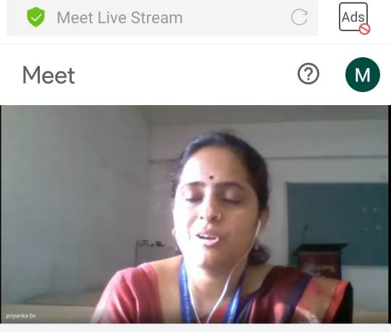

Webinar on Understanding of essentials of Marma Sharir and its applicability
A webinar on Understanding of essentials of Marma Sharir and its applicability by Dept. of Rachana Sharir, Parul Institute of Ayurved & Research on 18th May, 2020. Dr. Hemant Toshikhane, Dean, Faculty of Ayurveda, Parul University, coordinated the session. The webinar enlightened the students and was well appreciated by teachers & students. Department of Rachana Sharir, PIAR is thankful to the Guest speakers Dr. B.G. Kulkarni sir, Dr. Navin Chandra Joshi sir, Dr. Mukund Erande sir & Dr. O.P. Dave sir for accepting the invitation & delivering the webinar. Dept of Rachana Sharir expresses its heartfelt gratitude towards the President, Managing Trustees of Parul University & Dr. Hemant Toshikhane sir, Dean, Faculty of Ayurved, Parul University, Dr. B. G. Kulkarni sir, Principal, PIAR, Vadodara, Gujarat for support & motivation. Department of Rachana Sharir also thanks the technical support team of Parul University.
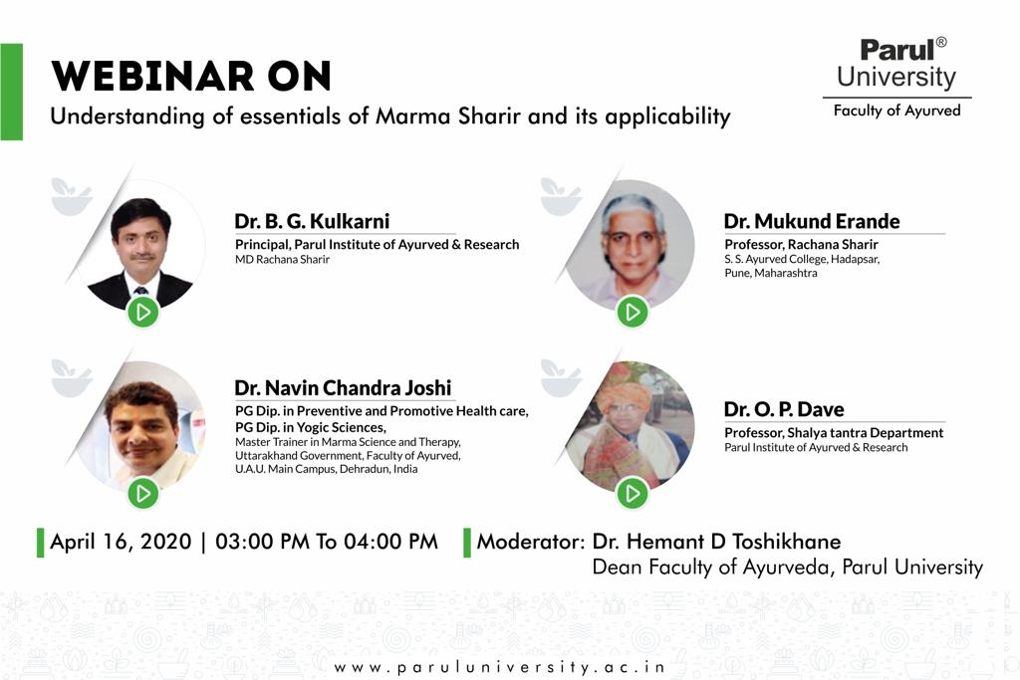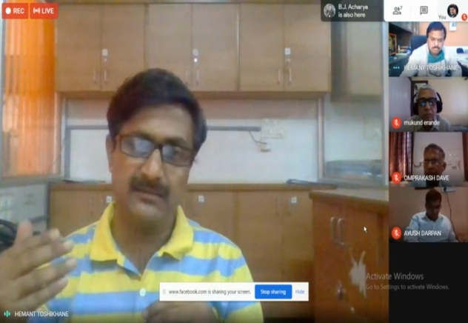
Webinar on Importance of Anumana Pramana
A webinar on Importance of Anumana Pramana was organised by Dept. of Ayurveda Samhita and Siddhanta, Parul Institute of Ayurved & Research on 22th May, 2020. Dr. Manjula K, coordinated the session. Dr Manisha Dunghav, Professor, Dr Arun Vaidya, Professor and Mr. Tejas Vyas, Lecturer, Department of Ayurveda Samhita, actively involved in the arrangements of webinar. The webinar enlightened the students and it was well appreciated by teachers & students. Department of Ayurveda Samhita, PIAR is thankful to the Guest speaker Dr Raja Rajeshwari NM for accepting the invitation & delivering the webinar and expresses its heartfelt gratitude towards the President, Managing Trustees of Parul University & Dr. Hemant Toshikhane sir, Dean, Faculty of Ayurved, Parul University, Dr. B. G. Kulkarni sir, Principal, PIAR, Vadodara, Gujarat for support & motivation. We also thank the technical support team of Parul University.
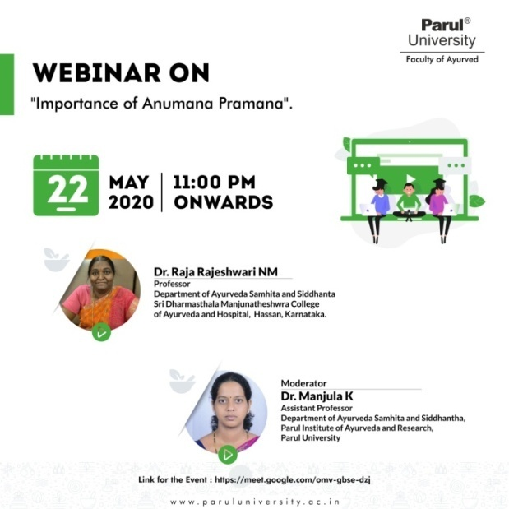 | 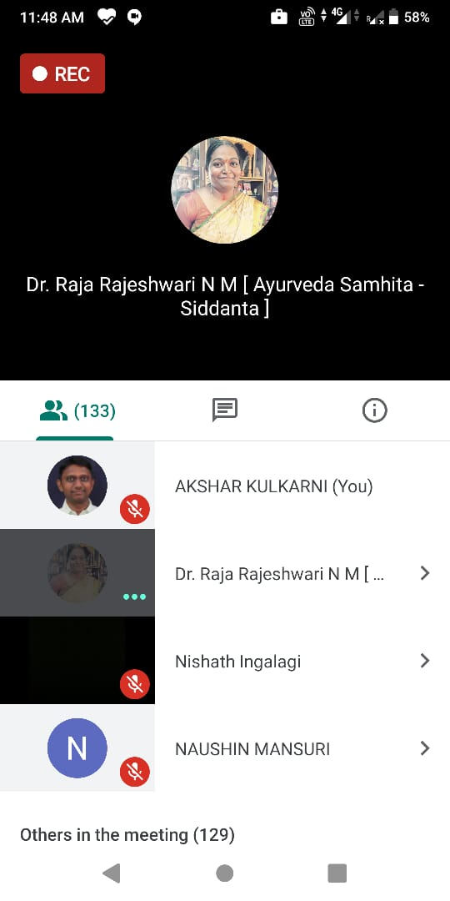
Webinar on Easy steps to ECG
A webinar on Easy steps to ECG was organised by Dept. of Rog Nidan, Parul Institute of Ayurved & Research on 11th May, 2020. Associate Prof. Dr. Hrishita Dahilekar, Department of Roga Nidana, PIAR, coordinated the session. Dr Swastika Sharma, Asst Prof. Department of Roga Nidana, PIAR actively involved in the arrangements of webinar. The webinar enlightened the students and was well appreciated by teachers & students. Department of Rognidana, PIAR is thankful to the Guest speaker Dr Rashmi madam for accepting the invitation & delivering the webinar. Dept of Roga Nidana expresses its heartfelt gratitude towards the President, Managing Trustees of Parul University & Dr. Hemant Toshikhane sir, Dean, Faculty of Ayurved, Parul University, Dr. B. G. Kulkarni sir, Principal, PIAR, Vadodara, Gujarat for support & motivation. Department of Roga Nidana also thanks the technical support team of Parul University.
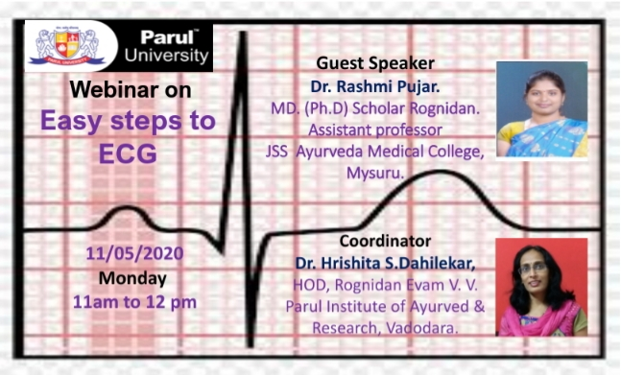 | 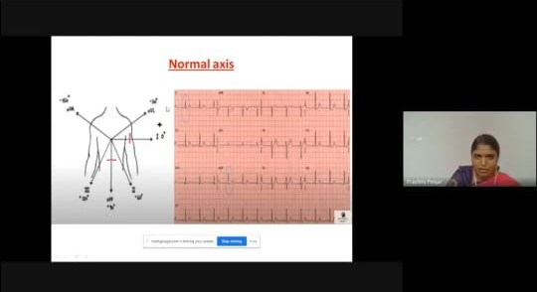

Webinar on Challenges in Management of Paediatric Diseases in COVID 19 Situation

A webinar on Challenges in Management of Pediatric diseases in COVID-19 situation was organised by Dept. of Kaumarabhritya, Parul Institute of Ayurved & Research on 16th May, 2020. Webinar started at 2:00 PM with the introduction and welcome of all guest speakers.
It was interactive session webinar, questions were pre-collected and online viewers questions were asked to the panelists. Dr Mauli Vaishnav, Assistant Professor, Department of Prasuti Tantra and Streeroga, PIAR has coordinated the session. Dr. Sudhir Pani, Professor & HOD, Department of Kaumarbhritya, Dr. SreevisakhT.S., Associate professor, Department of Kaumarbhritya, PIAR & Dr. Mauli Vaishnav, Assistant Professor, Department of Prasuti Tantra and Streeroga, PIAR were actively involved in the organizing and arranging the webinar.

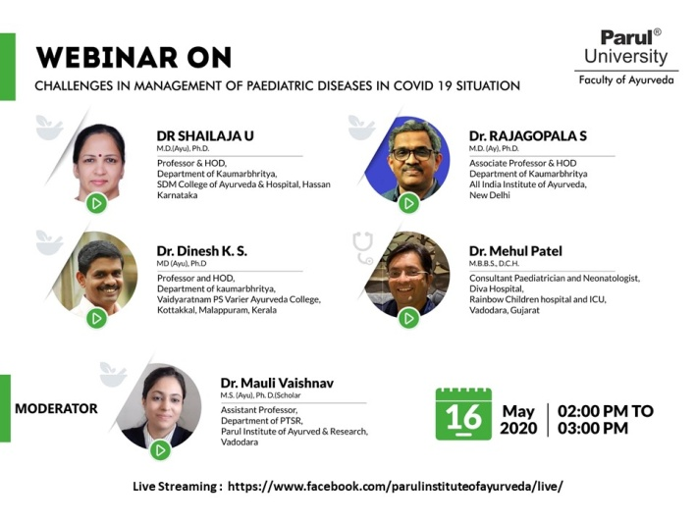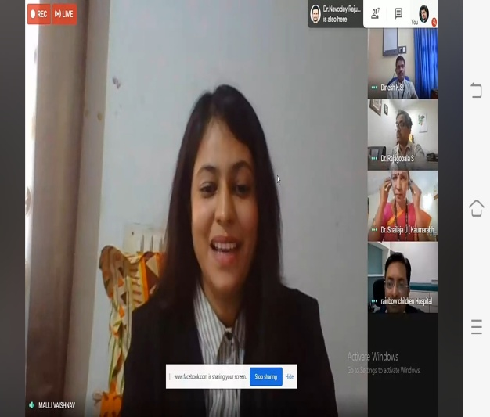

Webinar on Shatkriyakala - Applied Aspect

A webinar on Shatkriyakala - Applied Aspect was organised by Dept. of Kriya Sharir, Parul Institute of Ayurved & Research on 2nd May, 2020. Webinar started at 12:00 Noon with the introduction and welcome of all guest speakers. Prof. Dr. Sarita Ohol, Head, Department of Kriya Sharir, PIAR, coordinated the session. Dr Akshar Kulkarni, Asso. Prof. Department of Kriya Sharir, PIAR & Dr N.R. Navoday Raju, Asst. Prof. Department of Kriya Sharir, PIAR actively involved in the arrangements of webinar. The webinar enlightened the students and was well appreciated by teachers & students. Department of Kriya Sharir, PIAR is thankful to the Guest speaker Dr Kalpana Sathe madam for accepting the invitation & delivering the webinar. Dept of Kriya Sharir expresses its heartfelt gratitude towards the President, Managing Trustees of Parul University & Dr. Hemant Toshikhane sir, Dean, Faculty of Ayurved, Parul University, Dr. B. G. Kulkarni sir, Principal, PIAR, Vadodara, Gujarat for support & motivation. Department of Kriya Sharir also thanks the technical support team of Parul University.

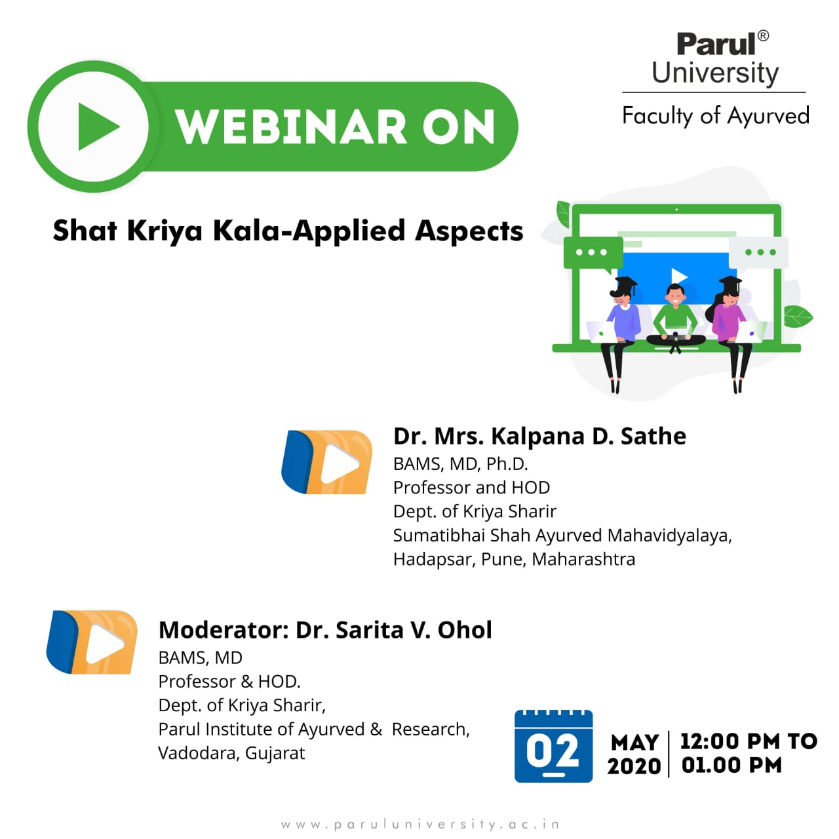 | 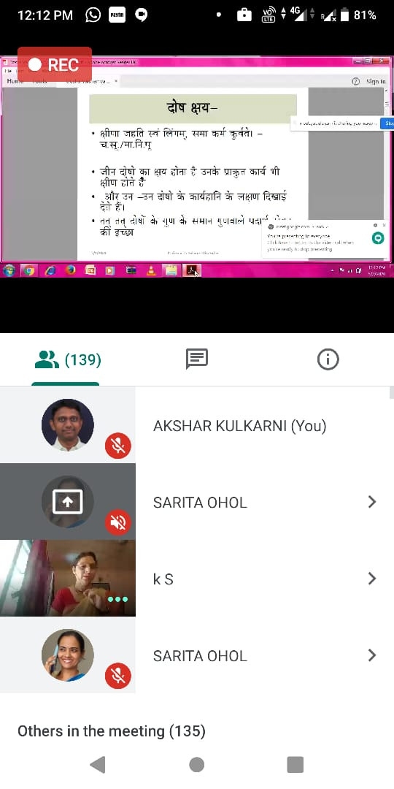

National Seminar on hepatobiliary and pancreatic diseases
A Knowledge sharing National Seminar on hepatobiliary and pancreatic diseases was recently held at campus. Padmashree Balendu Prakash, an Indian Ayurvedic physician, former Physician to the President of India and the founder of Paadav, a specialty Ayurvedic hospital in Dehradun. The Government of India awarded him the fourth highest civilian award of the Padma Shri in 1999, Dr Sunil Naik, an Eminent Ayurved Consultant in hepatobiliary diseases in Belgaum also shared his clinical expertise with the students,Dr Sushil Narang, a renowned GI surgeon in Ahmedabad .These all were the keynote speaker at the seminar which bagged 600+ registrations.

