WEBINAR ON IMPORTANCE OF SATWAVAJAYA CHIKITSA IN MANASA VYADHI

As a part of “UG WEBINAR SERIES 2021 2021”, Department of Kayachikitsa, Parul Institute of Ayurved and Research, Vadodara has organized webinar on 12.01.2022 from 11.15 to 12.00 pm on the topic: Importance of Satwavajaya chikitsa in Manasa Vyadhi by the resource person Dr Laxmi Sanganal, MD (Ayu) Associate Professor, Department of Kayachikitsa, Bapuji Ayurveda Medical College hospital, Shimmoga
Google meet Link: https://meet.google.com/cgz-fkdc-sir

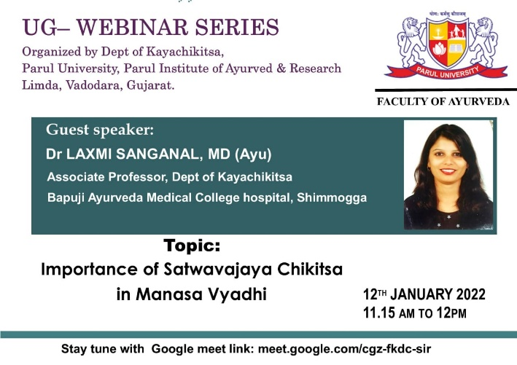

WEBINAR ON ABHYANTAR SNEHAPANA

As a part of “UG WEBINAR SERIES 2021 2021”, Department of Panchakarma, Parul Institute of Ayurveda And Research, Parul University, organized webinar on 06.12.2021 from 04:00 PM – 05:00 PM; on the topic “Abhyantar Snehapana” by the resource person Dr.Mayura Kanoonga, Assistant Professor at Veena Vahini Ayurvedic college, Bhopal. Coordinator- Dr Nilam Pritesh Deore, Professor, PIAR and Dr. Divya B. Associate Professor, PIAR was the Moderator. Webinar was conducted for 4th year students
Google Meet link-http://meet.google.com/jvj-irjz-wmh

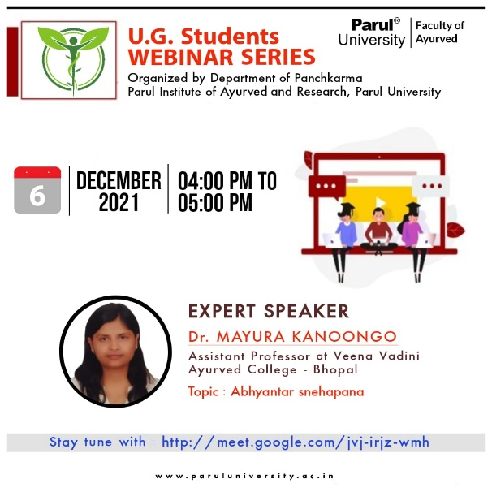

WEBINAR ON NEONATAL RESUSCINATION

As a part of “UG WEBINAR SERIES 2021 2021”, Department of Koumarabhrutya, Parul Institute Of Ayurveda And Research, Parul University, organized webinar on 06.12.2021 from 04:00 PM – 05:00 PM; on the topic “Neonatal Resuscination” by the resource person Dr Kirti Rathod, Associate Professor, Govt Ayurved College, Vadodara. Coordinator for the session was Dr. Sreevishak TS, Associate Professor, PIAR and Dr. Deepthi V. Assistant Professor, PIAR was the Moderator. Webinar was conducted for 3rd year students.
https://meet.google.com/uqi-onas-hmz

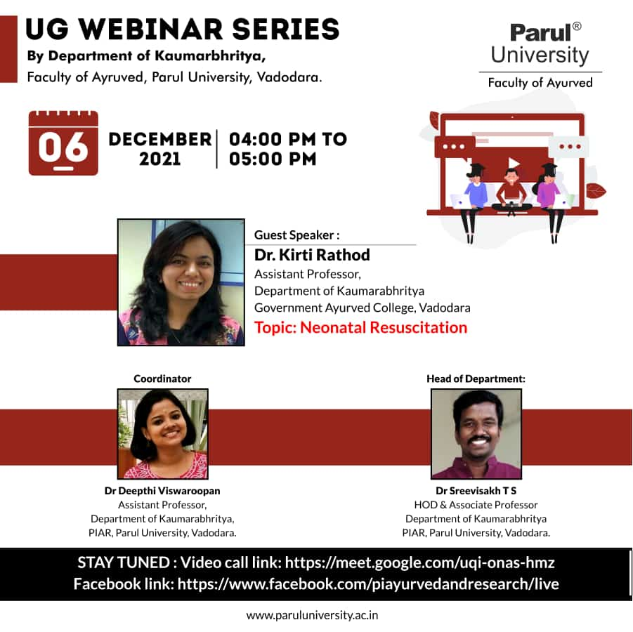

WEBINAR ON AHARA MALA

As a part of “UG WEBINAR SERIES 2021 2021”, Department of KRIYASHARIR, Parul Institute Of Ayurveda And Research, Parul University, organized webinar on 03.12.2021 from 11:00 AM – 12:00 Noon on the topic “Ahara Mala” by the resource person Dr. Amit Mujumdar, Associate Professor, D Y Patil Ayurveda College, Navi Mumbai. The session was Coordinated by Dr Sarita Ohol, Professor, PIAR and Dr. Navoday Raju, Assistant Professor, PIAR was the Moderator. The Webinar was conducted for 1st Year BAMS students. Link for the webinar: https://meet.google.com/ycg-cgwa-wgl

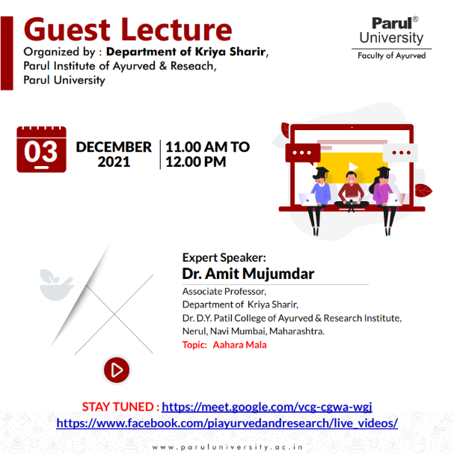

WEBINAR ON SAMHITA FOR CLINICAL PRACTICE

As a part of “UG WEBINAR SERIES 2021 2021”, Department of Ayurveda Samhita & Siddhanta, Parul Institute Of Ayurveda And Research, Parul University, organized webinar on 16.12.2021 from 10:00 AM – 11:00 AM on the topic “Samhita For Clinical Practice” by the resource person Dr. Shrinath M Vaidya, Professor, Dean Academics & Head Sri Dharmasthala Manjunatheshwara College of Ayurveda & Hospital, Hassan, Karnataka. The session was Coordinated by all the faculties of the department and Dr. Manjula K, Associate Professor, PIAR was the Moderator. The Webinar was conducted for 1st and 3rd Year BAMS students. Link for the webinar: https://meet.google.com/zib-uyzh-lyx

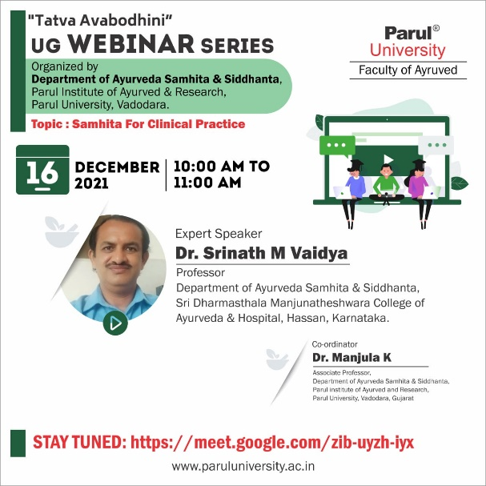

WEBINAR ON KARNA PAREEKSHANA VIDHI

As a part of “UG WEBINAR SERIES 2021 2021”, Department of Shalakya Tantra, Parul Institute Of Ayurveda And Research, Parul University, organized webinar on 11.12.2021 from 10:00 AM – 11:00 AM on the topic “Karna Pareekshana Vidhi” by the resource person Dr. Aiswarya P., Assistant Professor, Dept. Of Shalakya Tantra, Pankajakasthuri Ayurveda Medical College, Kattakad, Kerala. The Moderator of the session was Dr. Meena Yadav, HOD, Dept of Shalakya Tantra, Parul Institute of Ayurved and Research, Vadodara and coordinated by Dr. Eshwari Salian, Assistant Professor and Dr. Gautam Dabhi, Assistant Professor, Dept of Shalakya Tantra, Parul Institute of Ayurved and Research, Vadodara. The Webinar was conducted for 4th Year BAMS students. Link for the webinar:

meet.google.com/hdk-tgku-ckj

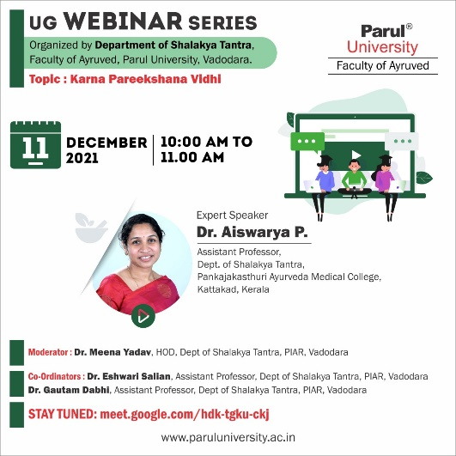

WEBINAR ON CLINICAL ANALYSIS OF GARBHINIPARICHARYA AND ITS UTILITY

As a part of “UG WEBINAR SERIES 2021 2021”, Department of PTSR, Parul Institute Of Ayurveda And Research, Parul University, organized webinar on 10.12.2021 from 03:00 PM – 04:00 PM on the topic “Clinical Analysis of Garbhiniparicharya and its utility” by the resource person Dr. Monika Chauhan, Associate Professor & head Dept. Of Shalakya Tantra, Patanjali Ayurveda College, Haridwar, Uttarakhand. The Moderator of the session was Dr. Akanksha Chandel, Dept of PTSR, Parul Institute of Ayurved and Research, Vadodara. The Webinar was conducted for 3rd Year BAMS students. Link for the webinar:

meet.google.com/gaf-ksfa-wqv

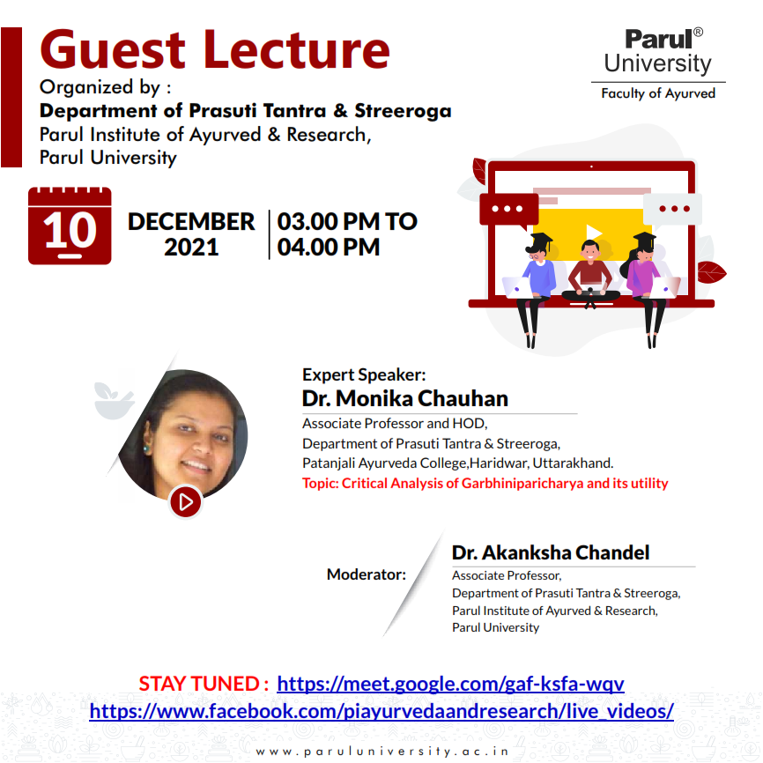

WEBINAR ON DIAGNOSIS AND TREATMENT OF SNAKEBITE

As a part of “UG WEBINAR SERIES 2021 2021”, Department of of Agadatantra, Parul Institute of Ayurved and research, Parul University, organized webinar on 22.12.2021 from 03:00 PM 04:00 PM on the topic “Diagnosis and Treatment of Snakebite” by the resource person Dr. Sachin Mangattu, Associate Professor & HOD, Department of Agadatantra, BG Garaiya Ayurveda College, Rajkot, Gujarat. The Webinar was conducted for 3rd Year BAMS students. Link for the webinar:

meet.google.com/bpm-wcwj-ooc

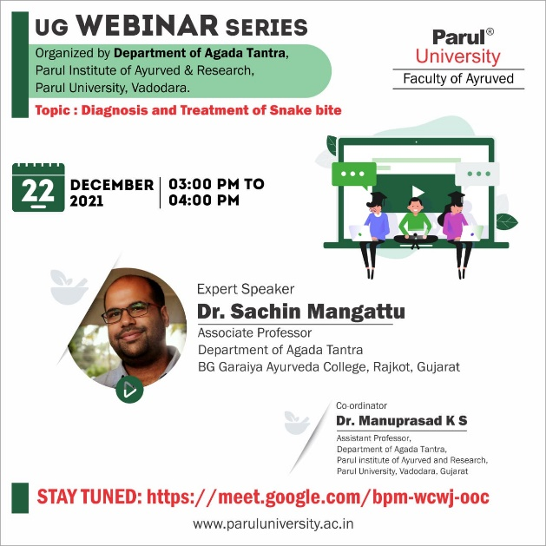

WEBINAR ON MALE INFERTILITY

As a part of “UG WEBINAR SERIES 2021 2021”, Department of Kayachikitsa, PIAR is organized webinar on 22.12.21 from 11.15am to 12.00 pm on the topic “Male Infertility” by the resource person Dr Jibi Varghese, MD (Ayu), Professor, Department of Kayachikitsa, D Y Patil Ayurved College and Research, Pimpri, Pune. The Webinar was conducted for 4th Year BAMS students. Link for the webinar:

https://meet.google.com/cgz-fkdc-sir

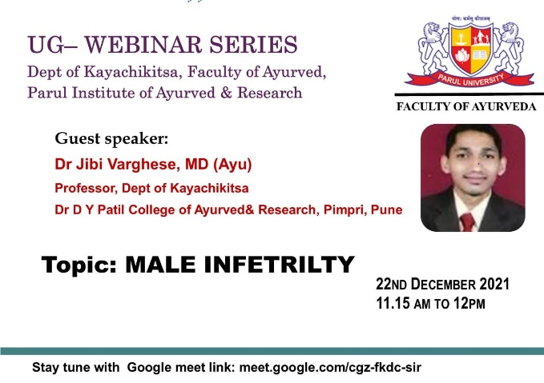

WEBINAR ON BASICS OF X-RAY AND IT'S INTERPRETATION

As a part of UG WEBINAR SERIES 2021 2021 Department of ShalyaTantra, Parul Institute of Ayurved and Research, Parul University Organized webinar on 30/12/2021 from 12:00 to 1:00 p.m on the topic “Basics of X-ray and it's interpretation” by the resource person Dr. Aswin Haridas Assistant Professor, Dept. Of Shalya Tantra, SDM College of Ayurveda, Udupi,

Karnataka. The session was Co-ordinated by Dr.K.L.Mahajan, Professor and H.O.D; Dr.Shailesh Jaiswal, Associate professor and Dr. Akhi

Assistant Professor, Dept of Shalya Tantra, Parul Institute of Ayurved and Research, Vadodara. Dr.Pawar Chandrakant, Associate professor was the moderator for the session. Webinar was conducted for 4th Year BAMS students.

Join using following Link- meet.google.com/vvb-jqtd-nxj

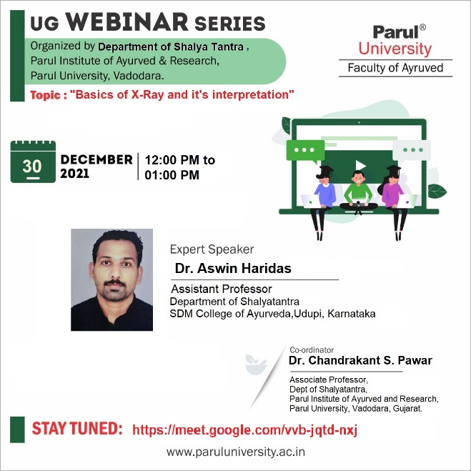

SEMINAR ON Clinical and Investigative Parameters of Respiratory System

Seminar was organised by Department of Kriya Shareera on 28.12.2021
- Clinical and Investigative Parameters of Respiratory System by Dr. Pratima Gupta, Associate Professor, KVG Ayurveda Medical College and Hospital, Sullia, Karnataka

Ayurvedic and Contemporary Understanding of Respiration by Dr.Sreelekshmi G., Assistant Professor, Pankaksthuri Ayurveda Medical College and PG Centre, Thiruvananthapuram, Kerala

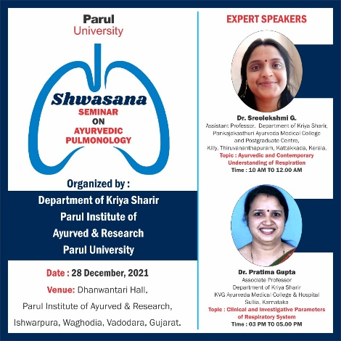

Webinar on World Blood Donation Day

Department of Shalya Tantra, Parul Institute of Ayurved and Research (PIAR) had arranged a webinar on the topic “Basics of Fracture and its Management”, on 29.06.2021, 10:00 AM - 11:00 AM, by Dr. Rajaneesh Giri, Professor and Head, Department of Shalya Tantra, S.D.M. College of Ayurveda, Udupi, Karnataka.

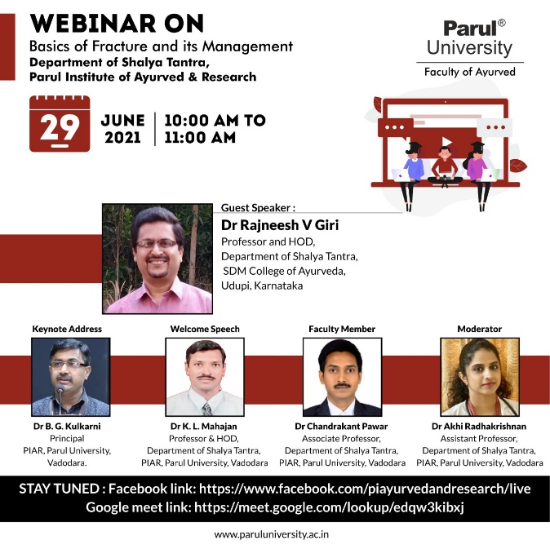

Webinar on World Blood Donation Day

Department of Roga Nidana & Vikruti Vigyan, Parul Institute of Ayurved and Research (PIAR) had arranged a webinar “World Blood Donation Day” on 14.06.2021 from 09:30 AM - 01:00 PM. The session was graced with the presence of Dr. Komal Patel, Trustee & Director of Medical and Paramedicals; Dr. Hemant Thoshikane, Dean, faculty of Ayurved, Parul University; DR.B.G Kulkarni, Principal. The eminent personalities for the sessions were:
- Dr. Ram Shukla, M.D. (Panchakarma), Principal Investigator, Thalassemia Speciality Clinic, Government Akhandanand Ayurved Hospital , Ahemadabad, on the topic “Rakta Basti – An Alternative Therapy For Blood Transfusion in Thalassemia”
- Dr. Santosh Wanave, MBBS, M.D. (Path) Founder and Director of Disha CRL Laboratories, Mumbai, on the topic “Blood Banking Techniques”
- Dr. Anand Kshite, MBBS, M.D. (Path), Krishna Laboratory and Transfusion Officer, S.B. Bajaj Blood Bank, Pandharpur, on the topic “Blood Banking Techniques”

Moderators for the session were: Dr. Hrishita Dahelikar, Professor & HOD, Dr. Krishna Thorat, Associate Professor, Dr. Swatika Sharma, Assistant Professor, Department of Roga Nidana & Vikruti Vigyan.

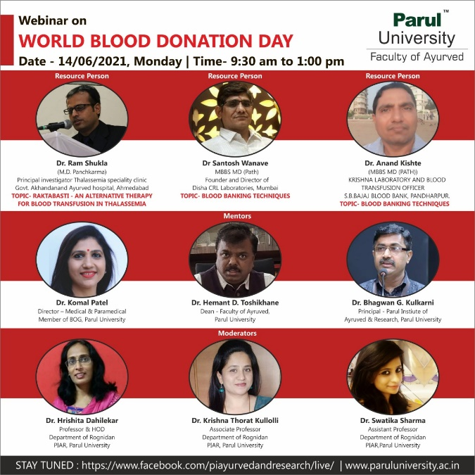

Webinar on Environmental day and Ayurvedic thoughts

On the occasion of World Environment Day 2021, Department of Dravyaguna Vigyan, Parul Institute of Ayurved and Research, Parul university, had conducted a webinar on “Environmental day and Ayurvedic thoughts”, followed with the plantation of 200 new medicinal plants. The session was graced with the presence of Dr. Komal Patel, Trustee & Director of Medical and Paramedicals; Dr. Hemant Thoshikane, Dean, faculty of Ayurved, Parul University; DR.B.G Kulkarni, Principal.

The eminent personalities for the sessions were
- Dr. Vinodkumar TG Nair, BOG of CCIM Government of INDIA; Senior Scientist JNTBGRI, Palode, Kerala - Guest of honour
- Dr. Jayan Damodaran, Professor Dept of Swastavrutha Government Ayurveda College Thiruvananthapuram, Kerala – “Environment day - Ayurvedic thoughts”
- Dr.Priya Sunil Bhide; Pediatric Physiotherapist & Urban waste management expert - “Urban Waste Management”

Moderators for the session were: Dr. Suwarna Meshram, Professor, Dr. Prashanth Krishnan, Associate Professor & HOD, Dr. Bhavin Dhanavade, Assistant Professor, Department of Dravyaguna Vigyan.

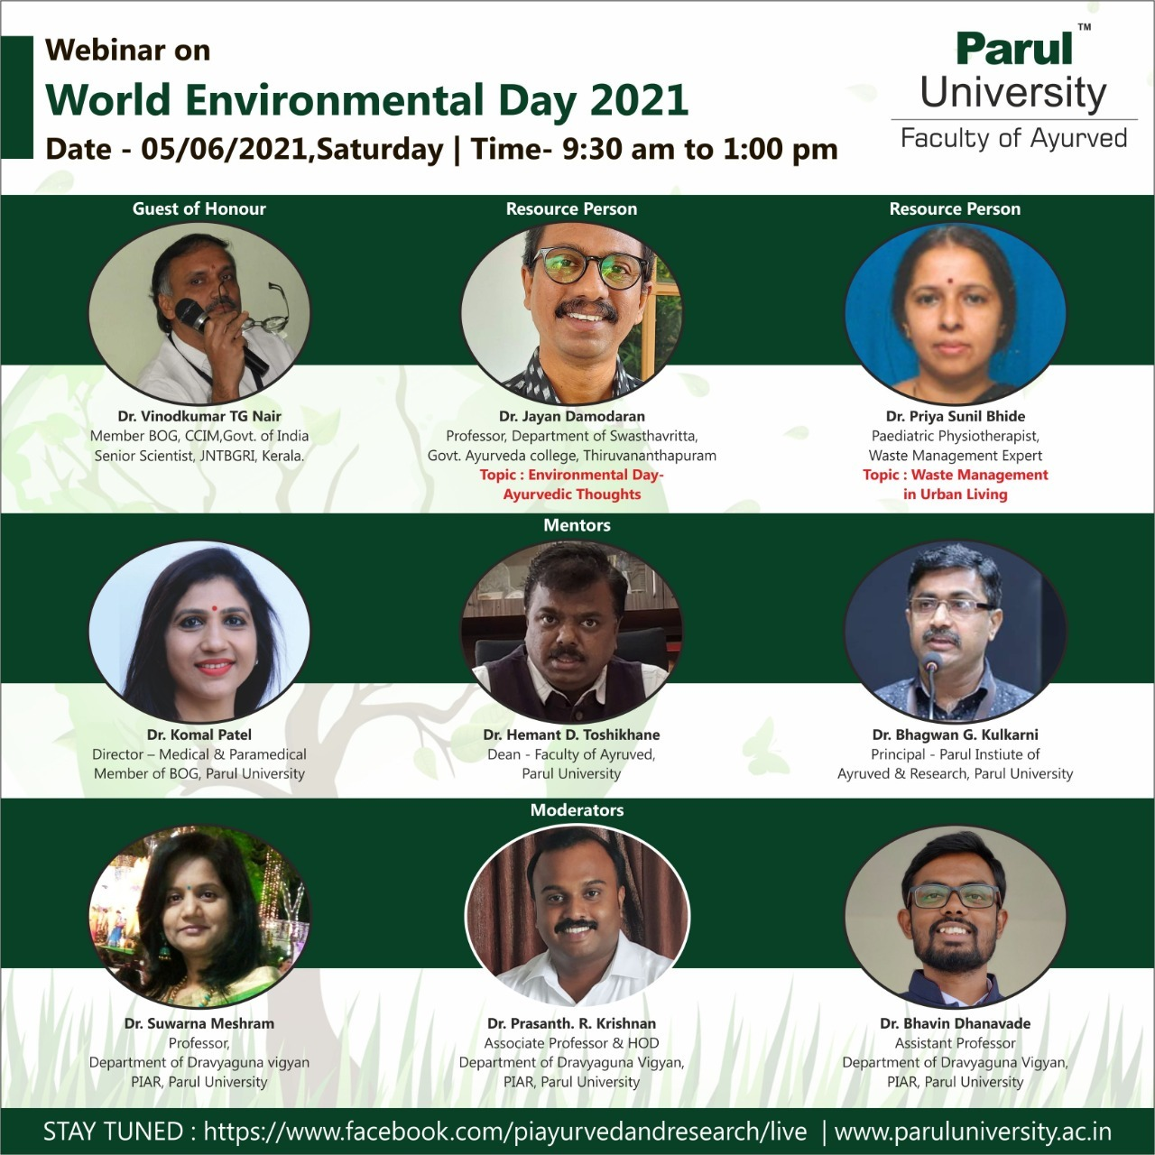 | 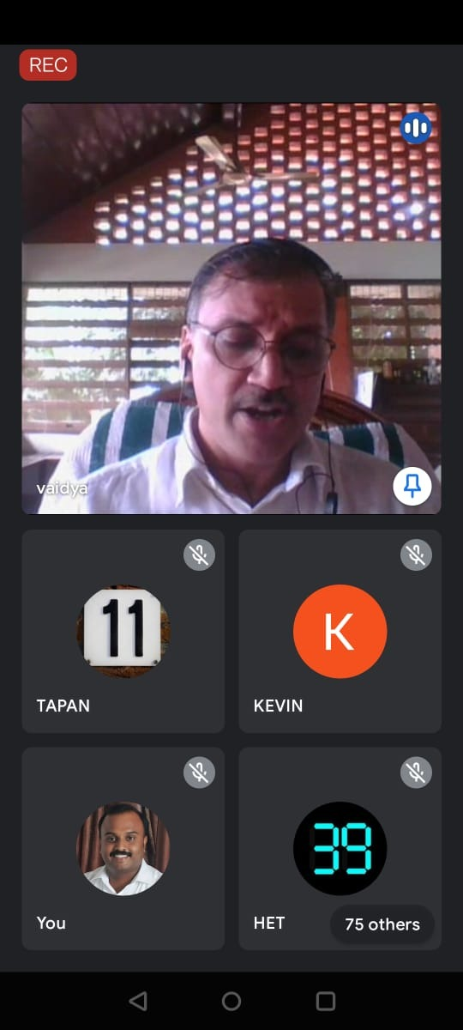
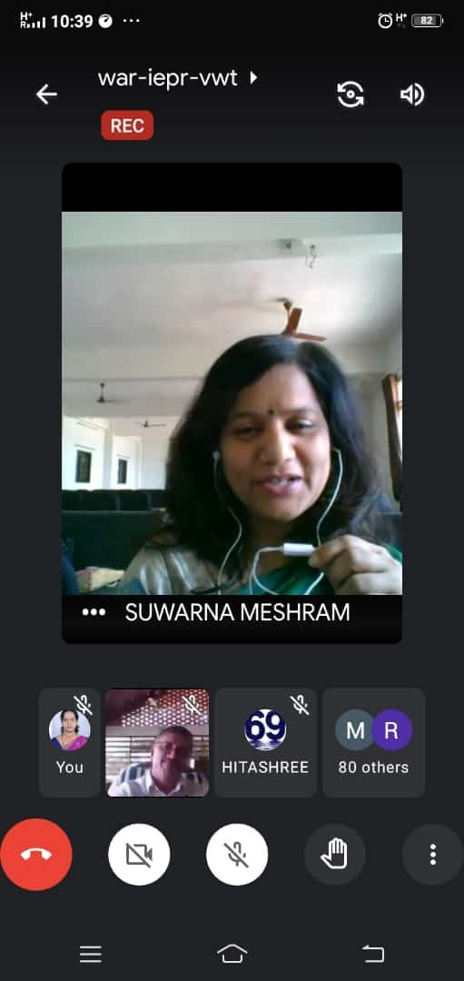 | 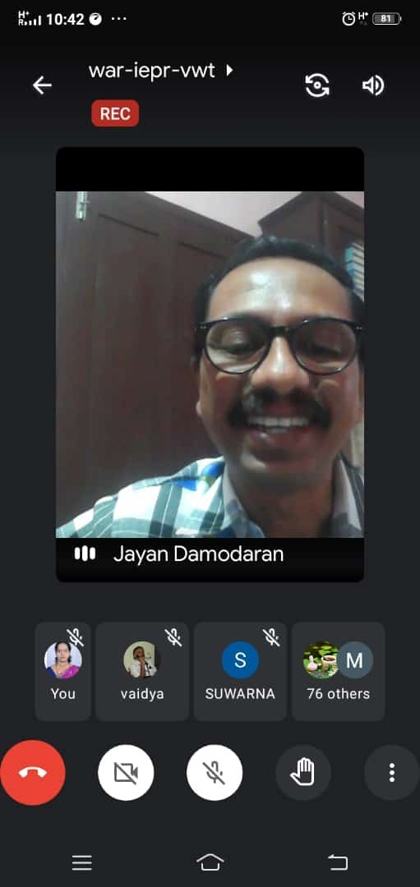

Webinar on Nutrition & Nutritional Disorders in Children

Department of Koumarabhritya, Parul Institute of Ayurved and Research (PIAR) had arranged a web conference on the topic “Nutrition & Nutritional Disorders in Children” on 28.05.2021, 11:00 AM- 12:00 Noon by Dr. Vijayalakshmi Mallannavar, Associate Professor, Department of Koumarabhritya, SDMCA&H, Hassan, Karnataka

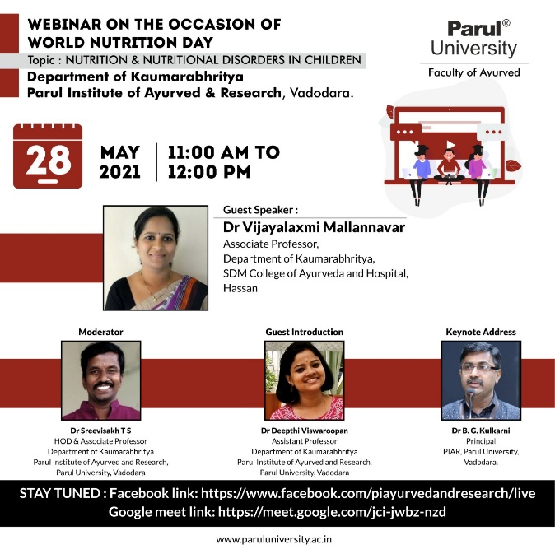 | 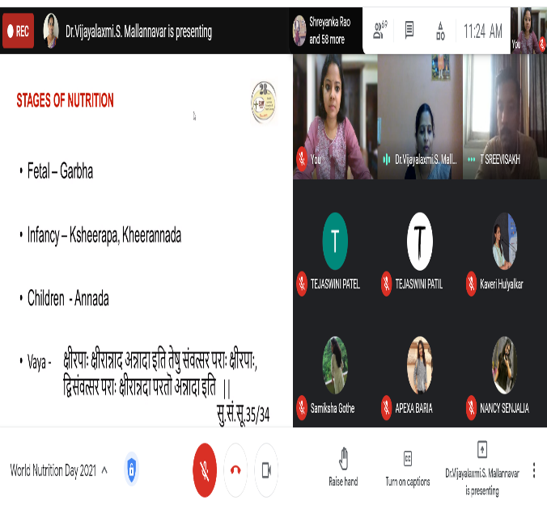

Webinar on Understanding of Covid - 19 & Ayurveda

Department of Ayurveda Samhita & Siddhanta, Parul Institute of Ayurved and Research (PIAR) had arranged a web conference on the topic “Understanding of Covid - 19 & Ayurveda” on 24.05.2021, 11:00 AM- 12:00 Noon by Dr. Sudarshan Hande, Associate Professor, Department of Samhita & Siddhanta, School of Ayurved, D.Y. Patil University, Nerul, Navi Mumbai, Maharashtra.

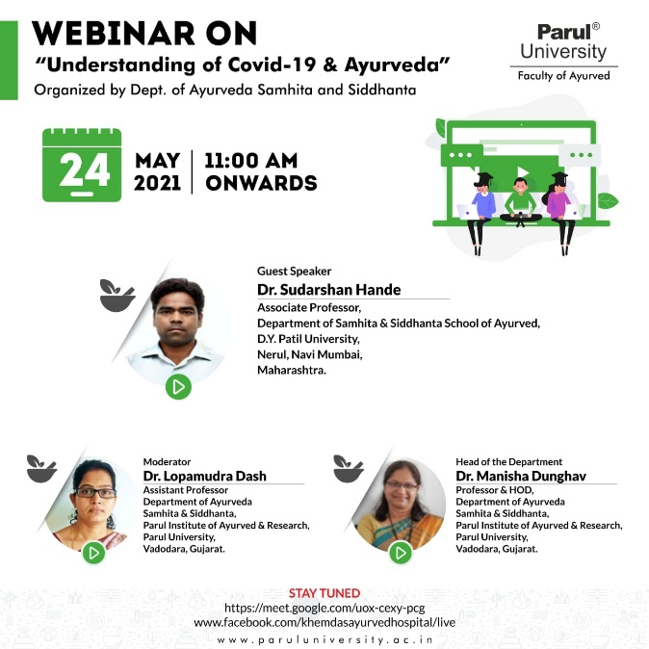 | 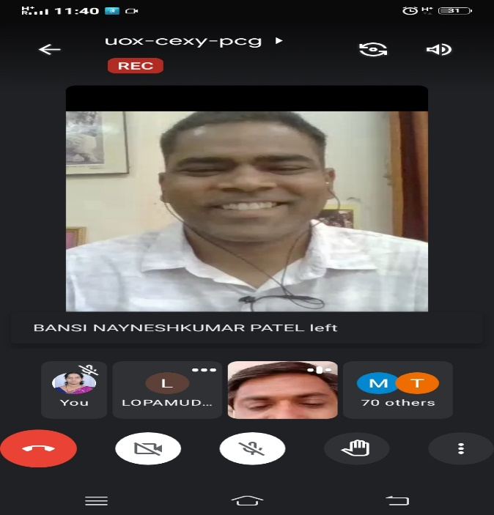

Webinar on Muscle Physiology W.S.R. to Molecular Muscle Contraction

Department of Shareera Kriya, Parul Institute of Ayurved and Research (PIAR) had arranged a web conference on the topic “Muscle Physiology W.S.R. to Molecular Muscle Contraction”, on 22.05.2021, 11:00 AM - 12:00 Noon, by Dr. Anoop M, Associate Professor , Department of Kriya Sharira , K.J. Institute of Ayurveda & Research, Savli, Vadodara, Gujarat

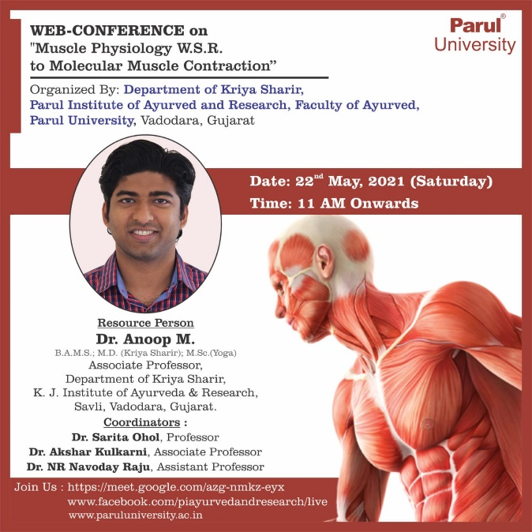 | 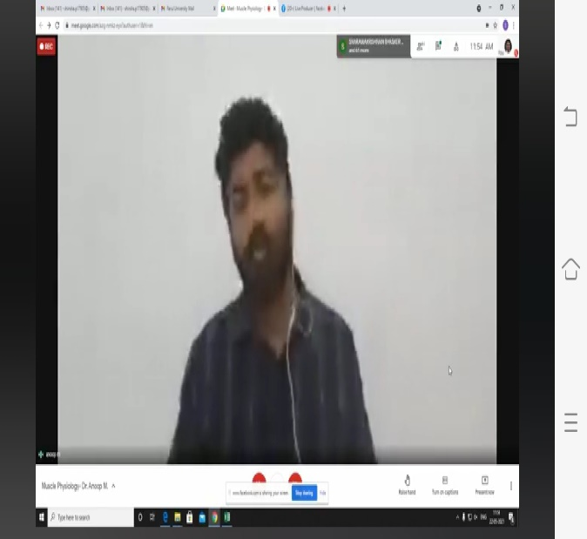

Webinar on Career Counselling

Department of Dravyaguna Vigyan, Parul Institute of Ayurved and Research (PIAR) had arranged a web conference “Career Counselling” on the topic “Scopes for BAMS students after completing BAMS in the field of Ayurveda” on 12.05.2021, 11:00 AM - 12:00 Noon by Vaidya Rakesh Salve, Professor & HOD, Department of Rasa Shastra & Bhaishajya Kalpana; Vice Principal, MRIAS College, Gandhinagar, Gujarat

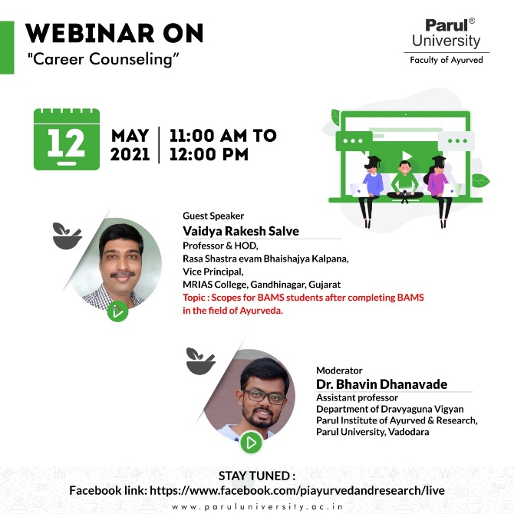 | 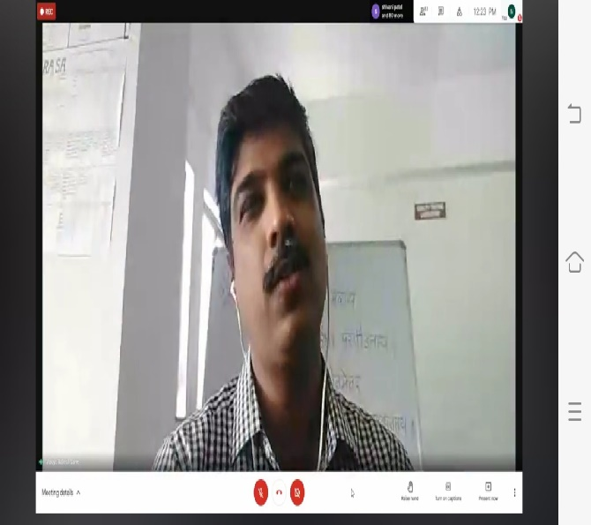

Webinar on Management of Aamvata

Department of Kayachikitsa, Parul Institute of Ayurved and Research (PIAR) had arranged a web conference on the topic “Management of Aamvata”, on 03.05.2021, 11:15 AM – 12:15 PM, by Dr. Rajesh A. Udapudi, MD, PhD (Ayurveda), Dean and Professor, Department of Kayachikitsa, JSS Ayurveda Medical College, Mysuru, Karnataka

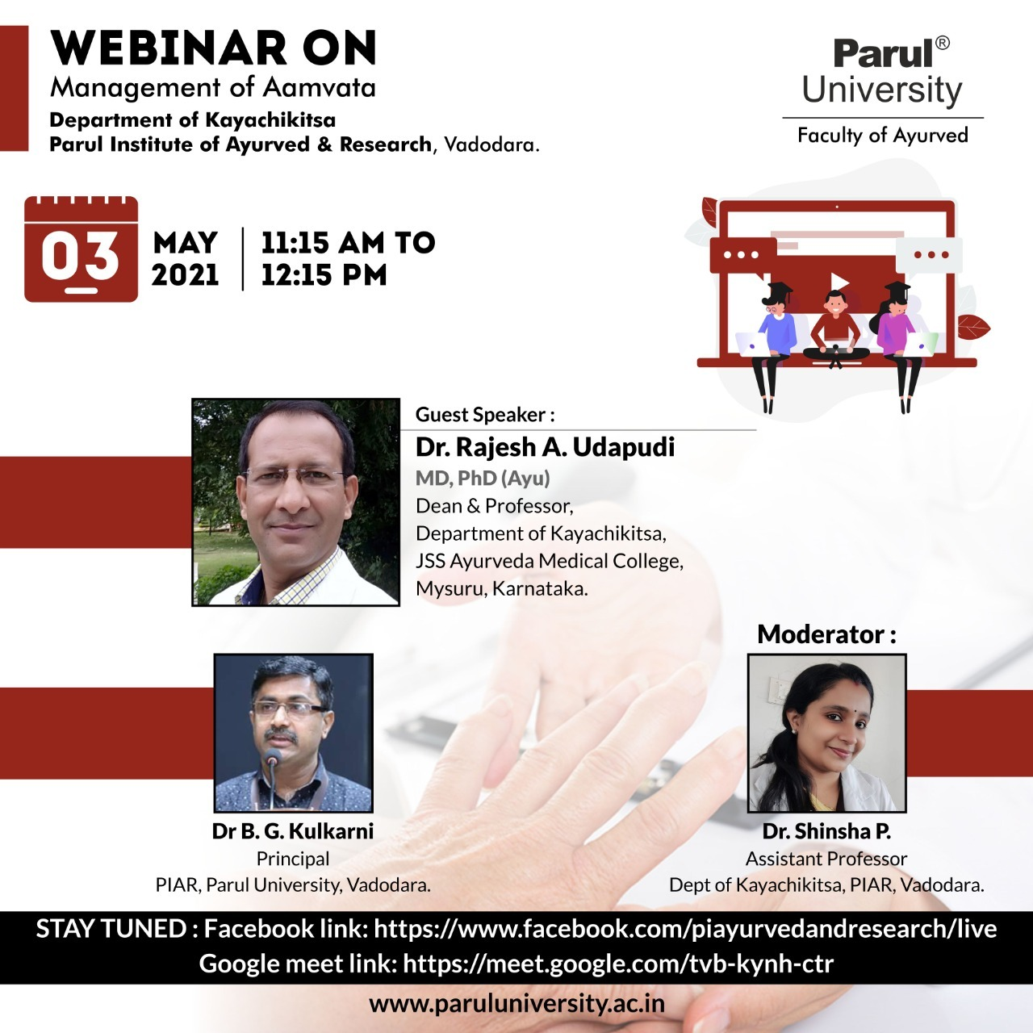

Webinar on Nasya Karma - Principles & Practices

Department of Panchakarma, Parul Institute of Ayurved and Research (PIAR) had arranged a web conference on the topic “Nasya Karma - Principles & Practices” on 30.4.2021, 12:00 Noon - 01:00 PM by Dr. Channabasavanna B Mashalkar, Professor & HOD, PG Department of Panchakarma, N.K. Jabashetty Ayurvedic Medical College & PG Centre, Bidar, Karnataka

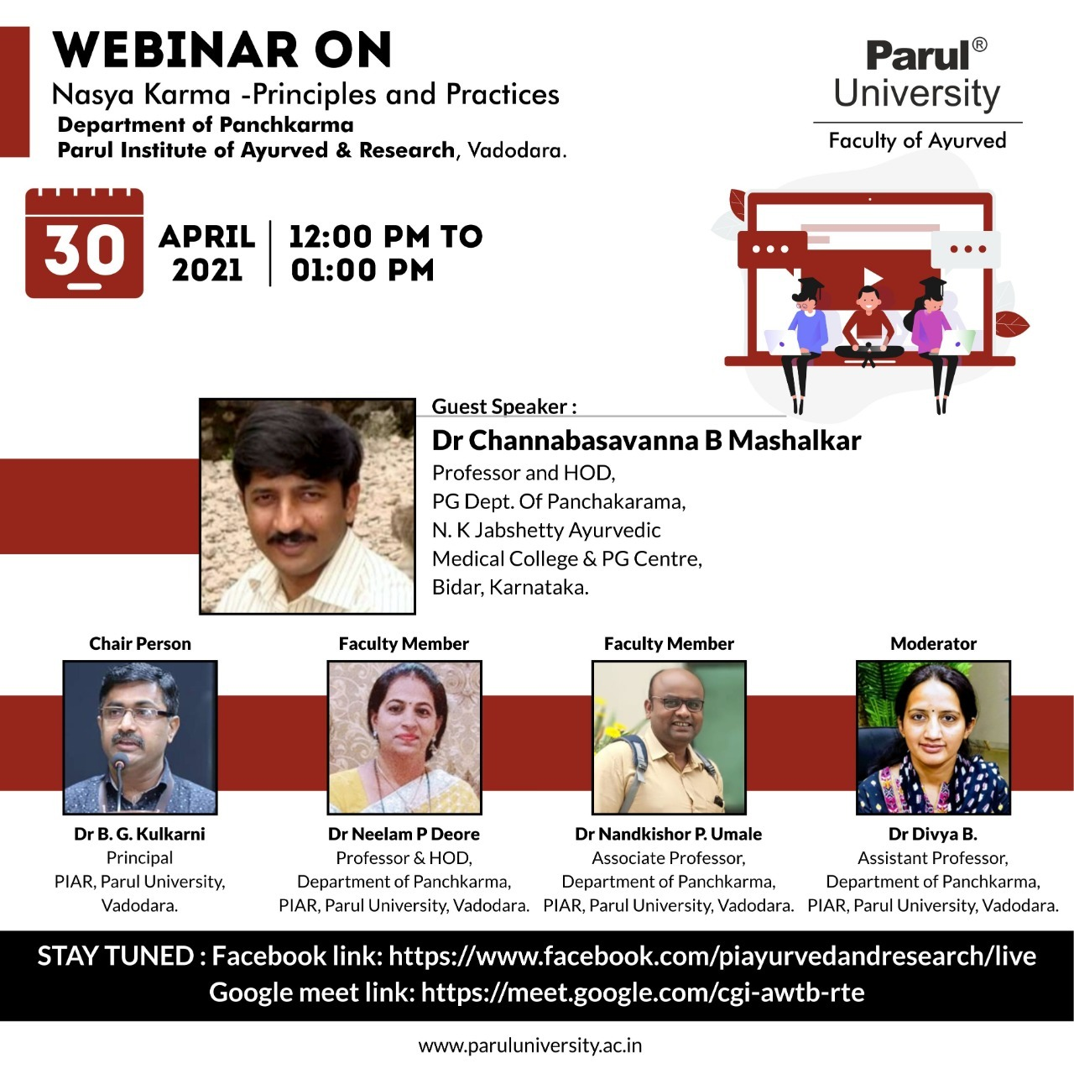

Webinar on Phases of Clinical Trial

Department of Research & Publication, Parul Institute of Ayurved and Research (PIAR) had arranged a web conference on the topic “Phases of Clinical Trial”, on 29.04.2021, 3:00 PM - 4:00 PM, by Dr. Arun Raj GR, Assistant Professor, Department of Kouarabhrutya, SDMCA&H Hassan, Karnataka

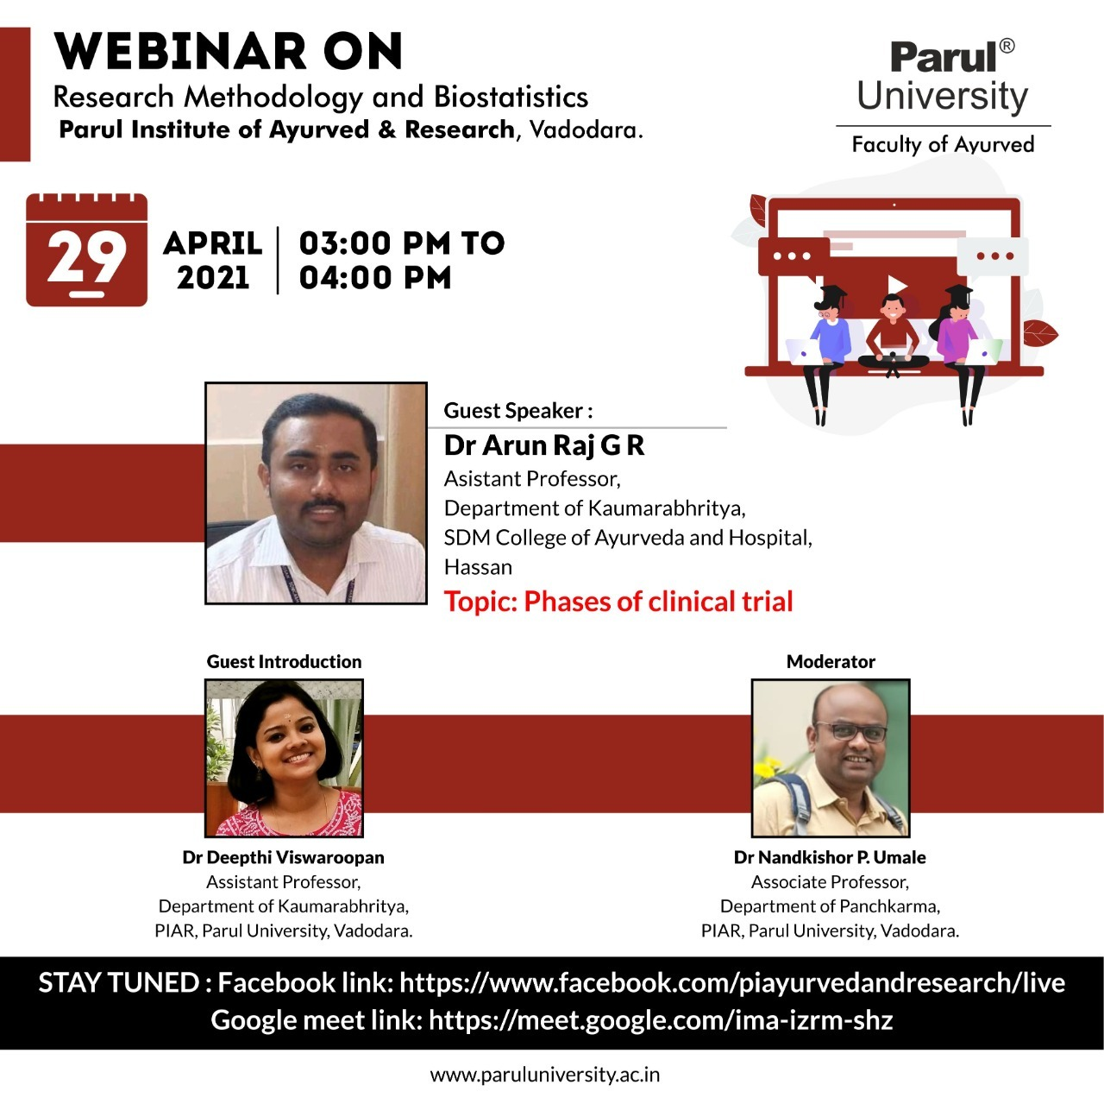

Webinar on Understanding of Basic Concepts to Practice Panchakarma

Department of Panchakarma, Parul Institute of Ayurved and Research (PIAR) had arranged a web conference on the topic “Understanding of Basic Concepts to Practice Panchakarma” on 26.04.2021, 02:00 PM - 03:00 PM by Dr. Sangeeta H Toshikhane, Professor & HOD, Department of Panchakarma, Parul Institute of Ayurved, Parul University, Vadodara

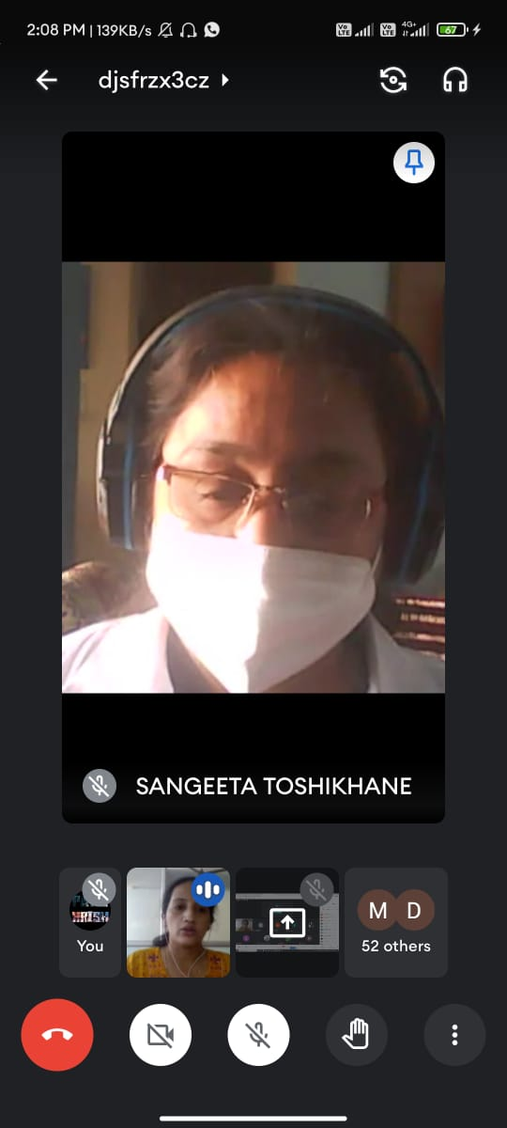

Webinar on Clinical Applications in Otorhinolaryngology - Every patient counts- WHO safety checklist for patient safety in Otorhinolaryngology

Department of Shalakya Tantra, Parul Institute of Ayurved and Research (PIAR) had arranged a web conference on the topic “Clinical Applications in Otorhinolaryngology - Every patient counts- WHO safety checklist for patient safety in Otorhinolaryngology”, on 24.04.2021, 09:00 AM – 10:00 AM, by Dr Yogesh Dabholkar, Professor & HOD, Dept of ENT, D.Y Patil Medical College, Nerul, Mumbai

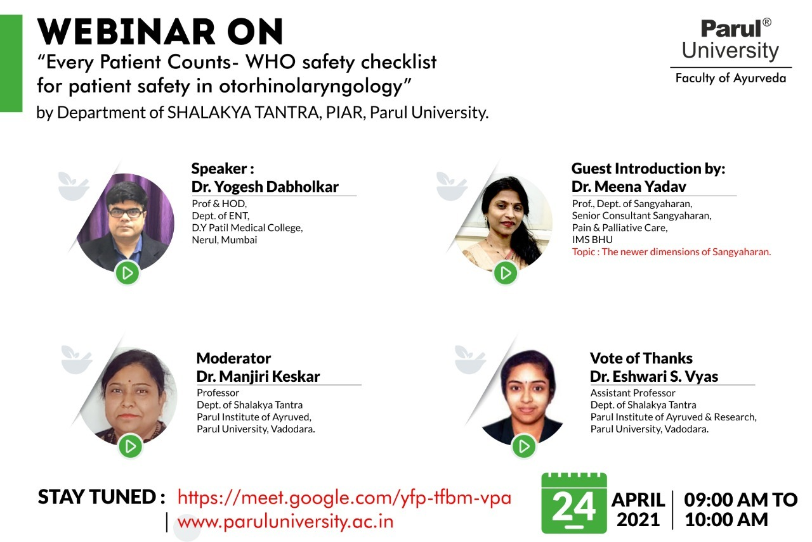

Webinar on Roganidan: - Diagnostic approach to Udara Vyadhi

Department of Roganidana Evam Vikruti Vigyan had arranged a web conference on the topic “Roganidan: - Diagnostic approach to Udara Vyadhi”, on 26.03.2021 by Dr. Manjiri S. Deshpande, M.D., Ph.D., Professor, Department of Roga Nidan Evam Vikruti Vigyan, Tilak Ayurved Mahavidyalaya, Pune, Maharashtra.

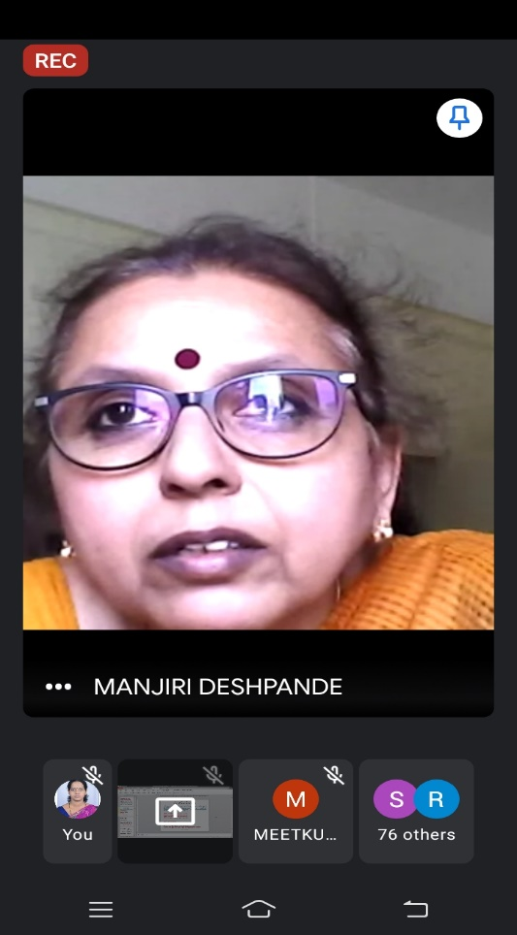 | 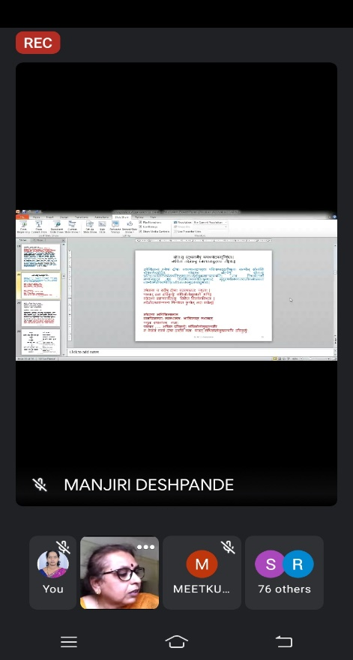

Webinar on Prakruti Parikshan – A Key to Complete Health Improvement Programme

Department of Kriya Sharir organized a webinar on the topic “Prakruti Parikshan – A Key to Complete Health Improvement Programme” on 25.02.2021 by Vd. Sunita D Shrisath, Professor and Head Dept of Kriya Sharir, Smt. KGMP Ayurved Mahavidyalaya, Charni Road, Mumbai, Maharashtra, India.

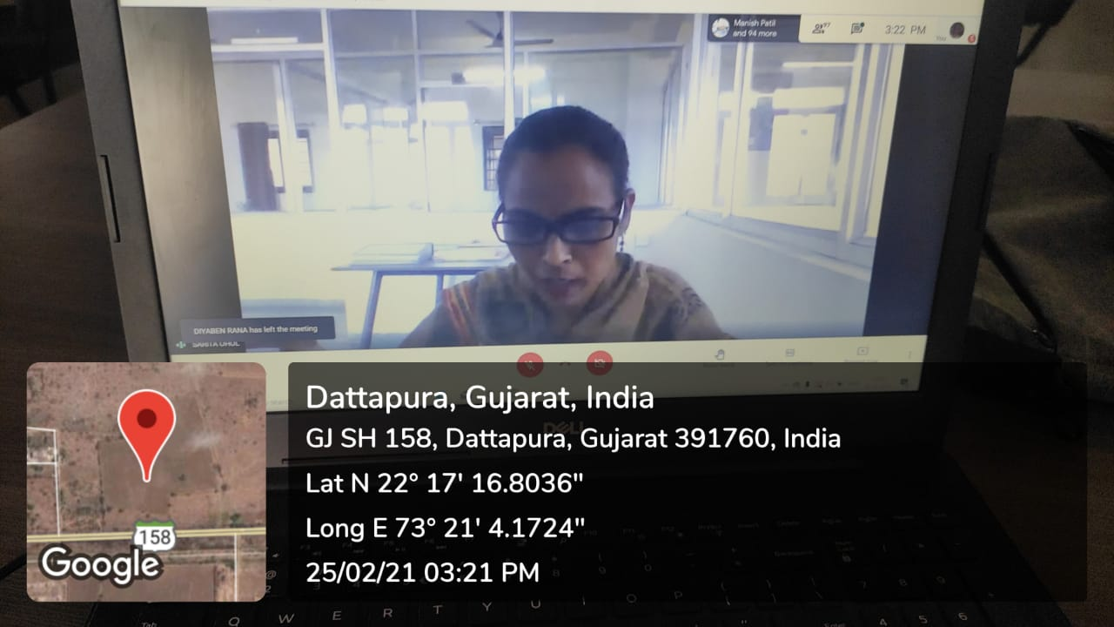 | 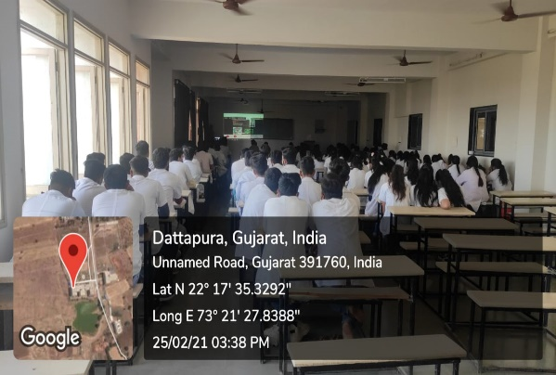

Webinar on Significance of Research and Publication

Department of Research & Publication Cell organized a webinar on the topic “Significance of Research and Publication” on 18.02.2021 by Dr. Girish KJ, Dean Academics & Professor, Department of Kayachikitsa, SDMCA&H, Hassan.

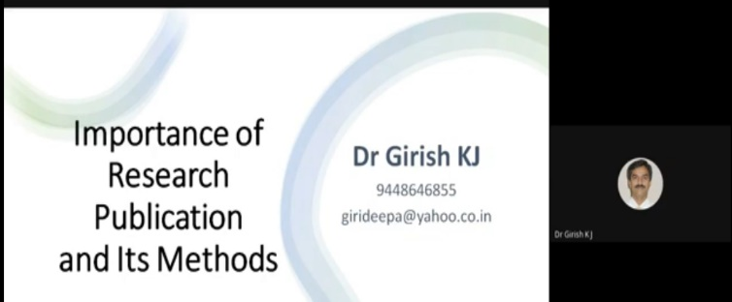 | 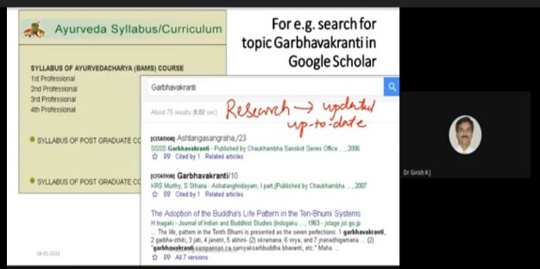

Webinar on Importance of Purvakarma before Shodhana

Department of Panchakarna, Parul institute of Ayurveda and Research, Organized a Webinar on the topic“Importance of Purvakarma before Shodhana” on 11th January, 2021 from 03:30 pm- 04:30 pm for the teaching faculties, Post graduate students of PIA and final year BAMS students of PIAR. The resource person for the session was Vaidya Rohini Salve, Associate Professor, Department of Panchakarma, Government Akhandanand Ayurved College, Ahemdabad, Gujarat

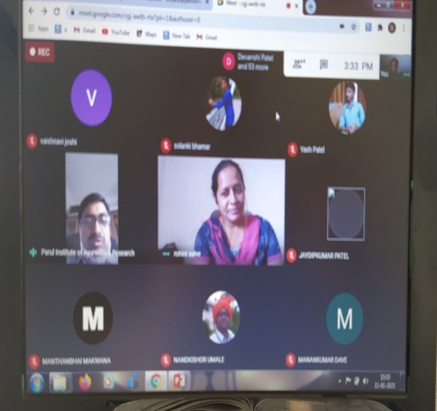 | 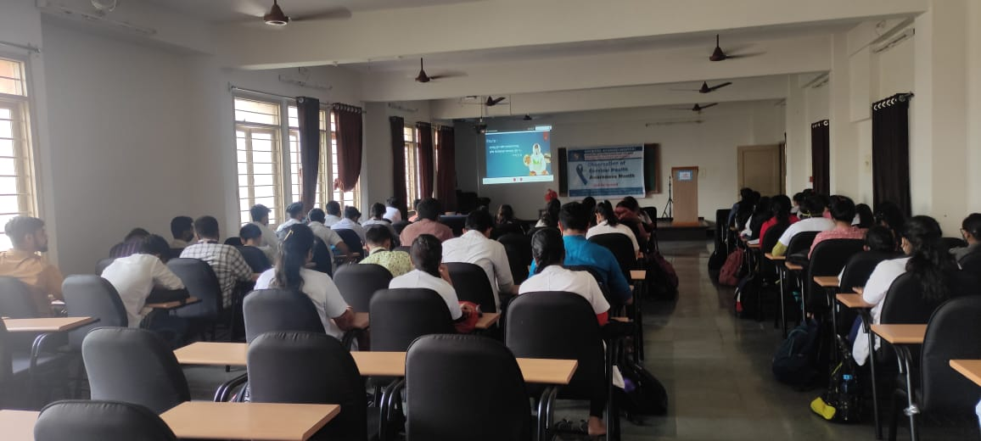

Seminar on Decoding Diabetic Retinopathy- Ayurvedic way

Department of Kayachikitsa has conducted webinar (Guest Lecture) for Faculties and 4th year BAMS students on 30/01/2021 during 10-11 am on online platform (through google meet) on the topic Decoding Diabetic Retinopathy- Ayurvedic way” by Dr. Prasad Suresh Vaidya, Chief Physician & Director, Ayurmedica Healthcare Services, Mumbai, Maharashtra.

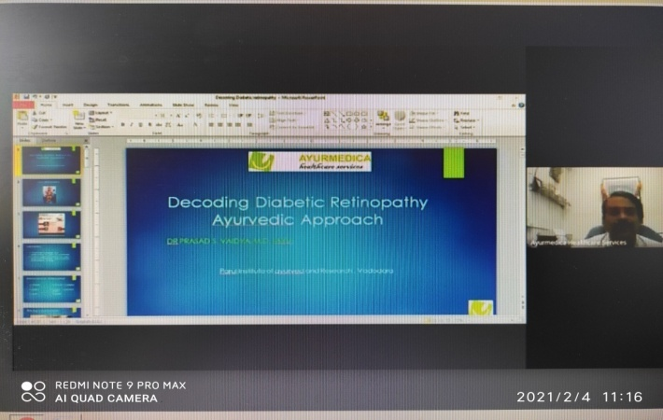 | 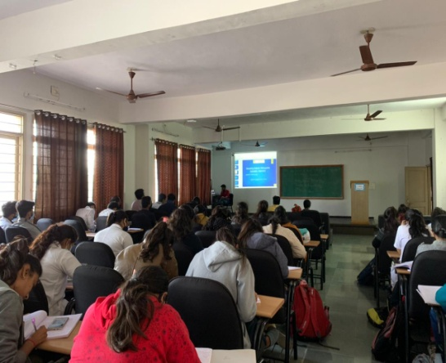

Webinar on Mind your Migraine

Department of Shalakya Tantra, Parul institute of Ayurveda and Research, Organized a Webinar on the topic “Mind Your Migraine” on 02.01.2021 from 11:00 AM to 12:00 Noon by the resource person Dr. Rajbir Singh, Associate professor & H.O.D, Department of Shalakya tantra, Dr. Sarvepalli Radhakrishnan Rajasthan Ayurved University, Jodhpur. The event moderator was Dr. Arohi Parmar, Assistant Professor , Department of Shalakya Tantra, Parul Institute of Ayurveda and Research.Meeting Link: https://meet.google.com/gtn-sgjt-fzm

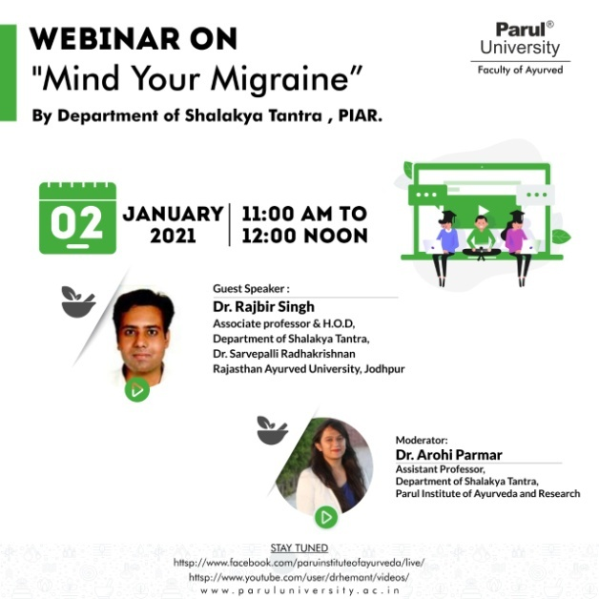 | 