SEMINAR/WEBINAR - 2022
WEBINAR ON UNDERSTANDING THE DISEASE EPILEPSY THROUGH AYURVEDA

As a part of UG Webinar Series, Department of Koumarabhritya, Parul Institute of Ayurveda And Research, Parul University Organized webinar on the topic Understanding the disease epilepsy through Ayurveda, on 11.04.2022 at 3:00 – 4:00PM by Dr. Preehi HM, Assistant Professor, Department of Koumarabhritya, JSS Ayurvedic Medical College & Hospital, Mysuru

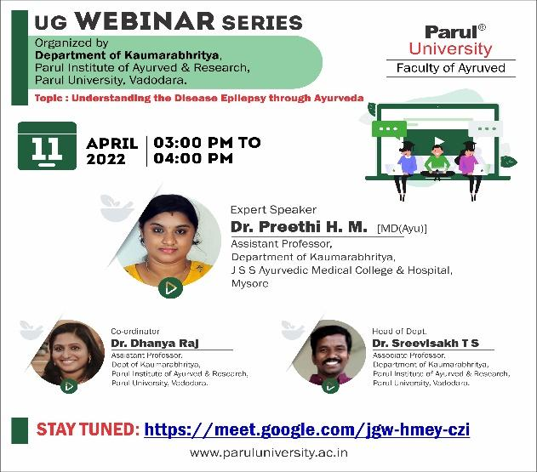

WEBINAR ON CORNEAL ULCER

As a part of UG Webinar Series, Department of Shalakya Tantra, Parul Institute Of Ayurveda And Research, Parul University Organized webinar on the topic Corneal Ulcer by Dr.Janat, Assistant Professor, Dept. Of Shalakya Tantra, Mai Bhago Ayurvedic Medical College for Women, Sri Muktsar Sahib, Punjab on 08/04/2022, 3-4p.m
The link for the session was - meet.google.com/hdk-tgku-ckj

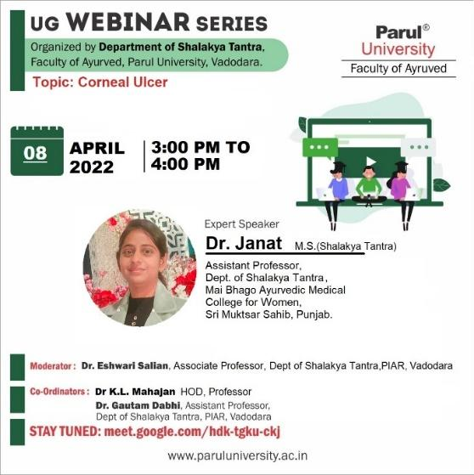

SEMINAR ON THE ROLE OF VAIDYA IN CLINICAL PRACTICE

Department of Ayurveda Samhita & Siddhanta, PIAR (Ayurved) had organised expert session on the the topic The role of Vaidya in clinical practice by Dr. Manisha Dunghav Professor, Department of Ayurved Samhita & Siddhanta, Vasant Prabha Ayurveda College, Vadnagar, Mehasana, Gujarat on 23.03.2022

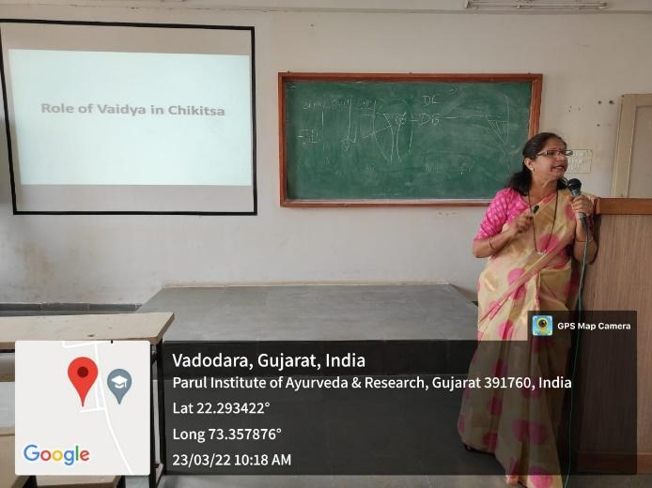

WEBINAR ON ROLE AND SCOPE OF AYURVED IN PUBLIC HEALTH

Department Of Swasthavritta And Yog, Parul Institute Of Ayurved And Research, Parul University presents a Youtube Live webinar on the topic of "Role And Scope Of Ayurved In Public Health" on 12.03.2022 from 11:00am to 12:00pm. After the global pandemic the public health has become one of the fastest growing sector of health care. In this era the health care demands a holistic approach and Ayurved graduates can utilize this apportunity with their skills and expertise for betterment of society and also have a great career. Guest Speaker:- Dr. Sudhir Joshi , MD (Ayurved), District Ayurved Officer, Vadorara, Government Of Gujarat.
Youtube - https://youtu.be/fkiT69-urX4
Department of Ayurveda Samhita & Siddhanta, PIAR (Ayurved) had organised expert session on the the topic The role of Vaidya in clinical practice by Dr. Manisha Dunghav Professor, Department of Ayurved Samhita & Siddhanta, Vasant Prabha Ayurveda College, Vadnagar, Mehasana, Gujarat on 23.03.2022

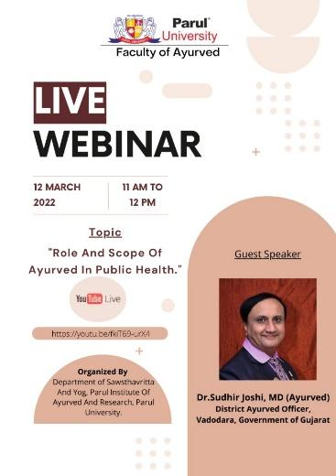

WEBINAR ON UNDERSTANDING VIRECHANA

Role And Scope of Ayurved in Public Health a apart of UG WEBINAR SERIES 2021, Department of Panchakarma, had organised UG Webinar series on 07.03.2022 at 4-5 PM on the topic “Understanding Virechana” by expert Dr. Sangameshwar N Doddagoudar, Assistant Professor, SS Ayurvedic Medical College and Hospital Haveri, Karnataka. The beneficiaries were fourth year BAMS

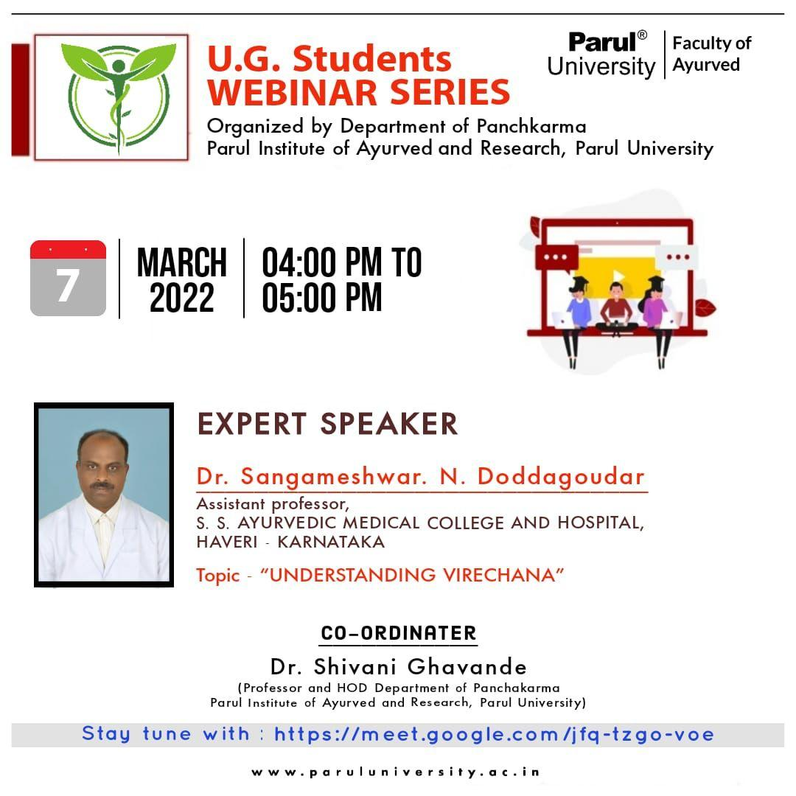

WEBINAR ON INFANT FEEDING - NAVAJATASHISHU POSHANA

As a apart of UG WEBINAR SERIES 2021, Department of Kaumarabhritya, Parul Institute of Ayurved and Research, organized a webinar as a part of UG Webinar Series on the topic "Infant feeding - Navajatashishu Poshana" by the expert speaker Dr. Thushar T S, Assistant Professor, Department of Kaumarabhrithya, PNPS AYURVEDA MEDICAL COLLEGE, KANHANGAD, KERALA on 02.03.2022 3 PM to 4 PM. The session was co-ordinated by Dr. Dhanya Raj MD(Ayu), Assistant Professor, Department of Kaumarabhritya, Parul Institute of Ayurved and Research, Parul University, Vadodara. The beneficiaries of the event were third year BAMS. Google meet link: https://meet.google.com/cya-ijgj-baf

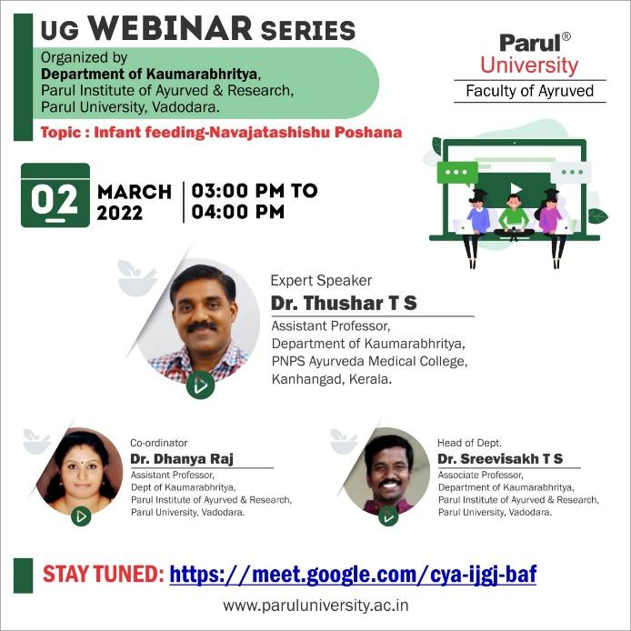

WEBINAR ON UNDERSTANDING THE CONCEPT OF RASAYANA

As a apart of UG WEBINAR SERIES 2021, Department of Ayurveda Samhita & Siddhanta, Parul Institute of Ayurved and Research, organized a webinar as a part of UG Webinar Series “Tatva Avabodhini” on the topic "Understanding the concept of Rasayana" by the expert speaker Dr. Meera E, Associate Professor & head, Department of Ayurveda Samhita & Siddhanta, PNNM Ayurveda Medical College & Hospital, Trissur, Kerala on 09.03.2022 10:00 AM to 11:00 AM. The session was co-ordinated by Dr. Manjula K, Associate Professor, Department of Ayurveda Samhita & Siddhanta, Parul Institute of Ayurved and Research, Parul University, Vadodara. The beneficiaries of the event were third year BAMS.

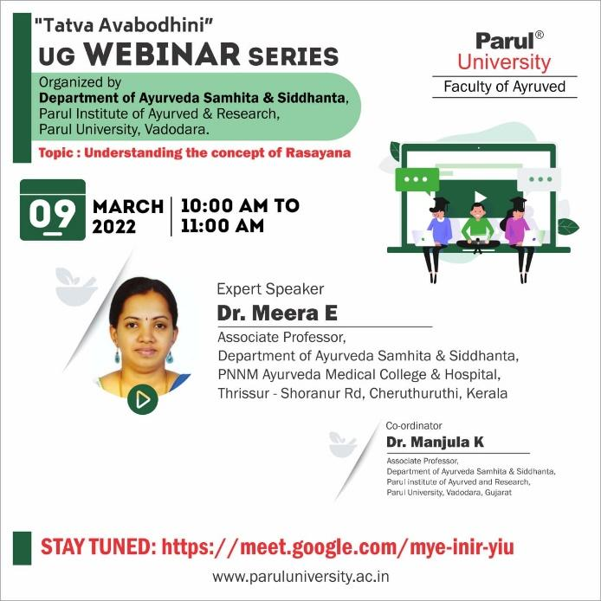

WEBINAR ON CLINICAL EXAMINATION OF ANORECTAL CONDITIONS

As a apart of UG WEBINAR SERIES 2021, Department of Shalya Tantra, Parul Institute Of Ayurved And Research organised a webinar. The Guest Speaker for the session was Dr. Nita Kedar, Professor & HOD, Dept. Of Shalya Tantra, PMT Government Ayurved College, Nagpur, Maharashtra; on the Topic “Clinical examination of anorectal conditions” on 26.02.22 at 10:00 to 11:00 A.M for final BAMS students.
Following is the Link- meet.google.com/vvb-jqtd-nxj

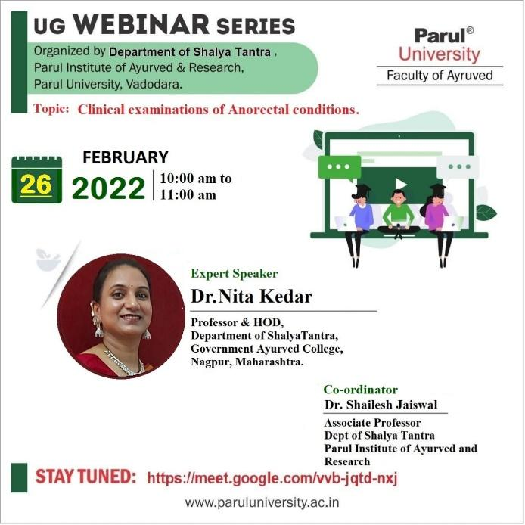

WEBINAR ON STRESS MANAGEMENT

As a apart of UG WEBINAR SERIES 2021, Department of Kayachikitsa, Faculty of Ayurveda, Parul University, Vadodara organised the webinar on the topic “Stress Management” by expert Dr. Rekha Phull, Professor, Department of Kayachikitsa, S G T University, Gurgaon, Haryana on 21.02.2022 at 3pm to 4 pm for final BAMS students.
Following was the link: meet.google.com/cgz-fkdc-sir

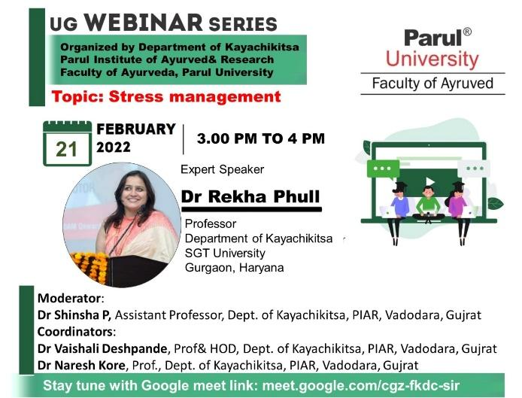

WEBINAR ON PRATISHYAYA - THE ANCIENT RHINITIS
As a part of UG WEBINAR SERIES 2021, Department of Shalakya Tantra, Parul Institute of Ayurved and Research, Parul University organised a webinar on the topic “Pratishyaya - The Ancient Rhinitis” by the expert Dr. S.Md. Nihaluddin, Assistant Professor, Dept. Of Shalakya Tantra, Dayanand Ayurved Medical College and Hospital, District Siwan, Bihar on 14.02.2022 at 2:00-3:00 P.M for final BAMS students.
Google Meet link- meet.google.com/hdk-tgku-ckj
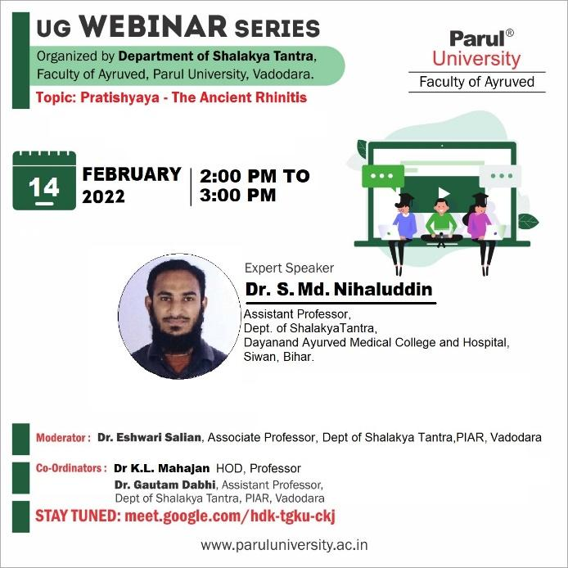
WEBINAR ON TRAUMATIC CORNEAL INJURIES- AN AYURVEDIC APPROACH

As a apart of UG WEBINAR SERIES 2021, Department of Shalakya Tantra, Parul Institute of Ayurved and Research, Parul University, organized UG WEBINAR SERIES 2021-22 on the topic- Traumatic Corneal Injuries- an Ayurvedic Approach on 04/03/2022, 3:00 PM – 4:00 PM by the expert speaker, Dr. Ayana Raj P., Associate Professor, Dept. Of Shalakya Tantra, Adichunchanagiri Ayurvedic Medical College, Bangalore, Karnataka. The session was moderated by Dr. Eshwari Salian, Associate Professor, Dept. of Shalakya Tantra, Parul Institute of Ayurved and Research, Vadodara. The beneficiaries of the event were Fourth year BAMS. Link- meet.google.com/hdk-tgku-ckj

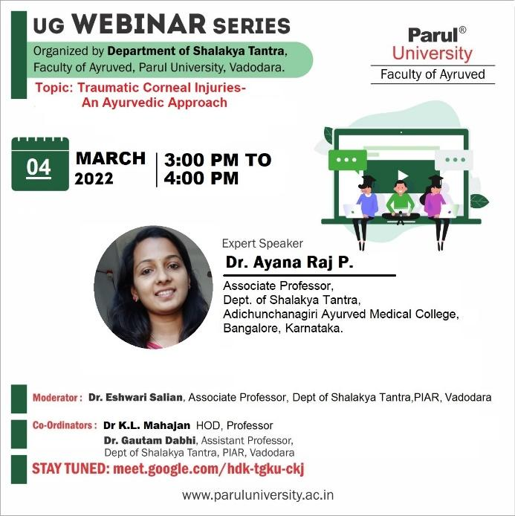

WEBINAR ON OVERVIEW OF MIDDLE EAR DISORDERS & ITS MANAGEMENT

As a part of “UG WEBINAR SERIES 2021” Department of Shalakya Tantra has organized a webinar on 7.1.2022 from 2.00pm to 3.00pm on the topic Overview of Middle Ear Disorders & its management by Dr. Miral Pate, Assistant Professor, Dept. Of Shalakya Tantra, Gokul Ayurvedic College, Gokul Global University, Sidhpur, Patan, Gujarat.
Google Meet Link- meet.google.com/hdk-tgku-ckj
